Solartron Instruments 1887/1988
Specification issue D ?

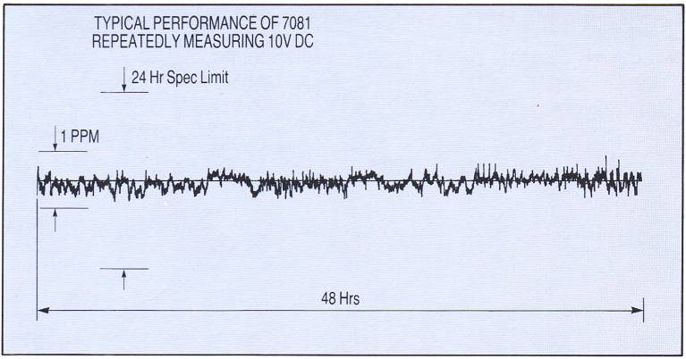
7081 noise :
0.5 ppm p-p (5 μV) ≈ 0.09 ppm rms

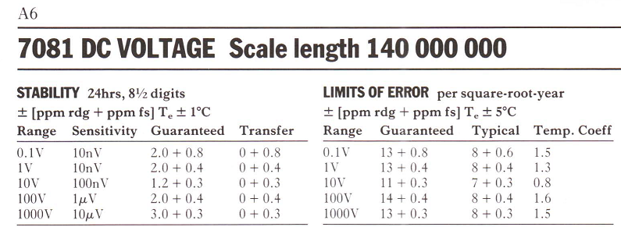
Transfer noise is 0.3 ppm p-p, 24 hrs instability is 1.2 ppm.
Temp-co is 0.8 ppm/°C at +/–5 °C.

Solartron 7071/7081 Operating manual, 1989
Specification issue E ?

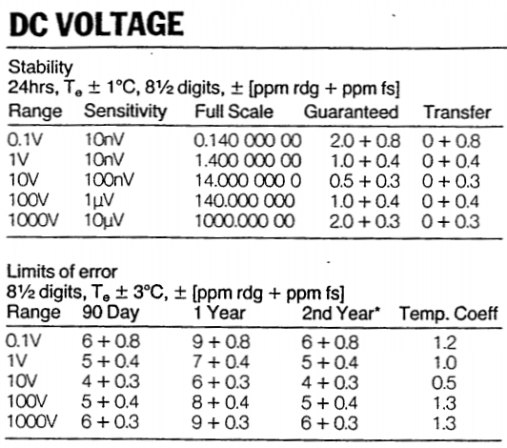
Transfer noise is the same 0.3 ppm p-p,
but 24 hrs instability is 0.5 ppm now!
Temp-co is lower (0.5 ppm/°C), but temperature span is lower too (+/–3 °C).

Instruments test specification, 1994

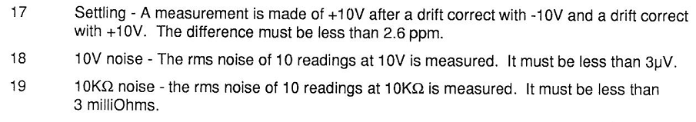
Allowable settling error is 2.6 ppm. I. e. readings discontinuities can be as large as 26 μV!
Allowable 10 V noise is 3 μV rms that approximately equal to 18 μV p-p!
Solartron 7081 statistics by Lymex Zhang (lymex / bg2vo)

DMM’s low frequency noise, Standard deviation
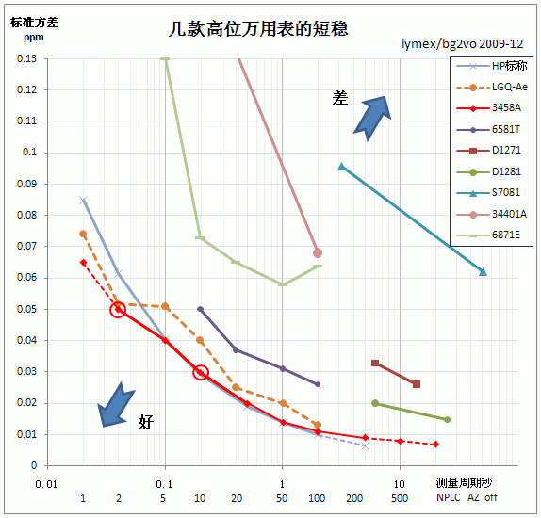
Measured 7081 rms noise at 7 ½ mode is 0.095 ppm (1 μV rms or 6 μV p-p).
Measured 7081 rms noise at 8 ½ mode is 0.062 ppm (0.6 μV rms or 4 μV p-p)

