7081/7071 DIGITAL VOLTMETER
MAINTENANCE MANUAL
Issue 5: August 1986________________________________________________Part No. 70810014
SOLARTRON
Sthlumberger
Solartron Instruments. Victoria Road. Farnborough
Hampshire. England GU14 7PW Telephone: Farnborough (0252) 544433
Telex: 858245 Solfar G Cables: Solartron Farnborough
%c-i:;?ti pursue a poiicy ot continuous developmeni ana proauct improvement. The specification .n this Document may ther'tore be chanoed witnout notice.
19^83
SAFETY
These instruments have been designed and tested in accordance with the recommendations of IEC 348 Class 1. They are primarily intended for indoor use. and for such use are supplied in a safe condition. However, no degradation of their safety will be caused if they are occasionally subjected to temperatures below normal room temperature.
This manual contains information and warnings which the user should follow to ensure his own safety and for the continued safe operation of the instruments. The 7081 and 7071 have been engineered with ease of use as one of the primary considerations. Attention has also been given to making the instruments immune to most inadvertent overloads. It should be appreciated, however, that even the most sophisticated measuring instrument can be dangerous when connected to high voltages, unless elementary safety precautions are observed.
The voltage limits of IkV on AC and DC mean that no damage will be caused to the instruments at this level of input. Other than the displayed reading, however, no indication is given to the user that a voltage of such magnitude is present at the input terminals. Care should therefore be exercised whenever dvm input leads are being connected to/removed from live circuits, especially where high voltages are known to exist, or high transients could occur.
Similarly, when using the instruments on mains operated equipment capable of delivering high voltage outputs, it is strongly recommended that the equipment under test is NOT switched off with a dvm still connected. For example, consider a 7081 connected across the secondary winding of a large mains transformer. The instruments very high input resistance is such that in the event of the mains supply being interrupted, the resultant back emf induced in the undamped secondary could be in the order of lOOkV. This is obviously hazardous to the user and would certainly harm the voltmeter.
Whenever it is likely that the safety of the instruments have been impaired, e.g. if there are any visible signs of damage, failure to perform correctly, or if the specfications have been exceeded in any way, the instrument should be made inoperative and referred to a suitable repair organisation.
Any adjustment, maintenance or repair of these instruments should be carried out only by a skilled person who is aware of the hazards associated with mains operated equipment. Such adjustment, maintenance or repair should be carried out in accordance with the procedures, and observing the precautions, detailed in this Maintenance Manual.
0053g/1122g/PD
CONTENTS
Page
Chapter 1 General Information
1.1 . Introduction 1.1
1.2 Presentation of Information 1.1
1.2.1 Power Rails 1.1
1.2.2 Split Pads 1.1
1.2.3 Test Points 1.2
1.3 Principles of Operation 1.2
1.4 Functional Description 1.2
1.4.1 Signal Conditioning 1.3
1.4.2 A-to-D Converter 1.3
1.4.3 Digital Section 1.3
1.4.4 Power Supply 1.4
1.5 Fault Diagnosis Guide 1.4
1.5.1 Display 'Dead' 1.5
1.5.2 Display Statment Error 1.5
1.5.3 Self Test Fail 1.6
1.5.4 'Wrong' Readings 1.7
1.5.5 'Noisy' Readings 1.7
Chapter 2 Printed Circuit Board 1
2.1 Introduction 2.1
2.2 Data Input 2.1
2.3 Annunciators 2.1
2.4 Annunciator Clock Signals 2.1
2.5 Display 2.2
Chapter 3 Printed Circuit Board 3
3.1 Introduction 3.1
3.2 Floating Link 3.1
3.2.1 Link Handshake 3.1
3.2.2 Wakeup 3.1
3.2.3 Negative Acknowledge 3.2
3.2.4 Power Up Sequence 3.2
3.3 RS232 Interface 3.2
3.4 Minate Interface 3.4
3.5 Keyboard Interface 3.5
3.6 Display Interface 3.7
3.7 I/O Clock 3.8
3.8 Reset 3.9
3.9 Power Supplies 3.10
3.9.1 Earthy Power Supply 3.10
3.9.2 Power Fail Detect 3.11
3.9.3 Floating Power Supply 3.11
3.10 Test Points 3.13
0053g/1122g/PD
Printed Circuit Board 4
Page
4.1 Microprocessor Set _ 4.1 4.1.1 Read/Write (R/W) 4.1
•4.1.2 Interrupt Request (IRQ) 4.1
4.1.3 Non-Maskable Interrupt (NMI) 4.1
4.1.4 Reset (RESET-) 4.2
4.1.5 Address Bus and Data Bus 4.2
4.2 Address Decoders 4.2
4.3 Direct Memory Access (DMA) 4.4
4.3.1 Channel 0 4.5
4.3.2 Channel 1 4.6
4.4 GP-IB Interface 4.7
4.4.1 GP-IB Address Selection 4.8
4.4.2 GP-IB Signal Lines 4.8
4.5 Test Points 4.10
Chapter 5 Printed Circuit Board 5
 | 5.1 | Introduction
 | 5.2 | V-To-T Converter
 | 5.3 | Reference
 | 5.4 | Ratio Circuit
 | 5.5 | Ohms Circuit
 | 5.6 | Glug Counters
 | 5.7 | Clock Divider
 | 5.8 | Clock Oscillator
 | 5.9 | Non-Volatile Memory (NVM)
 | 5.10 | Floating Power Supply
 | 5.11 | Test Points
Chapter 6 | Printed Circuit Board 6
 | 6.1 | Introduction
 | 6.2 | Attenuator
 | 6.3 | Input Amplifier
 | 6.4 | DC Ranging  6.4.1 Input Protection  6.4.2 Ranging
 | 6.5 | Amplifier Output Limit
 | 6.6 | AC Attenuator and Buffer
 | 6.7 | AC RMS Converter
5.1 5.1 5.2 5.3 5.4 5.4 5.6 5.7 5.7 5.8 5.8
6.1 6.1 6.2 6.2 6.3 6.3 6.3 6.4 6.5
6.7.1 The Absoluter 6.5
6.7.2 The Converter 6.6 6.8 Test Points 6.8
0053g/1122g/PD
Chapter 7 Parts Lists and Circuit Diagrams
7.1 Introduction
7.2 Components Parts List Abbreviations 7.2.1 Circuit Reference
. 7.2.2 Component Types Parts Lists PCB 1 PCB 3 PCB 5 PCB б PCB 8 PCB 14 General Assembly
7.1 7.1 7.1 7.1
7. 7, 7. 7. 7. 7,
2
3
8
18
26
27
•л
7.29
Circuit Diagrams PCB 1 PCB 3
PCB 4 and 8 PCB 5 PCB 6
-""<
Component Layout Diagrams PCB 1 PCB 3
PCB 4 and 8 PCB 5 PCB 6
Chapter 8 Monitor, Calibration and Self Test
8.1 Monitor Command 8.1
8.1.1 Earthy Monitor 8.1
8.1.2 Floating Monitor 8.3
8.1.3 Interpreting Calibration Constant Data 8.4
8.2 Calibration Messages 8.6
8.3 Calibration Commands 8.7
8.3.1 CALIBRATE. DUMP 8.7
8.3.2 CALIBRATE, REFRESH 8.8
8.4 7081 Calibration 8.9
8.4.1 Complete Re-calibration 8.9
8.4.2 Partial Re-calibration 8.11
8.4.3 GP-IB Calibration Program 8.11
8.5 Self Test 8.13
Chapter 9 Setting Up Procedure
9.1 Introduction
9.2 Test Equipment
9.3 Safety
9.4 Printed Circuit Board 4 Test
9.5 Printed Circuit Board 6 Test
9.6 Assembly Check
9.7 Power Supply and Digital Checks
9.8 Analogue Checks
9.1 9.1 9.1 9.1 9.2 9.3 9.4 9.5
0053g/1122g/PD
Chapter 10 Instrument Assembly Parts
10.1 Introduction 10.1
Instrument Assembly Drawings 10.2
Digital Voltmeter Chassis Assembly Part 1 Chassis Assembly Part 2 Displayed Keyboard Assembly Front Moulding Assembly Cover Top Final Assembly Cover Bottom Final Assembly Panel Rear Assembly
Index
0053g/1122g/PD
CHAPTER 1
General Infonnation
CONTENTS
Page
1.1 | Introduction | 1.1
1.2 | Presentation of Information | 1.1
1.2.1 1.2.2 1.2.3 | Power Rails Split Pads Test Points | 1.1 1.1 1.2
1.3 | Principles of Operation | 1.2
1.4 | Functional Description | .1.2
1.4.1 1.4.2 1.4.3 1.4.4 | Signal Conditioning A-to-D Converter Digital Section Power Supply | 1.3 1.3 1.3 1.4
1.5 | Fault Diagnosis Guide | 1.4
1.5.1 1.5.2 1.5.3 1.5.4 1.5.5 | Display 'Dead' Display Statement Error Self Test Fail 'Wrong* Readings 'Noisy' Readings | 1.5 1.5 1.6 1.7 1.7
Figures
1.1 Microprocessor Set 1.3
1.2 Fault Diagnosis Flow Chart 1.5
1935g/0142g
1.1 INTRODUCTION
This manual contains technical information that is intended primarily to meet the needs of the service engineer. A detailed treatment of the principles of operation is not included but the descriptive text covering each circuit diagram is sufficient to enable the reader to understand the purpose of the circuit and its effect on its input(s). To facilitate fault diagnosis, attention is drawn to peculiarities of circuits, together with any precautions necessary when carrying out checks.
Both the 7081 and 7071 have identical electronic circuits. This means that all the circuits diagrams included in this manual are valid for both instruments. The difference between these two instruments exists primarily at the software level, and on the higher specification components required by the 7081 . The 7081 undergoes a significantly more rigourous quality control proceedure.
1.2 PRESENTATION OF INFORMATION
The circuit diagrams are arranged to fold out clear to the right. Signal paths are indicated by bold lines, arrows being used where necessary to indicate the direction of functional flow. In general this is from left to right, feedback paths flowing from right to left. To prevent ambiguity, however, and where space is limited, this convention has not been followed rigidly.
In addition to the circuit diagrams, lined drawings are reproduced in the manual to facilitate rapid identification of components during diagnostic checks.
1.2.1 Power Rails
These are represented by short, detached bars annotated to show the nominal voltage. Several separate bars, annotated with the same voltage, may appear on a diagram. These are electrically connected to a common rail derived from the Power Supply circuits.
Note that voltages specified on the circuit diagrams are in all cases nominal values, the actual values being dependent upon the load offered to the supply by the specific circuit. Inconsistencies between actual measured values and those quoted should not, therefore, be regarded with suspicion without considering other symptoms of possible unserviceability.
1.2.2 Split Pads
Split pads are used to provide a means of isolating various parts of the circuit for fault diagnosis. They are simply bridged with solder, open circuit being effected by removing the solder. It should be noted that excessive heat applied during this operation could damage the solder trace - a small, low wattage iron should be used.
1935g/0142g/JWS
1.1
1.2.3 Test Points
A further aid to rapid circuit check-out is the provision of test pins. These are indicated on the circuit diagrams and clearly marked on the pcb's.
1.3 PRINCIPLES OF OPERATION
The 7081 and 7071 employ an A-to-D Converter, which transforms the input voltage to a time analogue. This in turn is split into discrete, equal length time units, which are counted and the result displayed as a numerical indication of the measured quantity.
The V-to-T converter produces a pulse train, the pulse width being variable and proportional to the magnitude of the input signal. The pulses gate the output of a fixed frequency clock into a counter, over a time period which can be selected by the user. At the end of the time period, the total accumulated In the counter is a measure of the input during that time. An integrating technique is used whereby the total count is divided by the number of gating pulses used. The result obtained is displayed as a direct reading of the measured quantity.
Since the total count is much longer when operating at the longer integration times, the counter requires more capacity. This results in an increase in scale length and it follows that the display sensitivity is improved hand-in-hand with the increased measurement resolution.
1.4 FUNCTIONAL DESCRIPTION
The circuits of the 7081 and 7071 can conveniently be divided up into four major functional sub-divisions:
* Signal Conditioning
* A-to-D Converter
* Digital Section
* Power Supply
An input is processed by the Signal Conditioning circuits, which convert all measured quantities into a dc voltage, scaled to a level suitable for further processing. Input protection, reference and guard circuits are included in this sub-section.
The correctly scaled dc signal is converted to a train of digital pulses by the A-to-D Converter, these pulses being used to gate the output of a clock circuit.
Control of the measurement conversion and timing of the control sequences by the microprocessor set are two important functions of the Digital Section. It also contains the reversable counters which accumulate the gated clock pulses, and the latches which shift the counter contents to the databus.
1935g/0142g/JWS 1.2
The power supply provides all dc power for the instrument analog and digital circuits.
1.4.1 Signal Conditioning
The A-to-D Converter is capable of handling dc volts only, regardless of the measurement being taken. Therefore, the Signal Conditioning circuits convert the input to a dc voltage level. Once converted, the input signal is applied to an amplifier, the gain of which is determined by the range on which the instrument is operating. The amplifier output is compared with the instrument's reference and both signals are applied to the A-to-D Converter.
1.4.2 A-to-D Converter
The analogue input is converted to digital form by a circuit which produces a pulse train - the width of the pulses is proportional to the magnitude of the input. This technique is known as voltage-to-time conversion, the method employed being a variant in which "time" is in fact the difference between two distinct time periods. It is this differential which is used to control the number of clock pulses finally accumulated in an up/down counter in the Digital Section.
1.4.3 Digital Section
The Digital Section comprises the phase comparator which produces the pulses that are counted to digitally measure the applied input; the microprocessor clock which supplies timing and synchronising signals for the digital circuits and a microprocessor set for controlling and shifting data.
The microprocessor set consists of two Central Processing Units and their associated memory devices as shown in Figure 1.1.
Earthy
Floa:ing
CPU
DMAC
NVM
CPU
Communicates with Display, Keyboard, RS232 and GP-IB interfaces
Controls A-To-D converter
ROM
ROM
RAM
Figure 1.1 Microprocessor Set
RAM
1935g/0142g/JWS
1.3
The 'Floating' processor controls the A-to-D Converter and the range/mode drive circuits, and communicates with the Non-Volatile Memory (NVM) and the 'Earthy' processor. It has its own internal Read Only Memory (ROM) but also utilises external Random Access Memory (RAM) and ROM.
The 'Earthy' processor performs the following functions:
* communicates with the 'Floating' processor to command measurements.
* communicates with the Display, Keyboard, RS232 and GP-IB interfaces.
* calibrates results.
* controls the processing of results.
* controls the storage of results.
It has its own ROM and RAM set. In addition, some of the data movement is handled by a Direct Memory Access Controller (DMAC).
1.4.4 Power Supply
The Power Supply features two pulse width-modulated switching regulators to provide both the "earthy" and "floating" supply rails. A mains transformer is used to connect the rear panel ac input to the regulators through full-wave rectifiers. A Power Fail Detect circuit is also included.
Note: The analogue boards (printed circuit boards 5 and 6) form a calibrated set and may be used with any other digital boards (and vice versa) provided that the software fitted is of the same issue and status. This is possible because the Non-Volatile Memory (NVM), which holds the calibration constants, is located on the analogue boards.
1.5 FAULT DIAGNOSIS GUIDE
Owing to the complex nature of 7081/7071 circuits it is virtually impossible to document fully all fault conditions that might arise. However, It is possible to quickly narrow down a fault condition to a particular PCB, and sometimes to an area of just a few components. The following pages should prove especially useful since the comments are based firmly on the experiences of the 7081/7071 Test and Service Personnel.
Note: Sometimes an instrument may be suspected of being faulty because it gives 'wrong' or unstable reading. In cases like these, the fault quite often turns out to be a poor understanding of measurement techniques by the user. Before dismantling the 7081 or 7071, make absolutely certain during measurement or calibration that the proper precautions are taken to guard against interference, thermal emfs, high resistance leads, etc.
1935g/0142g/JWS 1.4
DISPLAY
"dead"
7081/7071
Switch-on
, DISPLAY STATEMEKTl ERROR"
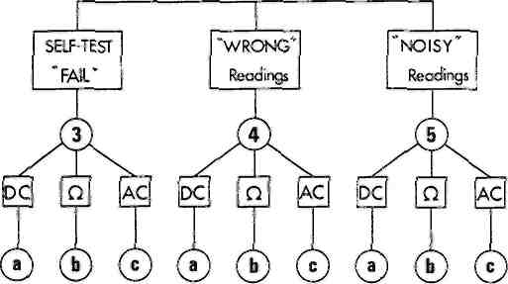
Figure 1.2 Fault Diagnosis Flow Chart
1.5.1 Display 'Dead'
Check the +5V rail at D58 cathode, PCB3.
If the indicator lamps are also blank the fault could lie on PCB3 or PCB4. If substitute boards are available, use these to narrow down the search. The failure could be a MPU, DMA, RAM or ROM fault. Suspect ICs 401, 402, 406 to 411, 430, 412 to 415, or a display system fault on PCB3.
If the display shows incorrect symbols and figures, a PCBl failure should be suspected.
1.5.2 Display Statement Error
A correctly calibrated instrument must always show a RESUMED statement on power-up. Under error conditions, the following statements might be seen:
INITIALISED - This indicates that the NMI routine for retaining the history file at power-down was incorrect. Check the power supply of IC56; the battery circuit of PCB4 RAM.
CAL INCOMPLETE - This indicates that the NVM on РСВ5 has not received all calibration constants following a calibration routine.
NVM FAIL - This could indicate a failure of the NVM circuitry, or of IC804. A spare NVM would prove useful here.
l935g/0142g/JWS
1.5
WAIT @ F - This could indicate a communication failure between the 'floating' and 'earthy' PCBs. Check IC9, IC10, ICll or the clock of PCB3. On PCB5 check IC801, IC803, IC826 or the clock.
MAINS FAULT - This indicates that a mains character has not been received from the earthy side and would normally indicate a PCB5 failure. Check IC303. IC834, IC801. If the fault still persists, PCB3 must be suspected.
@F - This indicates that the WAIT @ F stage has been passed, but a fault probably exists in the 'floating' link. That is, in terms of the information flow between the 'earthy' and 'floating' circuits. The fault could lie on PCB3 or PCB5. Rarely, PCB4 or PCBl could be faulty.
The fault is often due to a temperature sensitive 1С and manifests itself after the instrument has been switched on for some time. It is difficult to localise this fault but it is more prevalent on PCB5. Check the floating logic sheet or V-T converter (sheet 1).
Suitable replacement boards and/or judicious use of a tin of freezer spray would not go amiss here.
1.5.3 Self-Test Fail
A fail here usually indicates a major fault in the PCB 5 analogue section.
(a) DC
A fail of the OV test probably indicates a faul in the V-T converter stage (sheet 1), IC201, or the circuits associated with the RATIO circuit (sheet 3) of the integrator input.
If the OV test passes but shows a fail at 10V, a fault could lie in the input amplifier which prevents the 10V reference level from being fed to the V-T converter.
(b) OHMS
If а кй fault is Indicated check that there is:
(1) approximately 20V across R604 (ii) approximately 6V across F609.
If either of these is wrong suspect IC601 or IC602. Failing these, check TR610 and the circuits around IC604.
(c) AC
Where an AC fail is indicated it is beneficial to check the AC level at TP705 to see whether the fault lies in the AC buffer or the AC converter. As an approximation, with IV, 1kHz applied to 7081/7071 input, range IV, TP705 should be IV rms. The corresponding level out of the converter should be 5VDC (@ ТР757).
l935g/0142g/JWS
1.6
1.5.4 'Wrong' Readings
(a) DC
With a shorting-plug applied to the instrument input check the ranges 10V to O.lV. If the indicated zero error gets larger as the range is -reduced this indicates a fault in the chopper channel of the input amplifier. Check operation of IC101, IC104, IC401, IC404, IC405, and TR404.
If a constant error appears on all ranges suspect the V-T converter (sheet 1), IC201 or the input switching circuits to SP201.
If the zero readings are correct but the scaling of the readings is wrong (with an input applied) firstly check that the correct level is being applied to the V-T converter at SP201. If the level is correct check the reference voltage supplies (±10V).
(b) OHMS
A failure to provide correct resistance readings is usually due to Incorrect levels at ТР601 or ТР603. The fault could lie in IC601, IC602, IC605, TR601, or TR602. If these are fine then check IC604, IC606, TR610, TR605. and D605.
(c) AC
Reference to section 6.7.1 can usually indicate the area of failure. If the system is basically working but the readings are incorrect then the various gain defining resistors could be suspect: R725, R750. R751a and R751b.
1.5.5 Noisy Readings
(a) DC
Noisy readings on the 0.1V range are especially indicate of a noisy component in the input amplifier. Suspect component in the input amplifier. Suspect components D403, TR401, TR412, IC401. If the 10V range is also noisy (with short circuited input) then IC201 is a likely cause.
(b) OHMS
Noisy readings on the kP. ranges when the DC ranges are normal
could be caused by IC601, IC602. IC603. Also D601, D602, D616, D617
could produce noise if they become 'leaky*.
(c) AC
If the AC readings are noisy the switching circuits around TR758 and TR759 could be at fault. Unstable readings could be produced by a breakdown by any of the FETs TR770 to TR779. By applying an input of approximately IV @ Ikhz to input, and heating up the FET's Individually with a hot-air gun (never apply direct heat to a component!), the fault may be quite quickly found by examining the display for any unreasonable large change in value.
The setting of the balance control RV751 is quite critical to ensure a minimum of noise on the AC readings. See Test Procedure for the correct adjustment of this pot.
!935g/0l42g/JWS
1.7

CHAPTER 2
Printed Circuit Board 1
CONTENTS
 | Page
2.1 Introduction | 2.1
2.2 Data Input | 2.1
2.3 Annunciators | 2.1
2.4 Annunciator Clock Signals | 2.1
2.5 Display | 2.2
Figures
2.1 Display Segments | 2.2
Tables
2.1 Annunciators | 2.1
2924g/0142g
2.1
INTRODUCTION
This printed circuit board permits processed data to be digitally
displayed and the front panel annunciators to be lit as required.
2.2 DATA INPUT
Processed data enters the printed circuit board via PL101, pins 14 to 21. and is applied to octal D flip-flops IClOl and IC102. IClOl is clocked by EDATSTB- and IC102 by ODATSTB-. On the rising edge of the clock signals the data is transferred to the Q5 outputs of IClOl and IC102 from where it is fed to both the Annunciator and the Display circuitry.
2.3 ANNUNCIATORS
The Q outputs of IClOl and IC102 are applied to the D inputs of IC110/111 and IC112 respectively. IC110 to 112 are controlled by the BLANK+ signal such that, when BLANK+ goes to logic 0, a rising clock edge causes the D inputs to be transferred to the Q outputs Jto light the LED annunciators. IClll and IC112 are clocked by one Q output of IC106 and IC110 is clocked by the other Q output.
2.4 ANNUNCIATOR CLOCK SIGNALS
IC106 is driven by the Serial Data Ouput from Display drivers IC107 and IC108.
The serial data is applied to the D input of IC106 and transferred, upon a rising 4800Hz clock edge, to Jthe Q output. The inverse of the data signal also appears at the Q output and is used directly to clock IClll and IC112. The Q output is applied to the D input of the second stage of IC106. On the next rising clock edge, the inverse of the original IC106 input appears at the Q output and is used to clock IC110. IC110 is delayed by one 4800Hz clock cycle with respect to IClll and IC112.
IC110 to IC112 are used to drive the annunciators indicated in Table 2.1.
Table 2.1 Annunciators
1С
Annunciator
110 111
112
NULL ON, SAMPLE. TRACK, TALK, LISTEN. PROGRAM
5x9, COMPUTE, LOCAL, SRQ, 6x9, 7x9, 8x9, DIG FILT; [7081] AY,, COMPUTE, LOCAL, SRQ. 5K. 6X. 7)4, DIG FILT; [7071]
V---, V~, V~ +---, Й, -FILT. TRUE P., RATIO, AUTO
2924g/0142g/JWS 2.1
2.5 DISPLAY
The Q outputs from IC101 and IC102 are applied, via Buffers IC104 and IC105, to the Display, DS101. This display is controlled, via its grid inputs, by Display Drivers IC107 and IC108.
DSPDAT+ is applied to the Serial Data Input of IC108. On a rising edge of the 4800Hz signal, DSPDAT+ is transferred to ICl08's internal shift registers. When the BLANK+ signal falls to logic 0, the data signal is passed out of the device, via its parallel output pins, to the grid inputs (Gl to 10) of DS101.
The Serial Data Output from IC108 is applied to the Serial Data Input pin of IC107. IC107 operates in exactly the same fashion as IC108 except that there is a delay, with respect to IC108, of one clock pulse. The parallel outputs from IC107 are applied to the grid inputs (Gil to 20) of DS101.
Serial Data Output from IC107 is applied to the D input of IC106 as described under 'Annunciator Clock Signals'.
The anode inputs to DS101, i.e. inputs a to n, ',' and '.', denote which segment of the display digits is to be lit (see Figure 2.1). The grid inputs denote which of the twenty digits are to be lit.
- • a
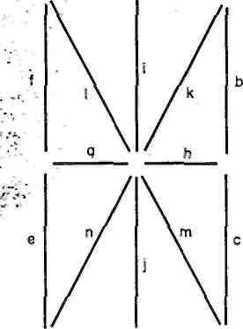
Figure 2.1 Display Segments
DS101 lights when the grid and anode inputs are positive with respect to the filament inputs. Fl and F2 supply the filament inputs to DS101.
CAUTION: The outputs of IC107 and IC108 are rated at 40V maximum. Care must be taken when probing these ICs not to connect an output to an input pin as the inputs are rated at only 5.5V maximum.
2924g/0142g/JWS
2.2
CHAPTER 3 Printed Circuit Board 3
CONTENTS
3.1 Introduction 3.1
3.2 Floating Link 3.1
3.2.1 Link Handshake 3.1
3.2.2 Wakeup 3.1
3.2.3 Negative Acknowledge 3.2
3.2.4 Power Up Sequence 3.2
3.3 RS232 Interface 3.2
3.4 Minate Interface 3.4
3.5 Keyboard Interface 3.5
3.6 Display Interface 3.7
3.7 I/O Clock 3.8
3.8 Reset 3.9
3.9 Power Supplies 3.10
3.9.1 Earthy Power Supply 3.10
3.9.2 Power Fail Detect 3.11
3.9.3 Floating Point Supply 3.11
3.10 Test Points 3.13
Figures
3.1 Printed,-Circuit Board 3 Interconnections 3.1
3.2 Display Interface 3.7
3.3 Display Interface Timing 3.8
3.4 I/O Clock Timing 3.9
3.5 Reset Control 3.10
3.6 +5V Supply Simplified Diagram 3.11
3.7 Floating Power Supply Simplified Diagram 3.12
Tables
3.1 RS232 Connector Pin/Signal Assignments 3.4
3.2 Minate Connector Pin/Signal Assignments 3.5
3.3 IC23 Logic States 3.6
3.4 Keyboard Matrix Connections 3.6
3.5 Test Points 3.13
2925g/0142g/JWS
3.1 INTRODUCTION
Printed circuit board 3 contains the main power supplies; the floating link, which provides the interface between the 'earthy' and 'floating' circuits; the microprocessor clock and reset circuits; and the RS232, Minate, Keyboard and Display interfaces-Figure 3.1 shows the interconnection between these circuits.
Clock
Floating Power Supply
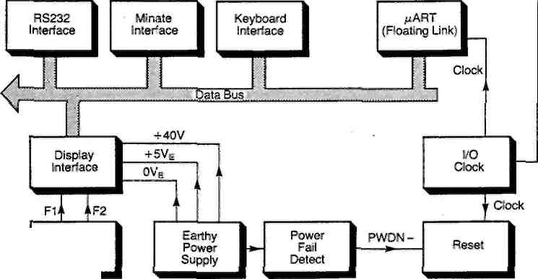
Figure 3.1 Printed Circuit Board 3 Interconnections
3.2 FLOATING LINK (Sheet 1)
A 7081 or 7071 is controlled by two microprocessors, one on the floating side and one on the earthy side. The two processors communicate through a two-wire serial link, which is optically isolated by IC10 and ICll. On the earthy side, the link is serviced by a UART, IC9. This operates under DMA control when receiving and under program control when transmitting.
3.2.1 Link Handshake
To ensure that the earthy and floating processors stay in step, all messages sent through the link are acknowledged. The processor which receives a message replies with a single character.
An exception to the single character reply occurs when new commands are sent by the earthy processor to the floating processor. In this case the single character is replaced by the new command. New commands are sent to the floating processor only when it is expecting an aknowledgement.
3.2.2 Wakeup
To keep the earthy side aware of the overload status of the analogue circuitry when the instrument is not measuring, the floating side prompts single glug integrations at 50ms intervals. Range information is sent also so that the earthy side can keep track of the analogue range during auto-range operation.
2925g/0142g/JWS
3.1
3.2.3 Negative Acknowledge
Most errors that may occur on the floating link can be detected by the receiving processor, which responds with a negative acknowledgement.
The DMA i's allocated a buffer for the received characters and if an attempt is made to use more buffer space than that allowed (buffer overflow) a 'float full' interrupt (DMA FL INT-) is generated. A 'float full' interrupt is also generated if a negative acknowledgement (which is a request to resend) is received from the floating side. The two error conditions are distinguished by the state of the 'float receive single' flag, which is set if a single character is expected (negative or positive acknowledgement). A buffer overflow results in a negative acknowledgement. A negative acknowledgement sets a flag which prompts a resend of the last message after a finite period of time.
The receipt of an End of String (EOS) generates an EOS Interrupt, which causes the received message to be inspected. Each character is placed in the buffer with a status byte that indicates whether or not the character was received correctly.
3.2.4 Power Up Sequence
The floating side is pushed out of reset by a character sent from the earthy side. This then displays WAIT 0 F.
As part of its reset procedure, the floating side determines the mains frequency and sends one of three characters denoting the frequency to the earthy side. If the character sent is unrecognised, the system goes to the floating reset state and MAINS FAULT is displayed.
If the mains character is valid, the floating side begins by presetting the hold-off counter. To do this it forces a hold-off message to the earthy side. Instead of giving a positive acknowledgement the earthy side sends a new command, i.e. DUMP, NVM. This starts a succession of messages from the floating side, all of which are acknowledged. An NVM or calibration state message is then displayed. Or, if the NVM DUMP has been successful, RESUMED or INITIALISED is displayed.
3.3 RS232 INTERFACE (Sheet 1)
The RS232 Interface circuit consists of the asynchronous communications interface adaptor (ACIA), IC19, buffers and drivers, IC4, IC25, and interface connector SK3.
The ACIA (IC19) provides a means of efficiently interfacing the microprocessor on printed circuit board 4 to devices requiring an asynchronous serial data format.
2925g/0142g/JWS 3.2
In the transmission of asynchronous data, no pre-synchronised clock is provided with the data. Also, the gaps between the data characters require that synchronisation be re-established for each character. Therefore, the receiving device must be capable of establishing bit and character synchronisation from the characteristics of the asynchronous format. Each character consists of a specified number of data bits preceded by a start bit and followed by one or more stop bits. The purpose of the start bit is to enable a receiving system to synchronise its clock to this bit for sampling purposes and thereby establish character synchronisation. The stop bit is used as a final check on character synchronisation.
The microprocessor processes eight bit parallel bytes that do not include start and stop elements. Therefore, serial data received in an asynchronous format must be converted to parallel form with the start and stop elements stripped from each character. Likewise, in order to transmit serial data, the parallel data byte from the microprocessor must be converted to serial form with the start and stop elements added to each character. This serial-to-parallel/parallel-to serial conversion is the primary function of IC19.
Data flow between the microprocessor and IC19 is via 8 bidirectional lines, DO through D7, that interface with the microprocessor data bus. The direction of data flow is controlled by the microprocessor via the Read/Write (R/W) input to IC19.
IC19 is enabled by a logic 0 signal ($4800) applied to its CS2 input. Specific registers within the ACIA are selected by the АО signal applied to its Register Select (RS) input. The microprocessor can read or write into the internal registers by addressing the ACIA, via the address bus, using these two input lines.
The microprocessor also applies a timing signal to the ACIA via the Enable input. The Enable (E) pulse conditions the ACIA's internal interrupt control circuitry and times the status/control changes.
The RS232 side of IC19 is configured as a DCE (data communications equipment) and is normally connected, via SK3, to a DTE (data terminal equipment) without an intervening modem link. Pin 2 of SK3 is marked TxD to indicate the path of data transmitted by a terminal to the instrument; Pin 3 is marked 'RCVD' to indicate the path of data received by a terminal from the instrument. Pins 5, 6, 8 and 20 are linked together inside so that a terminal sending DTR (data terminal ready) receives back the enabling states of CTS (clear to send), DSR (data set ready) and DCD (data carrier detect) whether the 7081 or 7071 is ready or not.
The Tx and Rx Clock inputs are both tied to the output of the MPU clock circuit on IC8 pin 6.
2925g/0142g/JWS
3.3
IC19 requests an interrupt to the microprocessor via its IRQ-output, which is applied to the Interrupt circuitry of IC13 as RS232INT-.
The pin/signal assignments for the RS232 connector are given in Table 3.1-.
Table 3.1 RS232 Connector Pin/Signal Assignments
Pin No. | Signal
1 | Ground
2 | Transmit Data (TxD) - Input to 7081 or 7071
3 | Receive Data (RCVD) - Output from 7081 or 7071
5 | Clear to Send (CTS)
6 | Data Set Ready (DSR)
7 | OV
8 | Data Carrier Detect (DCD)
20 | Data Terminal Ready (DTR)
3.4 MINATE INTERFACE (Sheet 1)
The Minate Interface consists of peripheral interface adaptor (PIA) IC20, MOSFETs TR6 and TR7, and interface connector PL4.
When IC20 is enabled by a logic 0 $5400 signal to its CS2 input the data flows between the microprocessor and IC20 on the data bus, via eight bi-directional data lines (DO through D7). The direction of data flow is controlled by the microprocessor via IC20 Read/Write (R/W) input. Two addressing inputs RS0 and RSI are used in conjunction with a control bit within the PIA for selecting specific registers in IC20. The microprocessor uses these address lines and the R/W signal to write into the PIA's internal registers.
The microprocessor applies a timing signal to IC20, via the enable input. This signal conditions the PIA's internal interrupt control circuitry and also controls the timing of the peripheral control signals.
The interface side of the PIA includes two 8-bit bi-directional data buses (PA0-PA7 and PB0-PB7) and four Interrupt control lines (CA1, CA2, CB1 and CB2). All of these lines are TTL compatible. In addition, all lines serving as outputs on the В side of the PIA can supply up to 1mA of drive current at 1.5V.
The outputs of IC20 are used as follows:
* lines PB0 to PB7 are fed to the N.V. Clock circuit,
* lines РАО to PA7 and CA2, CB2 are fed to the Minate Connector,
* line CA2 is supplied to the gate of MOSFET TR6 to turn it on,
* line CB2 provides the same function for MOSFET TR7.
The pin/signal assignments for the Minate connector are given in Table 3.2.
2925g/0142g/JWS
3.4
Table 3.2 Minate Connector Pin/Signal Assignments
Pin No. | Signal
1 | 1
2 | 2
3 | 4
4 5 | о  ₁₀ Device Control
6 | 20
7 | 40
8 | 80
9 | Contact closure remote trigger
10 | Out of Limit high
11 | Out of Limit low
12 | OVE
13 | +5V
24 | TTL compatible digitise complete signal
25 | lkV probe enable
3.5 KEYBOARD INTERFACE (Sheet 1)
The Keyboard Interface consists of peripheral interface adaptor (PIA) IC21 and BCD to decimal decoder IC23.
When IC21 is enabled by a logic low $4C00 signal applied to its CS2 input the data flows between the microprocessor and IC21 on the data bus, via eight bi-directional data lines (DO through D7). The direction of data flow is controlled by the microprocessor via IC21 Read/Write (R/W) input. Two addressing inputs, RSO and RSI, are used in conjunction with a control bit within the PIA for selecting specific registers in IC21. The microprocessor can read or write into the PIA's internal registers by addressing the PIA via the system address bits using these input lines and the R/W signal.
The microprocessor applies a timing signal to IC21 via the enable input. This signal conditions the PIA's internal interrupt control circuitry and also controls the timing of the peripheral control
signals.
The interface side of the PIA includes two 8-bit bidirectional data buses (РАО to РА7 and РВ0 to РВ7) and one Interrupt control line, CB2.
Outputs PBO to PB3 of IC21 are connected to inputs А, В, С and D of IC23, the 0 to 9 outputs of which are connected directly to the instrument keyboard. Table 3.3 shows the logic states of these pins relative to the A to D inputs. Outputs PBO to PB3 are also connected to IC26 the N.V. clock chip.
2925g/0142g/JWS
3.5
The inputs of IC21 are used as follows:
* Line PB4 (IkV range select) is connected to the Minate interface connector.
* Lines PB5 to PB7 are connected to the RS232 switch to enable reading of the baud rate set.
* Lines РАО to PA4 are connected to the keyboard.
* Line PA5 is connected to the calibration switch on the instrument front panel.
* Lines PA6 and PA7 are connected to switch SI for stimulus program activation.
* Line CB2 is connected to the Minate interface connector.
Refer to Table 3.4 for a listing of the Keyboard Matrix Connections.
Table 3.3 IC23 Logic States
D | с | В | A | 0 | 1 | 2 | 3 | 4 | 5 | 6 | 7 | 8 | 9
L | L | L | L | L | H | H | H | H | H | H | H | H | H
L | L | L | H | H | L | H | H | H | H | H | H | H | H
L | L | H | L | H | H | L | H | H | H | H | H | H | H
L | L | H | H | H | H | H | L | H | H | H | H | H | H
L | H | L | L | H | H | H | H | L | H | H | H | H | H
L | H | L | H | H | H | H | H | H | L | H | H | H | H
L | H | H | L | H | H | H | H | H | H | L | H | H | H
L | H | H | H | H | H | H | H | H | H | H | L | H | H
H | L | L | L | H | H | H | H | H | H | H | H | L | H
H | L | L | H | H | H | H | H | H | H | H | H | H | L
L = logic low H = logic high
Table 3.4 Keyboard Matrix Connections
Column |  | PL2 Pin Numbers
Row |  | 1 | 2 | 3 | 4 | 5 | 11 | 12 | 13
P  L 2  P I N N 0 S | 6 | V | RATIO | TRU fl | AUTO | DIG FILT | NULL ON | HIST  -» | SAMPLE
P  L 2  P I N N 0 S | 7 | Q |  | ~ FILT | PROG | SELF TEST | INITIALISE | MEM
P  L 2  P I N N 0 S | 7 | Q | ~+--
P  L 2  P I N N 0 S | 8 | V~ |  |  | COMPUTE | LOCAL | SRQ
P  L 2  P I N N 0 S | 8 | V~ | V---
P  L 2  P I N N 0 S | 9 | 6x9 | 5x9 | Д | 7x9 | 8x9 | NULL | HIST | TRACK
2925g/0142g/JWS
3.6
3.6 DISPLAY INTERFACE (Sheet 1)
Display data from the data bus (lines D7 to DO) is applied through inverting line_drivers_(IC22) to the Display, via PL6 pins 14 to 21. Outputs D6, D5, D4, Dl from IC22 and D7, D3, D2, DO from the data bus are applied to NAND gate IC24. If the EOS character appears during a receive DMA Bus cycle, the output from IC24 (end of string) is applied to IC3 in the interrupt circuitry to generate an EOS INT via IC16 Q output.
Chapter 4 includes a full description of the Display Interface operation in relation to the DMA.
Refer to Figure 3.3 for the display timing.
4800Hz
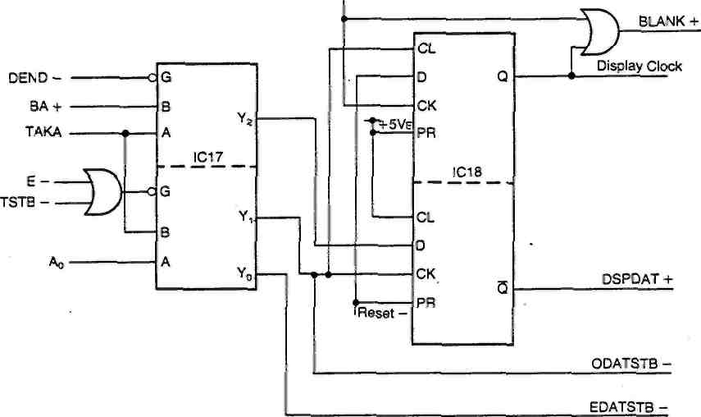
DMA and
Microprocessor
Display
Figure 3.2 Display Interface
2925g/0142q/JWS 3.7
4800Hz
and
BLANK+
Display Clock
J--------1_____I--------1_____I--------L
_П________П________П
DMA Active
Figure 4.1 >
DSPDAT +_________________________________L
- Cycles 1 to 23-------------*-'
24th cycle
If the DMA fails, Display Clock will remain at logic 1 and the Display will be blanked
Figure 3.3 Display Interface Timing
3.7 I/O CLOCK (Sheet 1)
A 1.2288MHz clock signal is generated by crystal XI, Inverters ICl and associated components, and applied to the Clock input of part 1 of binary counter IC2. IC2 divides the signal by 8 to give 153.6kHz at its Qq output and by 16 to give 76.8kHz at its Qq output.
The QC output signal is applied to IC8 D7 input, and the QD output signal to the D6 input of IC8, and to the Clock input of divider IC7.
IC7 divides the 76.8kHz signal to produce the following frequencies:-
38.4kHz to IC8 D5 input,
19.2kHz to IC8 D4, via inverter ICl and to IC2 part 2 Clock input,
9.6kHz to IC8 D3 input,
4.8kHz to IC8 D2, via inverter ICl,
2.4kHz to IC8 Dl input,
37.5Hz to provide a Clock signal for the Reset circuitry.
The 19.2kHz signal is applied to IC2 part 2. The QA and QB outputs are ANDed together in IC3 and the output applied to another part of IC3 along with IC2 part 2 Qn output. The output of this second section of IC3 is fed back to the clear input of IC2 part 2. This feedback causes IC2 part 2 outputs to be reset to zero every 11th clock cycle (see Figure 3.4). The Q_{c} output of IC2 part 2, i.e. 1745Hz, is passed to IC8 DO input.
IC8 output, to the RS232 interface, is selected by the values applied to its А. В and С inputs. These inputs are taken from the setting of the RS232 baud rate switch Si.
2925g/0142g/JWS 3.8
Clock
IC2 -
JlЛJШlJlГUЩЛJlRГLЛШLПШШlr '^ JUlJlJljnj^JLrLrLrLrLrL
Q.-I
Qc
Qd H
n
г
IC3/3
IC3/6
л 1
JL
A
Figure 3.4 I/O Clock Timing
3.8 RESET (Sheet 1)
The microprocessor reset circuit consists of binary counter IC5 and its associated components.
When there is no power loss to the instrument, i.e. PWDN- is at logic 1, IC5 is enabled to count, clocked by the 37.5Hz signal from the I/O Clock circuit. On the tenth count IC5 Q_{A} output will rise to logic 1 and enable a Reset pulse to the microprocessor set via IC6 pin 3. However, under normal operating conditions the microprocessor (IC401 on board 4) periodically clears IC5 by addressing $4C00 to disable the count. If the tnicroprocssor does not address $4C00 for approximately 130 to 160 milliseconds, reset is enabled.
When a power down occurs, the microprocessor must have sufficient time to run a checksum of its memory contents, etc, before it receives a reset command. The PWDN- signal is therefore applied to capacitor C2 and whilst this capacitor charges up 'Reset-' is held off. The time constant set by C2 and R4 allows sufficient time for the microprocessor to save its memory contents.
If Reset is disabled at switch SI, the microprocessor will not be reset regardless of the state of the power fail input.
2925g/0l42g/JWS 3.9
From I/O
Clock
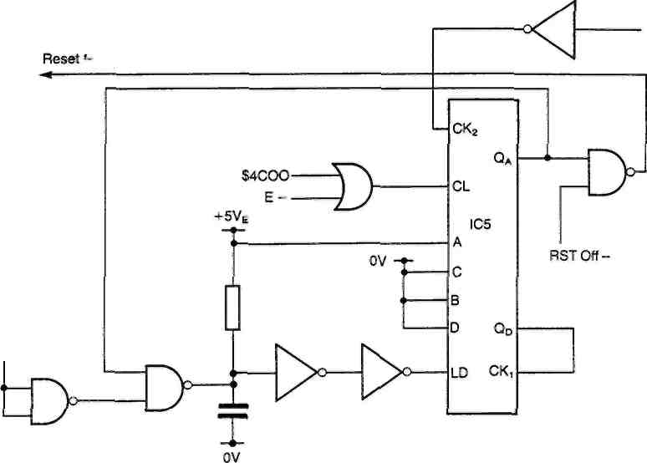
PVJDN -
Figure 3.5 Reset Control
3.9 POWER SUPPLIES (Sheet 2)
The instrument is fitted with a multi-purpose mains input unit mounted on the rear panel. This contains the mains input socket, fuses, voltage selector and filter. Switches a to e set the voltage to be supplied to transformer Tl.
3.9.1 Earthy Power Supply
The earthy power supply generates ±12V, +5V and +40Vdc for the earthy circuits, and includes a power fail detect circuit.
•
±12V Supply
The ac voltage is applied, via PL52, to bridge rectifier D54 where it is full-wave rectified. The rectified output is smoothed by capacitors C59 and C60, and passed through resistors R73 and R74. Zener diodes D60 and D61 finally drop the voltage level down to ±12V.
+40V Supply
The ac voltage from PL52 is passed to bridge rectifier D55 via voltage doubling capacitors C56 and C57. The rectified output is smoothed by C58 and applied to 5V regulator IC52. The 30V zener diode D56, between the +5v rail and the G input of IC52, supplies +35V. The +5V added to this by IC52 gives the +40V required. C61 provides high frequency stability.
+5V Supply
The +24V unregulated output from D54 is applied to the +5V circuit
at TR54. Refer to the simplified diagram in Figure 3.6.
2925g/0l42g/JWS
3.10
When TR54 Is closed, it is in saturation at. a voltage drop of approximately IV. When TR54 is opened L52 drives its left-hand end negative until diode D57 latches in and conducts; initially at the same instantaneous current that had been flowing in TR54 just prior to its opening. The voltage at point (A) is approximately equal to Vj_{n} for the time TR54 is closed (T_{on}) and approximately equal to OV for the time TR54 is open (T-T_{on})- The filter L52, C67 averages out the peak-to-peak ripple voltage of Vi_{n} and produces at Vq, a constant dc output voltage whose value is given by:
V_{Q} = Vin
(Ton)
Output voltage Vo is regulated by controlling the ratio of Ton/T. The frequency T is fixed and T_{on}, the duration of the "on" time for TR54, is varied by pulse width modulator IC55, turn-on pulse amplifier TR56, TR53 and associated components.
TR54 ... Vin ^—^ ^{tA)}

L52
: r
Turn-on Pulse
Amplifier TR56, TR53
R71
-CZD
Vo = +5V
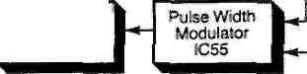
---1-----P ^-------1-----T------
C67 ™ ™ Р58/\* "J ™ ZC72-78
\ H^ C68
OV
Figure 3.6 +5V Supply Simplified Diagram
Zener diode D58 provides over-voltage protection, capacitor C68 removes voltage spikes and capacitors C72 to C78 provide local high frequency decoupling. R71 provides a current limit of about 2A via IC55.
3.9.2 Power Fail Detect
IC56, D59 and associated components provide a power fail detect circuit the output of which is applied to the reset circuit on Sheet 1.
When the output from capacitor C59 falls to less than +21V the ouput of comparator IC56 falls to the negative rail value. This makes PWDN- equal to logic 0.
3.9.3 Floating Power Supply
The ac voltage from PL51 is applied to bridge rectifier D51. There it is full-wave rectified and smoothed by C51 before being applied to transistor TR52.
2925g/0142g/JWS
3.11
When TR52 is closed, it is in saturation at a voltage drop of approximately IV. When TR52 opens L51 drives its left-hand end negative until D52 latches in and conducts. The voltage at point (B) is therefore approximately equal to V\_{n} during the time TR52 is closed (Ton) and approximately equal to OV during the time TR52 is open (T-Ton). Filter L51, C55 averages out the peak-to-peak ripple voltage of Vin and produces at Vo, a constant dc output voltage given by
Vin "
(Ton)
T
Output voltage Vo is regulated by controlling Ton, the duration of the 'on' time of TR52, via Pulse Width Modulator IC51, Turn-on Pulse Amplifier TR55, TR51 and associated components.
TR52
L51
R70
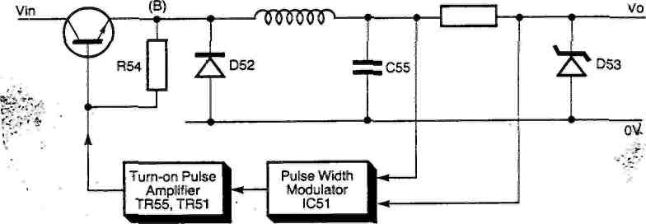
Figure 3.7 Floating Power Supply Simplified Diagram
Zener diode D53 provides overvoltage protection and R70 gives a current limit of about 2A.
A Vo value of +5V_{D} is output to board 5 via SK51. +5V_{S} is output to provide voltage sensing. The signal is returned to the circuit and compared with the reference value supplied to IC51.
SK51 also outputs 31V and 17V ac for use on board 5 the 'floating power supply' circuit.
2925g/0142g/JWS 3.12
3.10 TEST POINTS
The following Test Points are provided to assist in printed circuit board fault-finding.
Table 3.5 Test Points
Test Point (TP) | Signal
1 | TR52 Drain
2 | ov
3 | BLEEPER +
4 | BLEEPER -
5 | Bl -
6 | Bl +
51 | IC55 CT input
52 | IC51 CT input
53 | OVE
54 | +5VD
55 | OVF
56 | +12V
57 | OVE
2925g/0142g/JWS
3.13
CHAPTER 4
Printed Circuit Board 14
CONTENTS
Page
4.1 Microprocessor Set 4.1
4.1.1 Read/Write (R/W) 4.1
4.1.2 Interrupt Request (IRQ) 4.1
4.1.3 Non-Maskable Interrupt (NMI) 4.1
4.1.4 Reset (RESET-) 4.2
4.1.5 Address Bus and Data Bus 4.2
4.2 Address Decoders 4.2
4.3 Direct Memory Access (DMA) 4.4
4.3.1 Channel 0 4.5
4.3.2 Channel 1 4.6
4.4 GP-IB Interface 4.7
4.4.1 GP-IB Address Selection 4.8
4.4.2 GP-IB Signal Lines 4.8
4.5 Test Points 4.10
Figures
4.1 DMA Timing-Display (Channel 0) 4.6
4.2 DMA Timing-Receive Floating Data
(Channel 1) 4.7
4.3 GP-IB Interface Signal Lines 4.8
Tables
4.1 IC416 Operation 4.2
4.2 IC417 Operation 4.3
4.3 IC418 Operation 4.3
4.4 Links LK3 to LK8 4.3
4.5 IC419 Outputs 4.4
4.6 Test Points 4.10
2926g/0142g/JWS
4.1 MICROPROCESSOR SET
This circuit controls the other logic boards and consists of a microprocessor IC401, read only memory (ROM) IC412 to 415 and IC430, and random access memory (RAM) IC406 to 411.
IC401 contains all the functions required for multi-instruction processing: an arithmetic and logic unit; instruction decode and address registers; an instruction register; all of the clock and logic circuits required for timing and a full complement of data bus lines.
The microprocessor can modify its sequence of addresses on the basis of the results of previous operations. It can also store its own state when interrupted (IRQ) and continue from where it left off. when the Interrupt cycle is satisfied.
4.1.1 Read/write (R/W)
This signal determines the direction of data_flow between the microprocessor and its peripherals. When R/W is at logic 1, Read is selected; when at logic 0, Write is operative.
4.1.2 Interrupt Request (IRQ)
Several of the 7081 and 7071 internal and interface interrupt signals (DMA INT-, RS232 INT-, GP-IB INT- etc.) are combined in IC13 on printed circuit board 3 to form an Interrupt signal to the microprocessor. A logic 0 IRQ- from IC13 causes the microprocessor to initiate the interrupt sequence which begins with the microprocessor, after finishing its current instruction, testing the Interrupt Mask in the Condition Code Register and storing the contents of its programmable registers in memory locations specified by the Stack Pointer.
IC13 outputs a unique set of values on its А, В and С outputs, dependent upon which of the interrupts has been generated, to IC15 which buffers the signals and passes them onto the data bus. The microprocessor reads these signals from the data bus and thereby knows which interrupt requires service.
When the interrupt has been serviced, the microprocessor carries on from where it stopped.
4.1.3 Non-Maskable Interrupt (NMI)
The Non-Maskable Interrupt (NMI) is recognised by the microprocessor as soon as the NMI- line goes to logic zero. The interrupt is used as a power-failure sensor.
Except for the fact that it cannot be masked, the NMI interrupt sequence is similar to IRQ. After completing its current instruction, the microprocessor stacks its registers, sets the Interrupt Mask and fetches the starting address of the NMI interrupt service routine.
2926g/0142g/JWS 4.1
4.1.4 Reset (RESET-)
The Reset interrupt is used following power on to reach an initialising program that sets up system starting conditions. Therefore, the RESET- sequence is initiated by a positive going edge. Also, since it is normally used only in start-up mode, there is no reason to save the microprocessor contents on the stack.
4.1.5 Address Bus and Data Bus
The 16 line (АО to A15) address bus controls data transfer between the microprocessor set, input/output interfaces, memories etc. The transference of data can take place over part of, or the whole of the 8 data lines of the data bus (DO to D7).
4.2 ADDRESS DECODERS
The Address Decode circuit provides enable signals for the rest of the circuitry on this printed circuit board and consists of decoders IC416. 417 and 418, 2-to-l Selector IC419 and associated components.
IC416 uses address lines A13, A14 and A15 to generate logic 0 enable signals to the ROM and address decoder IC417. Refer to Table 4.1.
Table 4.1 IC416 Operation
Address Lines |  |  |  | IC416 Output Signals
 |  |  | $E000 | $C000 | $A000 | $8000 | $6000 | $4000
A13 | A14 | A15 | (IC412) | (IC413) | (IC414) | (IC415) | (IC430) | (IC417)
0 | 0 | 0 |  | 1 |  | 1 | 1 | 1
1 | 0 | 0 |  | 1 |  | 1 | 1 | 1
0 | 1 | 0 |  | 1 |  | 1 | 1 | 0
1 | 1 | 0 |  | 1 |  | 1 | 0 | 1
0 | 0 | 1 |  | 1 |  | 0 | 1 | 1
1 | 0 | 1 |  | 1 |  | 1 | 1 | 1
0 | 1 | 1 |  | 0 |  | 1 | 1 | 1
1 | 1 | 1 | 0 | 1 |  | 1 | 1 | 1
IC417 is enabled by a logic 0, $4000 signal from IC416 to produce logic 0 signals, from address lines A10 to A12, to PL401, IC419, IC420 and the DMA, IC402. Refer to Table 4.2.
2926g/0142g/JWS
4.2
Table 4.2 IC417 Operation
Address Lines |  |  |  | IC417 Output Signals
 |  |  | $5C00 | $5800 | $5400 | $5000 | $4C00 | $4800 | $4400 | DMA SELECT
A10 | All | A12 | {PL401, | (PL401, | (PL401, | (IC419, | (PL401, | (PL401. | (IC420, | (IC402,2)
 |  |  | 40) | 39) | 33) | 13,11) | 37) | 36) | 8)
0 | 0 | 0 |  | 1 | 1 | 1 | 1 |  | 1 | 0
1 | 0 | 0 |  | 1 | 1 | 1 | 1 |  | 0
0 | 1 | 0 |  | 1 | 1 | 1 | 1
1 | 1 | 0 |  | 1 | 1 | 1 | 0
0 | 0 | 1 |  | 1 | 1 | 0 | 1
1 | 0 | 1 |  | 1 | 0 | 1 | 1
0 | 1 | 1 |  | 0 | 1 | 1 | 1
1 | 1 | 1 | 0 | 1 | 1 | 1 | 1
IC418 is enabled by the A14 and A15 signals from the address bus, i.e. as long as both these signals are the same, IC418 uses address lines All, A12 and A13 to provide enable signals to the RAM. Refer to Table 4.3.
Table 4.3 IC418 Operation
 | Address Lines |  |  |  | IC418 Output Signals
 |  |  |  |  | $2800 | $2000 | $1800 | $1000 | $0800 | $0000
All | A12 | A13 | A14 | A15 | (IC411) | (IC410) | (IC409) | (IC408) | (IC407) | (IC406)
0 | 0 | 0 | 0 | 0 | 1 | 1 | 1 | 1 | 1 | 0
1 | 0 | 0 | 0 | 0 | 1 | 1 | 1 | 1 | 0 | 1
0 | 1 | 0 | 0 | 0 | 1 | 1 | 1 | 0 | 1 | 1
1 | 1 | 0 | 0 | 0 | 1 | 1 | 0 | 1 | 1 | 1
0 | 0 | 1 | 0 | 0 | 1 | 0 | 1 | 1 | 1 | 1
1 | 0 | 1 | 0 | 0 | 0 | 1 | 1 | 1 | 1 | 1
0 | 1 | 1 | 0 | 0 | 1 | 1 | 1 | 1 | 1 | 1
1 | 1 | 1 | 0 | 0 | 1 | 1 | 1 | 1 | 1 | 1
X | X | X | 1 | 1 | Disab | ed
X | X | X | 0 | 1 | Disabled
X | X | X | 1 | 0 | Disabled
The inputs to IC418, are also dependent upon links LK3 to LK8, which are, in turn, dependent upon the RAM fitted. Refer to Table 4.4.
Table 4.4 Links LK3 to LK8
RAM Fitted | Links Made
RAM Fitted | LK3 | LK4 | LK5 | LK6 | LK7 | LK8
TC5516P or HM6117P HM6116P HM6264 |  | • | • | / | • / | •
2926g/0142g/JWS
4.3
If HM6264 RAMs are fitted, the only enable signals generated by IC418 are $0000 and $2000.
IC419 is enabled by the R/W signal from the microprocessor; a Read signal selects the IC419 В inputs for output and a Write signal selects the A inputs. The 1A, 2B, ЗА and 4A inputs of IC419 are held to logic 1, the IB and 2A inputs to logic 0 and the 3B and 4B inputs are supplied by the $5000 signal from IC417. Refer to Table 4.5.
Table 4.5 IC419 Outputs
Inputs |  | IC416 Output Signals
Select | $5000 | 1Y(RD) | 2Y(WR) | 3Y(R$5000) | 4Y(W$5000)
1 1  0 0 | 1 0  1  0 | 0 0 1 1 | 1 1  0 0 | 1 0 1 1 | 1 1  1 0
The RD and WR outputs from IC419 are applied to the GP-IB Interface and the RAM. The R$5000 and W$5000 signals are fed off the printed circuit board via PL401 pins 35 and 34 respectively.
4.3 DIRECT MEMORY ACCESS (DMA)
The DMA procedure used in 7081 and 7071 can be briefly described as follows:-
* The microprocessor, (IC401), loads the DMA controller (IC402) with a starting address for the memory transfer and the number of words to be transferred.
* When the 7081 or 7071 input has data ready to be transferred to the memory or when the output is ready for transfer from the memory, the DMA controller sends a DMA request to the microprocessor.
* The microprocessor acknowledges the DMA request, floats its address and data buses and appropriate control lines, and suspends any processing that requires use of the address and data bus.
* The DMA controller provides an address to memory and control strobes to read or write memory. The input/output provides or accepts the data on the data bus. After a data byte is transferred, the DMA controller increments its address register and decrements its word count register. If the required number of words has not been transferred, the DMA controller repeats this step when the input/output is ready with the next data word.
* When the required number of words has been transferred, the DMA controller terminates the DMA request and interrupts the microprocessor to indicate that the DMA transfer is complete.
2926g/0142g/JWS 4.4
The DMA interface consists of a 16-bit address bus, an 8-bit bidirectional data bus and the following control signals; BA+ or DMA GRANT, BREQ- or DMA REQUEST- and R/tf.
The BREQ- (DMA Request) signal from the DMA circuitry commands the microprocessor to halt by going low. The Bus Available (BA+) signal from the microprocessor goes to a logic 1 when the microprocessor has halted and_all three-state lines are in the high impedance state. The R/W line is a command signal from the DMA channel to control the direction of transfer through the DMA interface. For the system to operate correctly, the DMA circuitry connected to the microprocessor's address bus, data bus and R/W line must have three-state outputs which are in the high impedance state when BA+ is low and the microprocessor is controlling the address, data and control buses. The time from the BREQ- line going low to the microprocessor halting and producing a BA+ (DMA Grant) will be variable depending on what instruction is being executed at the time BREQ- goes low and in which cycle of that instruction BREQ- goes low.
DMA requests involve two byte transfers; the first transfer has address line АО low (even address) and the second АО high (odd address). Before and after each transfer, the DMA performs a dummy cycle.
There are two channels which make requests to the DMA; Channel 0, the Display, and Channel 1, the Floating to Earthy Data Link.
4.3.1 Channel 0
Channel 0 requests are clocked by the 4800Hz signal from the I/O Clock circuit on printed circuit board 3. Twenty-four requests are made before the circuit generates an interrupt.
Once the DMA has the bus for a Channel 0 transfer, a dummy cycle occurs followed by the first DMA Transfer. When the transfer begins. Transfer Strobe - (TSTB-), Valid Memory Address - (VMA-) and Transfer Request 0 (TRQ0+) fall to logic low, and, during the transfer. Even Data Strobe - (EDATSTB-) goes low to the Display for half an E clock cycle.
The DMA then performs two dummy cycles followed by the second transfer. During this second transfer Odd Data Strobe -(ODATSTB) goes low to the Display for half on E clock cycle.
DSPDAT+ goes high on the rising edge of the 24th Odd Data Strobe-and goes low on the rising edge of the next.
Refer to Figure 4.1 for the DMA timing for this channel.
2926g/0142g/JWS
4.5
4.3.2 Channel 1
Channel 1 requests, via the Data Received (DR) line from IC9 pin 19 on printed circuit board 2, are delayed in IC29 by five E clock cycles. If a Channel 0 request occurs during this delay, Channel 0- takes the DMA, as it has a higher priority than Channel 1, and clears IC29. Once Channel 0 has finished its transfer, the Channel 1 request appears at the DMA after a further five clock cycles. This delay circuitry prevents latch up occuring between the earthy and floating processors.
Channel 1 transfers are similar to Channel 0 transfers except that Acknowledge Data - (ACKD-) goes low during the first transfer (instead of EDATSTB-) and Acknowledge Status - (ACKS-) goes low during the second transfer (instead of ODATSTB-).
IC18/3 | 4800 Hz  TRQ +  BREQ-  BA +  E-  BAEXTD +  TSTB-  VMA-  EDATSTB -  ODATSTB -  DEND -  DSPDAT + | _^/
IC18/5 |  | ---^ |  |  |  |  |  | -\
IC14/I2 |  | -JJJ | I |  | I |  | 1
IC402/36 |  | I | I | r~ | I | "1 | 1 | _J | _l
IC402/38 |  |  | I | DMA | I | 1 |  | 1  DMA - |  | ~l
u. Clock |  | Microprocessor |  | DMA |  |  |  | 1  DMA - | Dum | », Micro.
 |  | Microprocessor | Dummy | DMA |  | Dummy |  | 1  DMA - | Dum | ny
IC16/8 |  | Microprocessor | _| |  |  | и |  | 1 |  | ~l
IC14/1 |  |  | L |  | I |  | 1 | 1
 |  |  | L |  |  |  |  | Г
IC3/11 |  |  | ___I L |  | I | и | 1 | Г |  | -1
IC17/12 |  |  |  | "~l___Г~
IC17/11 |  |  |  |  |  |  |  | LJ
IC17/1 |  |  |  |  |  |  | 1 | i |  | -1
1С 18/8 |  |  |  |  |  |  |  | „X
666ns
The dotted lines show the Channel 0 Data Chain cycle
TAKA = 0 during this cycle, DSPDAT + goes high and low on the next cycle.
Figure 4.1 DMA Timing - Display (Channel 0)
2926g/0142g/JWS 4.6
IC9/19 DR (Data Received)
IC29/10
IC402/36 IC402/38
ц Clock
5 clock periods
TRQ
BREQ-
BA-
_ -JZT
TZT
ZL
Microprocessor
Dummy
— DMA
1С 16/8 | BAEXTD -
1С14/1 | TSTB-
1СЗ/11 | VMA -
1С 17/10 | ACKD-
1С 17/9 | ACKS-
IC17/1 | DEND-
1С 16/5 | EOS INT -
Dummy "~IT-
DMA
Dummy
Micro.
Low if EOS Character received
666ns
The dotted lines show the Channel 0 Data Chain cycle TAKA = 1 during the time that TSTB - is low.
Figure 4.2 DMA Timing - Receive Floating Data (Channel 1)
If an End of String (EOS) character (ASCII 8D) is received during a DMA cycle, an EOS Interrupt is generated, i.e. EOS INT - goes low. The software services this interrupt and resets the DMA
channel.
A DMA FL Interrupt is generated if more data comes in than expected or, if a negative acknowledge is received from the floating side.
Refer to Figure 4.2 for the DMA timing for this channel.
In order to exit from the DMA mode, the BREQ- line is switched high (synchronously with the clock), the BA+ signal returns low and the microprocessor resumes control of the bus. When BA+ falls low, the DMA channels address, R/W and data line are in the high impedance state.
4.4 GP-IB INTERFACE
The GP-ГВ Interface (IC420), with its associated bus-drivers, provides a means of connecting the voltmeter's microprocessor with external devices connected to the IEEE Standard bus. The handshake lines DAV, NRFD, NDAC are handled automatically by IC420.
Essentially the GP-IB Interface comprises fifteen registers, (one, the Address Switch Register IC424, is external to IC420). Seven of the registers may be written to by the microprocessor depending on the state of control lines RD, WR and RSO to RS2.
2926g/0142g/JWS 4.7
4.4.1 GP-IB Address Selection
The voltmeter address and Talk/Listen Status are set up on switch SW801 on printed circuit board 8. The values of the switch settings are then passed via socket SK801 to SK414 on printed circuit board 4 and from there via non-inverting line drivers IC424, to the data bus.
IC424 is enabled by a logic 0 $5800 signal from IC417 in the Address Decode circuit.
4.4.2 GP-IB Signal Lines
The microprocessor/GP-IB Interface and GP-IB Interface/IEEE bus signal lines shown in Figure 4.3 are summarised below:
Microprocessor Data Bus
Microprocessor Address Bus
Bus Management
Lines
Byte Transfer
(Handshake
Lines)
T/RI
Fig. 4.3 GP-IB Interface Signal Lines
Bidirectional Data (D0-D7) These lines allow data transfer between the microprocessor and the GP-IB. The data bus output drivers are three-state devices that remain in a high impedance (off) state except when the microprocessor performs a GP-IB read operation.
Chip Select (CS) IC417 selects the GP-IB interface by pulling the line low.
RD.WR These signals are generated by the microprocessor to control register access and the direction of data transfer on the data bus. In conjunction with control lines RSO to RS2 (see below), the RD line, when low, selects one of the eight read only registers; when WR is low one of the seven write only registers is selected.
12
£=
D7 D6 D5 D4 D3 D2 D1 DO
RS2 RS1
RSO
ATN
IFC
REN
SRQ
EOI
DAV
NRFD NDAC
D101 D102 D103 D104 D105 D106 D107 D108
CS CK
es
INT
RESET
Interface Bus
Signal Lines
2926g/0142g/JWS 4.8
Register Select (RSO, RSI, RS2). Used in combination with RD and WR for register selection.
Interrupt (INT) The INT output goes to the common interrupt bus for the microprocessor. The INT line is set active (low) when an interrupt occurs, and remains so until the microprocessor reads the Interrupt Status register.
Reset The active high Reset line is used to initialise IC420 during power-on/initialise. Reset is driven by an external power-up reset circuit.
Bus Management Lines (ATN, IFC, REN, SRQ, EOI) These lines are used to manage an orderly flow of information across the interface lines.
Attention (ATN) is sent by a controller over the interface. During the ATN active state, devices monitor the data lines (DO to D7) for addressing or an interface command.
Interface Clear (IFC) This signal is used to put the interface system into a known quiescent state.
Remote Enable (REN) is used to select one of two alternate sources of device programming data: local or remote control.
Service Request (SRQ) When active, the signal indicates the need for attention in addition to requesting an interrupt in the current sequence of events. This indicates to the controller that a device on the bus is in need of service.
End or Identify (EOI) signals the end of a multiple byte transfer signal and, in conjunction with ATN, executes a parallel polling sequence.
Clock Input (CK) Derived from the microprocessor clock generator, this input is used to synchronise control and data transfer throughout the interface.
Signal Lines (DI01 to DI08) These bidirectional lines allow for the flow of eight-bit ASCII interface messages and device dependent messages.
Byte Transfer Lines (ШАС, NRFD, DAV) These lines allow for the proper transfer of each data byte on the bus between talkers and listeners. NRFD is high to indicate that all listeners are "ready for data". A talker indicates that "data is valid" by putting DAV low and the transfer begins when NRFD falls low. Upon the reception of valid data by all listeners, NDAC goes high indicating that the "data has been accepted" by all listeners.
Transmit/Receive Control Signals (T/Rl and T/R2) These two signals control IC421 and 422 which drive the interface bus. The transmit/receive inputs of REN, IFC and ATN are held high to receive, while SRQ is held low to transmit. EOI (transmit or receive) is controlled by T/R2.
2926g/0142g/JWS 4.9
4.5
TEST POINTS
The following Test Points are provided to assist in printed circuit board fault finding.
Table 4.6 Test Points
Test Point (TP) | Signal
1 | START
2 | STOP
3 | CLOCK
4 | E
5 | GND
6 | A15
7 | OVE
8 | Not connected
9 | +5V
(TPl, 2, 3 and 5 are used with Locator).
2926g/0142g/JWS
4.10
CHAPTER 5
Printed Circuit Board 5
CONTENTS
 |  | Page
5.1 | Introduction | 5.1
5.2 | V-to-T Converter | 5.1
5.3 | Reference Voltage | 5.2
5.4 | Ratio Circuit | 5.3
5.5 | Ohms Circuit | 5.4
5.6 | Glug Counters | 5.4
5.7 | Clock Divider | 5.6
5.8 | Clock Oscillator | 5.7
5.9 | Non-Volatile Memory (NVM) | 5.7
5.10 | Floating Power Supply | 5.8
5.11 | Test Points | 5.8
Figures
5.1 Board 5 Schematic 5.1
5.2 Glug Generation and Timing 5.6
Tables
5.1 Microprocessor Frequency Settings 5.6
5.2 Test Points 5.9
2927g/0142g/JWS
5.1 INTRODUCTION
Board 5 contains the voltage-to-time converter, the glug counters, the microprocessor and the non-volatile memory (NVM). It also provides a clock divider and oscillator circuit, and the reference, ratio and ohms circuits for the instrument. The board has its own power supply. A schematic of these functions with their interconnections is shown in Figure 5.1.
Integrator fnput
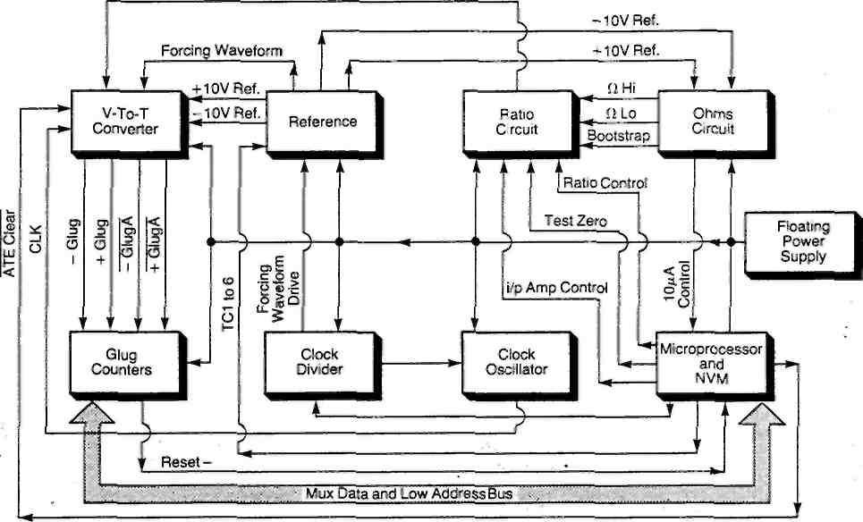
Figure 5.1 Board 5 schematic
5.2 VOLTAGE-TO-TIME CONVERTER (Sheet 1) This circuit, comprising an integrator, comparators, clock synchronised bi-stables and reference switching FETs/transistors, converts the voltage output from the main amplifier into two pulse trains. The pulses are used to gate the clock into a reversible counter which produces a nett count proportional to the measured input.
The integrator, which comprises IC201 (a d.c part) and IC202 (a conventional fast part) has the following inputs connected:
1. The input to be measured
2. The forcing waveform
3. +Reference, -Reference or OV.
With the input at OV, and a 160Hz forcing square wave applied continuously to the integrator, the output is driven alternatively positive and negative through the thresholds of the two comparators IC203 and IC204. The state of the two comparators is followed by IC205, which synchronises the transitions to the clock. Outputs from IC205 are then used to drive FETs TR201 to
2927g/0142g/JWS
5.1
TR204. TR207, TR208 and transistors TR205. TR206, which switch the reference voltages or OV to the integrator input. With this arrangement the output will always remain dynamically balanced about zero, irrespective of the input to the integrator.
The ratio of R202 to R201 is set so that, without calibration, the instrument is guaranteed to read high and a calibration constant of <1 is required. This ensures that there are no missing digitised codes.
5.3 REFERENCE VOLTAGE (Sheet 2)
The reference voltage (+10V, -10V) is generated from D301 by IC305 and scaling resistors R306 a to d. IC306 and R305 determine the zero of the V-to-T convertor as they are used to center the reference voltage.
IC307 switches between +10V and -10V to generate the forcing waveform. R310 and R311 reduce transients (due to this switching) on the reference voltage.
R308 and R309 current limit the reference output in the event of a short-circuit. D302 ensures that, at power-up. the reference circuit starts-up in the correct direction. (The reference circuit has two stable operating states.)
The remainder of the circuit is concerned with
(a) setting up the linear component of the temperature coefficient of D301 and
(b) compensating for the curved component of the temperature coefficient of D301.
The linear component is controlled by IC301, which is a D-to-A convertor, and IC304, which is a buffer. The digital signals present on TCI to TC6 control the output current of IC301 and thus the output voltage of IC304, which may swing between OV and -10V. This in turn varies the current through D301 and hence varies the linear temperature coefficient. R303 converts the output swing of OV to -10V into a current swing through the diode.
The curved component of the temperature coefficient is compensated for by D351, IC351 and associated components.
D351 generates a current proportional to absolute temperature of lyA/K. This is offset by a current through R351 such that, at 27°C (300K), the voltage at pin 2 of IC351A is approximately zero. As a result, IC351B output will also be at zero, since it has no input, and transistor IC352 pins 3,4,5 will be biased off.
When the temperature is less than 27°C, IC351A pin 2 goes negative. This produces a positive output, which is fed back via D352. Hence IC351A acts as a virtual earth amplifier with an input of lyA for every degree Centigrade below 27°C.
2927g/0142g/JWS 5.2
The ratio of R352 to R353 (6.8k:10k) causes a positive current to flow into IC351B virtual earth, and an equal current of +0.6yA/°C to flow through transistors IC352 pins 1,2,3,9,10 and 11.
The action of IC352 is similar to that of the rms convertor and the output current from IC352 pin 5 is (Iinb/Iref where Iref is the current supplied by R354. Hence a square law relationship is established between the output current and the input current.
When the temperature is greater than 27°C, IC351A pin 2 goes positive. This produces a negative output, which is blocked by D352. Hence, the voltage at IC351A pin 2 (source impedance 33k-R351) is developed across the load of R352 and R353 in series. The current at IC351B pin б (virtual earth) is again 0.6yA/°C and causes an equal current to flow through IC352 pins 1,2.3,9,10 and 11.
The result is that for all temperatures a positive current of О.буАЛС flows into IC351B virtual earth, i.e. IC351A effectively performs the function of the absoluter in the AC RMS converter.
The output current from IC352 pin 5 is therefore:
Г(Т-27)х0.бЬ рА I ref
where T is the temperature in degrees Centigrade.
The output current is developed across R355, so that it is added to the zener voltage. This is because the diode characteristic is such that on either side of 27°C, the voltage falls.
5.4 RATIO CIRCUIT (Sheet 3)
Ratio measurements are performed using Hi and Lo lines. The voltages are switched through their own amplifier to avoid difficult switching of the main input amplifer. The ratio signals are routed into the main system just before the integrator.
TR502 buffers the input and generates bootstrapped rails to power the main amplifier IC502. TR504 protects IC503 against over voltage during negative measurements.
Switching allows either the ratio output, the input amplifier output, or zero to be measured. Zero is used during a drift correct or self-test. Transistors TR505 and TR506 are used to switch the signals as long as the input or output lies in the range -15V < V < +15V.
2927g/0142g/JWS
5.3
To prevent variation of resistance at turn-on, transistors TR505, TR506, TR508, TR509, TR516 and TR517 must be turned on by a voltage which has a fixed value above the signal voltage. This is supplied by the input signal 'I/p AMP + 5V BOOTSTRAP'. if this is not the case, non-linearity occurs as the input impedance to the integrator is only 160kfl.
Relay RL1 isolates the current source terminals from the current sources in non-kohm modes, when a two-wire cable is being used and RL501 connects the 10yA current source straight into the integrator for the kohm self-test facility.
5.5 OHMS CIRCUIT (Sheet 4)
True four-terminal ohms measurements are made since the current source is floating with an independent power supply. The reference is transferred across to the independent supply using IC601, IC602 and optocouplers IC605 a and b to give isolation. The only currents which flow between the two sections are insulation leakage currents and amplifier bias currents (~10pA).
The reference is generated across R604. This provides a current which regenerates a voltage across R609. This is then applied across either R611 or R612 to create either ЮуА or 1mA. FET switching is employed and hence a separate current switch and voltage sense FET is required for each position.
D608 ensures that the voltage dropped across TR607 and TR609 does not forward bias the gate-source junction and D605, D609, D610 are protection diodes in the event of a mains voltage being inadvertantly applied to the terminals.
In some cases the reference voltages collapse briefly after power-up and this can inject current into pin 10 of IC601 and IC602 via capacitors C605 and C606. R616 and R617 limit this current to a value which does not cause latch-up.
Since the power rails are assymetrical about 0V and only one transformer winding is used, D615 is included in the circuit to improve the balance and equalise the voltage stress on IC607 and IC608.
This circuit is used for measuring resistances up to IMP.. Above this value a conductance method is used, ratio-lng the unknown resistor to the 9.9МЙ attenuator resistor. The switching for this is done in the input attenuator.
5.6 GLUG COUNTERS (Sheet 5) ______ ______
The outputs from the V-to-T converter -GLUGA, +GLUGA, +GLUG and -GLUG are used to gate clock into a reversible counter chain comprising IC812, IC807, IC810 and IC811.
If the output of NOR-gate IC822 pin 10 rises to logic high, the counters are inhibited.
2927g/0142g/JWS
5.4
The Q output of D flip-flop IC835 determines the_direction of the count; if Q goes low, the counters count up. if Q goes high, the counters count down. As the D and Clock inputs to IC835 are permanently tied to V££, the state of the Q output is solely
dependent upon the state of the Reset and Clear inputs, i^e. -GLUGA and +GLUGA respectively. If -GLUGA goes low, the Q output also goes low and conversely, if +GLUGA goes low, the Q output goes high.
+GLUGA and -GLUGA are derived from the Q outputs of IC205 b and d in the V-to-T converter. IC205 b has comparator IC203 output applied to its D input and IC205d has comparator IC204 output applied to its D input. Both flip-flops are clocked by the 5.24MHz clock signal from IC835 in the clock oscillator circuit. Figure 5.2 shows the timing of +GLUGA and -GLUGA generation and the operation of the counter enable direction pulses.
The Q output of IC205b is applied to the D input of IC205a which outputs +GLUG on the next rising clock edge to IC821 pin 10 and IC822 pin 8.
IC821 gates together +GLUG and -KJLUGA to supply the 'clear' signal for IC813. Clear is generated when both +GLUGA and +GLUG are logic high.
The Q output from ic205d is also applied to the D input of IC205c which outputs -GLUG on the next rising clock edge to IC822 pin 9. IC822 provides 'chip enable' for IC812 as previously described.
IC813 acts as a glug synchronisation monostable and is continuously triggered until the final count down pulse, when the Qq output (pin 13) goes low. Latches IC809 and IC808 then
record the contents of the counters. After 0.5ps, IC813 triggers to reload the counters with zero and to send an interrupt request (IRQ-) to the microprocessor IC801. The microprocessor then reads the contents of the two latches (by sending GLUG HI-and GLUG LO- via IC805) and also re-enables IC813 in readiness for the next glug input.
2927g/0142g/JVS
5.5
IC203
Output
IC204 ,
Output 1
"*JUUUU |  |  |  | и | uu | ruu |  | m |  | ru | "UU | [\Jl |  | m |  | г
- GLUGA |  |  |  | и | Г |  |  |  |  | ru | I
+ GLUGA
-GLUG ~~|
+ GLUG
IC821/8
IC822/10 I
up-
Figure 5.2 Glug Generation and Timing
5.7 CLOCK DIVIDER (Sheet 5)
A mains derived 17VAC signal is buffered and isolated by IC303 before being applied to IC834. The output from IC834 pin б is applied to the microprocessor IC801 pin 19. which measures the mains frequency and sets its 400Hz. 60Hz lines accordingly. Refer to Table 5.1.
Table 5.1 Microprocessor Frequency Settings
Mains Frequency | Microprocessor Output Lines
Mains Frequency | 400Hz | 60Hz
50Hz 60Hz 400Hz | 0 0  1 | 1 0  1
If the mains frequency is equal to 50Hz, the Q_{c} output of IC819 is low to IC822 pin 2. IC822 therefore passes the mains frequency (50Hz) to the clock input of IC820. 60Hz is high to the A input enabling IC820 to divide the input frequency by 5 to give 10Hz at its Qq output. If the mains frequency is 60Hz, 60Hz is low and
IC820 divides the input by б to give 10Hz at QB. With a 400Hz mains frequency, the top half of IC819 is enabled giving 400 4 8, ie 50Hz, at its Q_{c} output. IC822 is disabled at pin б but enabled at pin 2 to pass this 50Hz signal to IC820 pin 2. IC820 then divides the frequency by 5 to give 10Hz at its Qb output.
2927g/0142g/JWS
5.6
The bottom half of IC819 is driven by IC814 and IC815. IC814 is clocked by the 5.24MHz signal from the clock oscillator circuit. The 5.24MHz signal is repeatedly divided down by IC814 and IC815 until 160Hz is output to IC819 clock input. IC819 divides this clock by 16 to give the 10Hz signal for IC824.
The forcing waveform drive signal for the reference circuit is also derived from IC814 and IC815. The Q^ (640Hz) and Q_{c}
(160Hz) signals from IC815 are applied to the D3, Dl, D2 and DO inputs respectively of IC833. When IC833 receives a logic high FWS signal from IC830, it outputs 640Hz at УО to the reference circuit. (The 640Hz signal is used when the unit is configured for nines =3). If FWS is at logic low, IC833 outputs 160Hz to the reference circuit.
5.8 CLOCK OSCILLATOR (Sheet 5)
The mean dc level on C814 controls the varactor diodes D808 and D809, the capacitance of which determines the frequency of the LC oscillator (TR805, L801 etc.) The output from the clock oscillator is applied via TR806 and TR807 to IC835 which divides the frequency by two to give a clock output. This is divided by 524288 (2^) to give the lOHzC signal from IC819/818. The lOHzC signal is phase-locked to the 10Hz derived from the mains input. Thus, the clock oscillator outputs approximately 5.24MHz which varies with the mains frequency.
5.9 NON-VOLATILE MEMORY (NVM) (Sheet 5)
The NVM (IC804) is organised in 1024 x 4 bit nibbles and is accessed via the normal address bus, to specify the NVM address, and the microprocessor (IC801) port 1 (P10 to P15), to specify the function required and to pass data.
The NVM has logical addresses in the range 0 to 1023 and physical addresses in the range 0 to 2046 (even values only). Since the access time of the NVM is slower than the normal microprocessor cycle time, the NVM is addressed twice for each operation. IC805, 823 and 806 convert an even address into the address to be accessed and assert 'chip select'. An odd address causes chip select to be unasserted.
As the NVM holds the calibration data for the instrument, the integrity of the storage is vital. Two data validation measures are used:
1. The information is duplicated on two pages.
2. Each page has an 8-bit checksum (stored in two consecutive nibbles). Since a simple checksum would not detect an 'all zeroes' failure, the stored checksum is offset by a value held in ROM (IC803). At calibration the information is written into both pages.
2927g/0142g/JWS
5.7
At power-up, information is read out of the NVM as a complete page. Page 1 is checked first by the microprocessor (IC801) and, If it is found to be correct, it is transmitted to the 'earthy' processor IC401 on board 4. If page 1 is found to be faulty, page 2 is checked. If page 2 is found to be correct, it is transmitted across; the 'earthy' processor uses this page whilst flagging a non-fatal error condition to the user. If page 2 is also faulty, the 'earthy' processor will use page 2 information whilst flagging a calibration error condition to the user.
An NVM erase voltage is generated by TR804, D806 and associated components, but is present at the NVM only when (i) the NVM is addressed (ii) an even address is applied to IC806, and (lii) Write is enabled. The NVM is not necessarily erased if the Erase voltage is present; erase has to be enabled first.
5.10 FLOATING POWER SUPPLY (Sheet 6)
This circuit produces the floating power for the analogue circuits
The ±15V supplies are produced from a bridge rectifier circuit, D901 and voltage regulators IC901, IC902. The ±28V supplies are obtained from the same inputs via a voltage doubler and voltage regulators IC903 and IC904.
5.11 TEST POINTS
The following Test Points are provided to assist in printed circuit board fault-finding.
2927g/0142g/JWS
5.8
Table 5.2 Test Points
Test Point (TP) | Signal
201 | Integrator
202 | -Glug
203 | +Glug
204 | Glugs
205 | OV
301 | Current
302 | 10V Ref
303 | -10V
304 | 3.8V
305 | OV
501 | Ratio In
502 | Ratio 6V
503 | Ratio -6V
504 | Ratio Out
505 | OV
601 | 10V
602 | -10V
603 | -25V
604 | OV
605 | 22V
606 | 37V
607 | IC604 Input
608 | IC604 Output
609 | Ohms Control
801 | Free S/S
802 | Clock
803 | GND
804 | $6400
805 | -15V
806 | $6500
807 | Frequency
901 | 28V
902 | 15V
903 | OV
904 | -15V
905 | -10V
906 | -28V
2927g/0H2g/JWS
5.9
 | CHAPTER 6 Printed Circuit Board 6
• | CONTENTS | Page
6.1 | Introduction | 6.1
6.2 | Attenuator | 6.1
6.3 | Input Amplifier | 6.2
6.4 | DC Ranging | 6.2
6.4.1 6.4.2 | Input Protection Ranging | 6.3 6.3
6.5 | Amplifier Output Limit | 6.3
6.6 | AC Attenuator and Buffer | 6.4
6.7 | AC RMS Converter | 6.5
6.7.1 6.7.2 | The Absoluter The Converter | 6.5 6.6
6.8 | Test Points | 6.8
Figures
6.1 Board 6 Schematic 6.1
6.2 Converter 6.8
Tables
6.1 Attenuator Relays 6.1
6.2 Test Points 6.8
2931g/0142g/JWS
6.1 INTRODUCTION
Board 6 contains the Input and signal conditioning circuits for the instrument, including the input amplifier, ac attenuator and rms converter. A schematic of these functions, with their interconnections, is shown in Fig 6.1.
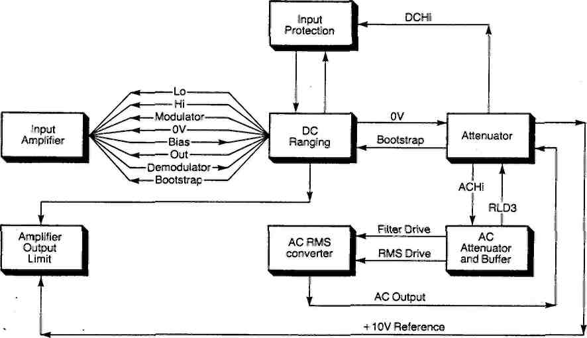
Figure 6.1 Board 6 schematic.
6.2 ATTENUATOR (Sheet 1)
The voltmeter input signals, from either the front or rear panel connector, enter printed circuit board 6 and are fed, via the front/rear switch SI, through various combinations of relays and resistors, depending upon the measurement function selected. The resistors attenuate the signals to the levels required for the voltmeter's circuitry. Table 6.1 indicates the relays made for different measurement functions.
Table 6.1 Attenuator Relays
Function | Relays On
0 to 10V dc | RL5
10 to lOOOVdc | RL4, RL6
Vac | RL3
0 to 1МЙ | RL5
IMP. to 1GQ | RL2, RL5, RL6
10V Test | RL2, RL4
2931g/0142g/JWS
6.1
Note: RL7 is closed whilst RL5 opens or closes.
AC input signals are passed onto the AC Attenuator and Buffer; dc and resistance signals to the DC Ranging circuit.
6.3 INPUT AMPLIFIES? (Sheet 2)
The voltage applied to the amplifier, via the Hi and Lo lines, is limited by diodes D401 and D408 to protect the circuit from accidental overload. The limited voltage is then applied to input FET pair TR401. IC401 is connected to the drains of TR401 to improve the common mode rejection and hence the settling time to transients; if the offset does not change the chopper channel need not resettle.
The output from IC401 is fed directly to IC402 and from IC402 to the amplifier output limit circuitry.
The offset from TR401 is fed, via a filter circuit consisting of R407, R408 and C404, to a bridge modulator made up of four low leakage FETs: TR406, TR407, TR408 and TR409. IC406 provides anti-phase switching signals for the modulator. The amplitude of these signals is determined by diode D404. The resultant modulated signal from the FETs is then amplified by low noise amplifier TR404 and high gain amplifier IC404.
Any dc output is removed by capacitor C410 and the signal is demodulated by IC405 and its associated components.
The amplified offset Is fed back into IC401 via R406, which is balanced by R404 to give rejection of rail noise.
IC402 is unity gain stable but TR401 provides gain for its inputs. This extra gain is "lost" by C401 (R402 + R401) in the lower limit and R403 (C401) in the upper limit. The result is to make the combination of TR401 and R403 have a gain of one and no phase shift at high frequencies.
The cross-over frequency between the high frequency amplifier and the chopper channel Is approximately 8Hz so that a 6dB per octave roll-off is maintained for most frequencies.
TR412 and IC402 provide low voltages which are defined relative to the input voltage, e.g. -6.2V. These can be used to provide rail currents for TR401 and TR404.
6.4 DC RANGING (Sheet 3)
The gain of the main input amplifier is controlled by the scaling resistor network in this circuit. The network also provides an additional measure of input amplifier protection, relative to the bootstrap.
2931g/0142g/JWS 6.2
6.4.1 Input Protection
Despite the use of an input attenuator, large input swings could still overdrive the input amplifier. The input protection circuit provides an extra safeguard, limiting the signal line excursions to approximately 15V. The circuit consists of diode D101, zener diode D102, D103 and associated resistors.
6.4.2 Ranging
Resistors Rill to R114 form the feedback paths for the input amplifier. The feedback, and hence the gain, is selected by one of the F.E.T. switches TR101 to TR103 which are driven from board 5 via the opto-isolators in IC104.
6.5 AMPLIFIER OUTPUT LIMIT (Sheet 3)
This circuit, which consists of operational amplifiers IC102, IC103, diodes D107 to D114 and associated components, ensures that the input amplifier output does not exceed ±15V. If the output is within these limits, the voltage at the non-inverting inputs to IC102 and IC103 is within ±10V. The circuit operation is as follows:
OV input to IC102
Amplifier output equals -12V. D112 is forward biased, thus enabling the IC102 feedback loop. IC103 output equals +12V, but its inverting input is kept at -10V by the reference input. Under these conditions, D107 and D108 are reversed biased and no current flows to D109, DUO, R110.
+10V input to IC102
Amplifier output equals -2V. D112 is still forward biased. IC103
output equals +22V, therefore D107 and D108 are still reverse
biased.
+15V input to IC102
Amplifier output rises above -2V. D112 is reversed biased, thus disabling the feedback loop. The amplifier (IC102) output therefore rises rapidly in an attempt to equalise its inputs. IC103 output, on the other hand, continues to track the input (Vj_{n} + 12) because of the -10V reference applied to its
inverting input. Therefore, as ТР106 rises to the rail voltage and TP107 equals +27V. diodes D107 and D108 become forward biased switching D109, DUO, R110 onto the input amplifier feedback loop.
Large negative voltages input to IC102
D114 in the feedback loop of IC103 becomes reverse biased and forces IC103 output more negative in an attempt to equalise its inputs. IC102, on the other hand, continues to track negative inputs. D107 and D108 are again forward biased and switch D109, DUO, R110 into the input amplifier feedback loop.
2931g/0142g/JWS 6.3
б.б АС ATTENUATOR AND BUFFER (Sheet 4)
This circuit is required to accommodate either rms ac only or the rms of the ac + dc. For the ac only case, RL701 is closed, RL702 open. For the ac + dc case, both RL701 and RL702 are closed. In any other-mode RL702 is closed to keep C701 discharged.
The ac gain of the attenuator is one at RL703 for high frequencies. At low frequencies the gain is rolled off by C701, R703, 707 and 708 in the ac only mode but. in the ac + dc mode, the gain begins to roll off because of C701, R703, 707 and 708 and then, flattens off again at about 0.95 because of R702. Therefore, to give a flat ac + dc response, a similar network, C702, R701 and R704 is introduced into the feedback path of buffer amplifier IC705.
For ac only, the buffer amplifier has a gain of one at all frequencies. In practice, a large capacitor is put in series with TR704 (C703). This gives a slight lift in response at low frequencies to counteract the effect of C701 at frequencies just above the cut-off point.
In the lOOmV and IV ranges, the signal passes through R711 at low frequencies and R722 plus C709 at high frequencies to clamp diodes D712 and D713. The combination of R711 and C709 in parallel, combined with the amplifier input capacitance, gives a gain of about 0.9985.
For the 10V and 100V ranges, the attenuator is put in the *100 position and the buffer set to either XI or X10. C706 and C720 compensate for capacitance across R703.
For the 1000V range, the attenuator is put in the -rlOOO position (R706).
For ac self-test, the attenuator is set to the 1000V position and a square wave generated from the forcing waveform is injected into the bottom of the attenuator. This method of injecting a low signal into the attenuator gives good isolation from the test voltage when normal measurement is being made without adding another relay to the sensitive input amplifier node.
IC705 forms the basis of the buffer amplifier. C704 is included in the circuit to prevent IC705 oscillating in the region of 50Hz. A gain of either 1 or 10 is required from the buffer amplifier, both with a bandwidth of at least 7MHz. TR703 and associated components C714, R721 and R720 provide the gain of 10. They are switched into the feedback loop by IC706, D716, D715, D717 and TR702 acting as a common-base amplifier. IC706 pin 1 is logic low so that D715 is forward biased and D716 causes the cathode of D715 to clamp at -9V. TR702 is an emitter follower which drives the common-base amplifier.
C712 compensates the feedback attenuator for the capacitive loading by the various components connected through TR706 when it is turned on.
2931g/0142g/JWS 6.4
To get a gain of one, the output stage is saturated; for this, the bias to TR703 is changed by turning off the low collector output, pin 1, of IC706. As a result, current flows from the positive rail through R705f. g, R716 and R720 (D715 is now reverse biased), and turns TR703 on. This effectively couples the emitter follower TR702 directly to the output. R718 is needed to decouple TR702 from the output load, which is fairly capacitive. Feedback is now unattenuated through TR705, giving an overall gain of one.
IC704 guards the sensitive input lines to the buffer amplifier and reduces the capacitance to ground. It also provides switch-on drive for TR704, TR705 and TR706.
6.7 AC RMS CONVERTER (Sheet 5)
The rms converter can be divided into two specific sections:
1. The absoluter, which converts the alternating signal into one with a single polarity.
2. The converter, that converts the varying single polarity input into a dc signal which represents the rms value of that input.
6.7.1 The Absoluter
The absoluter consists of a fast virtual earth amplifier with a pair of diodes in the output that generate the positive and negative components of the output signal separately. The bandwidth of the rms converter depends primarily on the bandwidth of this circuit and, for this reason, it is constructed to be as fast as possible. To speed up the output transition, from positive to negative polarity, the two diodes are driven by a constant current stage.
The input current is generated by R750 and the feedback is through R750 or R753 depending on the polarity. The positive output voltage is added to the original input signal (but with twice the weighting) through R751. Thus, for an input of -S volts, the converter has an input current of:
-S + 2S____S_
10k 10k " 10k
For an Input of +S volts, the converter input current equals:-S + OS S
10k 10k " 10k i.e. the input current is always positive.
The amplifier consists of two paths; a fast, low accuracy path and a slow, high accuracy path.
The fast path is through TR762 (a source follower), TR763 (an emitter follower), TR751 (common base) and TR764 which is the constant current output stage. The 100kHz frequency response is set by RV752. This component controls the phase shift of network C760, R759 and RV752 at 100kHz, and hence the gain.
2931g/0142g/JWS 6.5
The slow path is through integrator IC752. Change over from one path to the other occurs at 100kHz.
6.7.2 The Converter
The basic amplifier is very similar to the absoluter amplifier, but with RV752 replaced with a fixed resistor (R767) and a variable resistor (RV753) added. This allows the gain bandwidth product to be adjusted and, in effect, allows the 1MHz gain to be controlled.
A simplified circuit diagram of the converter is shown in Figure 6.2.
i) Transistors A and B, in conjunction with IC753, produce a voltage at the emitters of В and C, which is equal to 21og_{e}I_{in}
ii) D develops a voltage at its emitter which is equal to
log aV(I ), where av(I ) is the average value of e out out
lout derived from the filter output.
ill) The difference between (i) and (ii) is developed across the base emitter junction of С to produce I_{ou}t:
exp(21og_{e}I_{in} - log_{e}av(I_{0Ut})) = I_{out}
which implies
*±— -lout
av(Iout)
(iv) This is filtered again, to give: avtIJn - av(I_{out})] = av[I_{out}] which implies avl$_{n} = [av(I_{out})]2
or
av(Iout) = ^^{avI}?n
In other words, the filter output (avI_{ou}t) is •avlj_{n} which is simply the definition of the rms
value of Iin.
To obtain good gain stability transistors A and D are a matched pair? similarly В and C. Any offset between these transistors appears as a gain error given by:
exp(log_{e}I + V_{offset}) = I_{exp} V_{offset}
If Voffset =0' exp V₀f_{fset} = 1.
2931g/0142g/JWS
6.6
However, even the use of matched pairs can.give a certain improvement only, particularly with respect to long term drift, so the circuit goes one stage further.
Transistor pair A and D are swapped over at a rate of 10Hz, similarly В and C. The effect can be seen mathematically, i.e. the output is given by
5iexp(log_{e}I + V_{offset}) + Xexp (log_{e}I - V_{offset})
= X [Iexp V₀ff_{se}t + ^{Iex}P ("Voffset)]
For small values of V₀ff_{set}, a Taylor expansion may be used, i.e.
^{e}*P ^{v}offset = ¹ ⁺ Voffset ⁺ ^{v}_{offset}
2
giving:
X[lexp Voff_{set} + Iexp <-V_{of}fset>] " *I<2 + V₀ff_{S}et>
₌ _{I(1} + VSffset ) 2
The unchopped error would have been:
Id ⁺ V_{offset} ₊ ytoset_)
2
The components which achieve the switching are TR770 to TR779 inclusive. They are driven through resistors to minimise the transient disturbance by IC750, which switches between -15V and -1.3V. TR780 performs logic level shifting.
If the voltmeter is using an integration rate below 100ms on ac, a reading may be generated with the chopper in one of two states and no averaging effect will occur. Thus, as a result of ^{v}offset* ^{two} possible outputs could occur, differing by more than one bit. For this reason, RV751, R791 and R790 are included to reduce the offset to a minimum.
2931g/0142g/JWS
6.7
R751
AC
Output
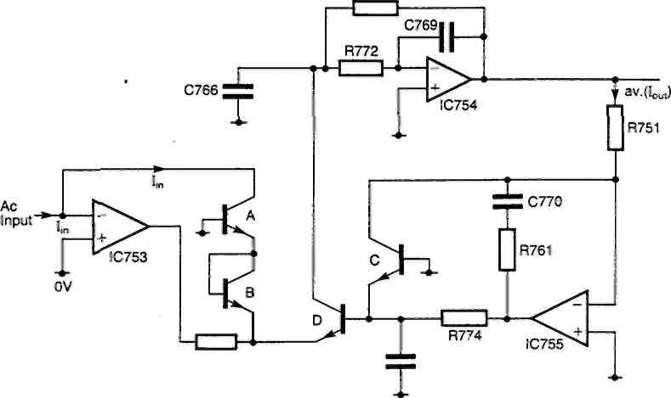
R770
Figure 6.2 Converter
6.8 TEST POINTS
The following Test Points are provided to assist in printed circuit board fault-finding.
Table 6.2 Test Points
Test Point (TP) | Signal
101 | HI
102 | LO
103 | DC Output
104 | Bootstrap
105 | 0V Mytchett
106 | +15 Clamp
107 | -15 Clamp
401 | Bootstrap
402 | Chopper Output
403 | Demodulator Output
404 | Demodulator
405 | OV
702 | AC Bootstrap
705 | Buffer Output
750 | Rectifier Bias
751 | Log Bias
753 | Bias
756 | Log Drive
757 | RMS Output
2931g/0142g/JWS
6.8
CHAPTER 7
Component Parts Lists and Circuit Diagrams CONTENTS
Page
7.1 Introduction 7.1
7.2 Comnponent Parts List Abbreviations 7.1
7.2.1 Circuit Reference 7.1
7.2.2 Component Types 7.1
Parts Lists
PCB 1
PCB 3
PCB 5
PCB 6
PCB 8
PCB 14
General Assembly
Circuit Diagrams
PCB 1
PCB 3
PCB 4 and 8
PCB 5
PCB 6
7.2 7.3 7.8
7.18 7.26 7.27 7.29
2890g/0142g/JWS
7.1
INTRODUCTION
This chapter contains detailed Parts Lists and Circuit Diagrams for each of the printed circuit boards fitted in the instrument. When ordering spare parts» it is essential to quote the instrumerlt serial number, located on the rear panel, as well as the full description shown in the appropriate parts lists.
7.2 | Component Parts List | Abbrevie | itions
7.2.1 | Circuit Reference
 | В - Battery |  | R | - Resistor (Q)
 | С - Capacitor (yF) |  | RL | - Relay
 | CSR - Thyristor |  | RNL | - Non Linear Resistor (fl)
 | D - Diode |  | RV | - Variable Resistor (Й)
 | FS - Fuse |  | S | - Switch
 | 1С - Integrated Circuit |  | SK | - Socket
 | L - Inductor |  | T | - Transformer
 | LP - Lamp (including Neon) |  | TP | - Terminal Post (or Test Point)
 | LK - Link |  | TR | - Transistor
 | MSP - Mains Selector PL - Plug | Panel | X | - Other components
7.2.2 Component Types Fixed Resistors
Variable Resistors
CACP Carbon Compos!tiion CAFM
CAFM Carbon Film CAFS
CKCA Cracked Carbon CAPM
MEFM Metal Film CAPS
MEGL Metal Glaze CMFM
MEOX Metal Oxide CMFS
POWW Power Wirewound CMPM
PRWW Precision Wirewound CMPS
TEMP Temperature Sensitive CMPS
TKFM Thick Film WWFM
TNFM Thin Film WWFS
VOLT Voltage Sensitive WWPM
WWPS
Carbon Front Panel Multiturn Carbon Front Panel Single Turn Carbon Preset Multiturn Carbon Preset Single Turn Cermet Front Panel Multiturn Cermet Front Panel Single Turn Cermet Preset Multiturn Cermet Preset Single Turn Cermet Preset Single Turn Wirewound Front Panel Multiturn Wirewound Front Panel Single Turn Wirewound Preset Multiturn Wirewoud Preset Single Turn
Capacitors
AIR Air MLAC
ALME Aluminimura Electolytic PAPF
ALMS Aluminimum Solid PAPM
CARB Polycarbonate PTFE
CERM Ceramic PYLN
ESTF Polyester Foil STYR
ESTM Polyester Metallised TAND
MICA Mica TANF
GLAS Glass TANW
Metallised Lacquer Paper Foil Paper Metallised PTFE
Polyproylene Film Polystyrene Tantalum Dry Tantalum Foil Tantalum Wet
2890g/0142g/JWS
7.1
РСВ 1 Parts List
Cct Ref. |  | General Description |  |  | Solartron Part No.
R101 R102 R103  R104 | CACP CACP CACP CACP | 5P.6 10k 10k 10k | 1/2И 1/4W 1/4W 1/4W | 10% 10% 10% 10% | 172305600 172041000 172041000 172041000
ClOl C102 C103 CI 04 | CERM CERH  CERM CERM | 47n 47n 47n lOOn | 12V 12V 12V 40V | 20%  20%  20%  +80%  -20% | 241744700 241744700 241744700 208450140
C105 C106 | CERM CERM | lOOn lOOn | 40V 40V | +80% -20% +80% -20% | 208450140 208450140
C107 | CERM | 330p | 500V | 20% | 241323300
IC101 IC102 IC103  IC104 | LS273 LS273 Resistor  UDN6118 | Pack. | 150 |  | 510004380 510004380 160400587 510005710
IC105 IC106 IC107 IC108 | UDN6118 LS74  UCN4810A UCN4810A |  |  |  | 510005710  510002600 510005180 510005180
ICllO  IC111 IC112  IC113 | LS374 LS374 LS374 Resistor Pack. |  | 150 |  | 510004390 510004390 510004390 160400587
D101  to  D122 | LED |  |  |  | 300750280
DS101 | FG209M |  |  |  | 300730460
PL101 | Plug, 26 | way |  |  | 351326030
 | Stick-on | Feet |  |  | 420310260
2890g/0l42g/JWS
7.2
PCB 3 Parts List
Cct |  |  |  |  | Solartron
Ref. |  | General Description |  |  | Part No.
Rl | CACP | lk5 | 1/4W | 10% | 172031500
R2 | CACP | lk5 | 1/4W | 10% | 172031500
R3 | CACP | 10k | 1/4W | 10% | 172041000
R4 | CACP | 47k | 1/4W | 10% | 172044700
R5 | CACP | 10k | 1/4И | 10% | 172041000
R6 | CACP | 470 | 1/4W | 10% | 172024700
R7 | CACP | 150 | 1/4W | 10% | 172021500
R8 | CACP | lk5 | 1/4W | 10% | 172031500
R9 | CACP | Ik | 1/4W | 10% | 172031000
RIO | CACP | 3k3 | 1/4W | 10% | 172033300
Rll | CACP | 27k | 1/4W | 10% | 172042700
R12 | CACP | 10k | 1/4W | 10% | 172041000
R13 | CACP | 47k | 1/4W | 10% | 172044700
R14 | CACP | 22k | 1/4W | 10% | 172042200
R15 | CACP | 10k | 1/4W | 10% | 172041000
R16 | CACP | 10k | 1/4W | 10% | 172041000
R17 | CACP | Ik | 1/4W | 10% | 172031000
R18 | CACP | lk5 | 1/4W | 10% | 172031500
R19 | CACP | 15k | 1/4W | 10% | 172041500
R51 | CACP | 100 | 1/4W | 10% | 172021000
R52 | CACP | lk8 | 1/4W | 10% | 172031800
R53 | MEFM | 3k3 | 1/8W | 0.5% | 192733302
R54 | CACP | 100 | 1/4W | 10% | 172021000
R55 | CACP | 47k | 1/4W | 10% | 172044700
R56 | CACP | 10k | 1/4W | 10% | 172041000
R57 | CACP | 22 | 1/4W | 10% | 172012200
R58 | CACP | 22 | 1/4W | 10% | 172012200
R59 | MEFM | 470k | 1/8W | 0.5% | 192754702
R60 | CACP | lk8 | 1/4W | 10% | 172031800
R61 | MEFM | 3k3 | 1/8W | 0.5% | 192733302
R62 | CACP | 100 | 1/4И | 10% | 172021000
R63 | CACP | 47k | 1/4W | 10% | 172044700
R64 | CACP | 10k | 1/4W | 10% | 172041000
R65 | MEFM | 33k | 1/8W | 0.5% | 192743302
R66 | MEFM | 12k | 1/8W | 0.5% | 192741202
R67 | MEFM | 22k | 1/8W | 0.5% | 192742202
2890g/0142g/JWS
7.3
PCS 3 Parts List (cont.l)
CCt |  |  |  |  |  | Solartron
Ref. |  | General Description |  | Part | No.
R68 | MEFM | 3k9 | 1/8W | 0.5% |  | 192733902
R69 | MEFM | 3k9 | 1/8W | 0.5% |  | 192733902
R70 | POWW | 0Й1 |  | 10% |  | 160200088
R71 | POWW | 0Q1 |  | 10% |  | 160200088
R72 | MEFM | 470k | 1/8W | 0.5% |  | 192754702
R73 | CACP | lk5 | 1/4W | 10% |  | 172031500
R74 | CACP | lk5 | 1/4W | 10% |  | 172031500
CI | CERM | 68p | 500V | 20% |  | 241316800
C2 | TAND | 4y7 | 10V | 20% |  | 265464700
C3 | VAR | 2 to 27p |  |  |  | 290030280
C4 | CERM | 22p | 500V | 20% |  | 241312200
C5 | CERM | 150p | 500V | 20% |  | 241321500
C6 | CERM | lOOp | 500V | 20% |  | 241321000
CIO | TAND | ly | 35V | 20% |  | 266061000
C51 | ALME | 2200y | 63V | +50%- | •10% | 208600264
C52 | ESTF | 4n7 | 100V | 10% |  | 227034700
C53 | ESTF | lOn | 100V | 10% |  | 227041000
C54 | TAND | lp | 35V | 20% |  | 266061000
C55 | TAND | 220y | 10V | 20% |  | 265482200
C56 | ALME | 47y | 40V | +50%- | •10% | 273774700
C57 | ALME | 47y | 40V | +50%- | ■10% | 273774700
C58 | ALME | 47y | 40V | +50%- | •10% | 273774700
C59 | ALME | 4700y | 50V | +50%- | ■10% | 208600268
C60 | ALME | 22y | 40V | +50%- | •10% | 273772200
C61 | ESTM | lOOn | 100V | 10% |  | 225451000
C62 | TAND | Юу | 25V |  |  | 208700108
C64 | ESTF | 4n7 | 100V | 10% |  | 227034700
C65 | ESTF | lOn •' | 100V | 10% |  | 227041000
C66 | TAND | ly | 35V | 20% |  | 266061000
C67 | TAND | 220y | 10V | 20% |  | 265482200
C68 | ALME | 220y | 10V | +1004 | .-10% | 273182200
C69 | ESTM | lOOn | 100V | 10% |  | 225451000
C70 | ESTM | lOOn | 100V | 10% |  | 225451000
C71
to | CERM | 47n | 12V | +50%- | •25% | 241744700
C78
Bl
Battery
800400260
2890g/0142g/JWS 7.4
PCB 3 Parts list (cont. 2)
Cct |  | Solartron
Ref. | General Description | Part No.
ICl | 74LS04 | 510002690
IC2 | 74LS393 | 510004470
IC3 | 74LS08 | 510002910
IC4 | 74LS14 | 510003120
IC5 | 74LS196 | 510004710
IC6 | 74LS03 | 510004140
IC7 | CD4040BE | 510001820
IC8 | 74LS151 | 510002720
IC9 | 6402 | 510002820
IC10 | 6N136 | 300540150
IC11 | 6N136 | 300540150
IC12 | Resistor pack 6.8k (15 off) | 160400569
IC13 | LSI 48 | 510005800
IC14 | 74LS157 | 510002240
IC15 | 74LS367 | 510003030
IC16 | 74LS74A | 510002600
IC17 | 74F139 | 510005880
IC18 | 74LS74A | 510002600
IC19 | 68A50 | 510003011
IC20 | 68A21 | 510002851
IC21 | 68A21 | 510002851
IC22 | 74LS240 | 510005310
IC23 | 74LS145 | 510004990
IC24 | 74LS30 | 510003560
IC25 | LM301 | 510001270
IC26 | MM58174N | 510005480
IC27 | LS32 | 510093140
IC28 | LS107 | 510004550
IC29 | LSI 64 | 510002890
IC51 | TL494 | 510000690
IC52 | 7805 Regulator | 510000500
IC55 | TL494 | 510090690
IC56 | LM311 | 510091280
TR1 | BC214L
TR2 | 3N163 | 300554530
TR3 | MPSA13
TR4 | BC107 | 300553320
TR6 | VN10KM | 300555860
TR7 | VN10KM | 300555860
2890g/0142g/JWS 7.5
РСВ 3 Parts List (cont.3)
CCt  Ref. | General Descr
TR51 TR52 TR53 TR54 | 2N2907A BD131 2N2907A BD131
TR55 TR56 | U1897 U1897
Dl D2 D3 | SD3 SD3 SD3
D51 D52 D53 D54 D55 | W04  VSK340  IN5339B  W04 W04
D56 D57  D58 D59 | C30  VSK340 IN5339B C5V6
D60 D61 | C12 C12
PL1 PL2 PL3 PL4 | Ribbon Plug, 40 way Bergstik Plug, 15 way Amp Header, 2 way Ribbon Plug, 26 way
PL5 PL6 PL51 PL52 | Ribbon Plug, 26 way Ribbon Plug, 26 way Amp Header, 8 way Amp Header, 6 way
LSI  LS2 | RM10 Inductor, 250yH RM10 Inductor, 250yH
N1 | Mains Selector Mains Switch
SI | 8-pole DIL Switch
SKI SK2 SK3 SK4 | Socket, 40 way DIL Socket, 40 way DIL Socket, 40 way DIL Socket, 24 way DIL
Solartron Part No.
SK51 Socket, 16 way DIL
300553800 300553800
300522160 300522160 300522160
300524700 300525850 300526000 300524700 300524700
300521430 300525850 300526000 300521450
300521480 300521480
352340110 352336070 352302080 352326110
352326110 352326110 352308060 352306090
309511001 309511001
550001480 375500020
375000540
300585190 300585190 300585190
300584190
300584860
2890g/0142g/JwS
7.6
РСВ 3 Parts List (cont.4)
CCt  Ref. | General Description | Solartron Part No.
FSl  FS2 | Fuse 200mA 240V Fuse 200mA 240V | 360106280 360106280
Tl | Mains transformer | 309617701
XI X2 | Crystal 1.2288MHz Crystal 32.768kHz | 300810360 300810640
TPl TP2 TP3 TP4 | Test Hook  Test Hook  Amp Disconnect Pin  Amp Disconnect Pin | 355400760 355400760 355900550 355900550
TP5 TP6 TP51 TP52 | Terminal Lug Terminal Lug Test Hook Test Hook | 355500430 355500430 355400760 355400760
TP53  TP54 TP55 TP56 | Amp Disconnect Pin Test Hook Test Hook Test Hook | 355900550 355400760 355400760 355400760
TP57 | Test Hook | 355400760
 | PCB Hinge (2)  PCB Edge Support (2) | 412011220 412011230
2890g/0142g/JWS 7.7
РСВ 5 Parts List
CCt  Ref. |  | General Description |  |  | Solartron Part No.
R201 R202 R203  R204 | MEFM MEFM MEFM MEOX | 160k 100k 10k  Ik | Matched Precision  pair  1/8И 0.5%  1/4W 5% |  | 169616002  192741001 195631000
R205 R206 R207 R208 | MEOX MEOX MEOX  MEFM | Ik 100k  100k 10k | 1/4И 1/4W 1/4W 1/8W | 5% 5% 5% 0.5% | 195631000 195651000 195651000  192741001
R209 R210 R211 R212 | MEFM MEOX MEOX MEOX | 10k 10k 560 10k | 1/8W 1/4W 1/4W 1/4W | 0.5% 5%  5% 5% | 192741001 195641000 195625600 195641000
R213 R214 R215 R217 | MEOX MEFM MEFM MEOX | 560 680 680 22k | 1/4W 1/8W 1/8W 1/4И | 5%  0.5%  0.5%  5% | 195625600 192726802 192726802 195642200
R218 R219 R220 R221 | MEOX MEOX MEOX MEFM | 22k 2k2  2k2 39k | 1/4W 1/4W 1/4W 1/8W | 5% 5% 5% 0.5% | 195642200 195632200 195632200 192743902
R222 R224 R301 R302 | MEFM MEOX MEFM MEFM | 100k 68 47k 470 | 1/8W 1/4И 1/8W 1/8W | 0.5% 5% 2% 2% | 192751001 195616800 160400571 192124700
R303 R304 R305a R305b | MEFM 4k7  (To be fitted MEFM 10k MEFM 10k |  | 1/8W 0.5% only if supplied with Matched Precision Pair |  | 192734704  diode D301  169616102
R306a R306b R306c R306d | MEFM MEFM MEFM  MEFM | 6k  12k7  600  300 | Matched Set | Precision | 169616201
R308 R309 R310 R311 | CACP САСР CACP CACP | 100 100 Ik  Ik | 1/8W 1/8W 1/8W 1/8W | 10% 10% 10% 10% | 172021000 172021000  172031000 172031000
R351 R352 R353 R354 | MEFM MEOX MEOX MEFM | 33k 6k8 10k 82k | 1.8W 1/4W  1/4W 1/8W | 0.5% 5% 5% 0.5% | 192743302 195636800 195641000 192748202
2890g/0142g/JWS
7.8
PCB 5 Parts List (cont.l)
Cct |  |  |  |  | Solartron
Ref. |  | General Description |  |  | Part No.
R355 | MEFM | 100 | 1/8W | 0.5% | 192721002
R501 | Network | 680 |  |  | 160400570
R502 | Network | 47k |  |  | 160400571
R503 | MEFM | 470 | 1/8W | 2% | 192124700
R504 | CACP | 10k | 1/8W | 10% | 172041000
R505 | CACP | 3k3 | 1/8W | 10% | 172033300
R506 | MEFM | 470 | 1/8W | 2% | 192124700
R507 | MEFM | 470 | 1/8W | 2% | 192124700
R509 | CACP | Ik | 1/8W | 10% | 172031000
R601 | MEOX | 2k2 | 1/4W | 5% | 195632200
R602 | MEOX | 2k2 | 1/4W | 5% | 195632200
R603 | MEFM | 100k | 1/8W | 0.5% | 192751001
R604 |  | 100k | Precision |  | 169616402
R605 | MEFM | 100k | 1/8W | 0.5% | 192751001
R606 | MEOX | 56k | 1/4W | 5% | 195645600
R607a | Network | 47k | 1.8W | 2% | 160400571
R607b
R608 | MEOX | IM | 1/2W | 1% | 195461000
R609 | MEFM | 30k
R611 | MEFM | 600k | Matched Precision Set |  | 169616303
R612 | MEFM | 6k
R614 | POWW | 12k | 2W | 5% | 193041200
R615 | MEFM | 470 | 1/8W | 2% | 192124700
R616 | MEOX | 10k | 1/4W | 5% | 195641000
R617 | MEOX | 10k | 1/4W | 5% | 195641000
R801 | CACP | 150 | 1/4W | 10% | 172021500
R802 | CACP | 3k3 | 1/4W | 10% | 172033300
R803 | CACP | ЗкЗ | 1/4W | 10% | 172033300
R804 | CACP | 22k | 1/4W | 10% | 172042200
R805 | CACP | 47k | 1/4W | 10% | 172044700
R806 | CACP | IM | 1/4W | 10% | 172061000
R807 | CACP | 100k | 1/4W | 10% | 172051000
R808 | CACP | 100k | 1/4И | 10% | 172051000
R809 | CACP | 220k | 1/4W | 10% | 172052200
R810 | CACP | 100k | 1/4W | 10% | 172051000
R811 | CACP | 47k | 1/4W | 10% | 172044700
R812 | CACP | 470 | 1/4И | 10% | 172024700
R813 | CACP | 10k | 1/4W | 10% | 172041000
R814 | CACP | Ik | 1/4W | 10% | 172031000
R815 | CACP | 100 | 1/4W | 10% | 172021000
R816 | CACP | 330 | 1/4W | 10% | 172023300
2890g/0142g/JWS
7.9
РСВ 5 Parts List (cont.2)
_{Cct} Solartron
Ref. General Description Part No.
R817 | CACP | 27k | 1/4W | 10% | 172042700
R818 | CACP | 47k | 1/4W | 10% | 172044700
R819 | CACP | 47k | 1/4И | 10% | 172044700
R820 | CACP | ЗкЗ | 1/4И | 10% | 172033300
R821 | CACP | 10k | 1/4W | 10% | 172041000
R822 | CACP | 680 | 1/4W | 10% | 172026800
R823 | CACP | 10k | 1/4W | 10% | 172041000
R824 | CACP | 2k7 | 1/4W | 10% | 172032700
R825 | CACP | 6k8 | 1/4W | 10% | 172036800
R826 | CACP | 6k8 | 1/4W | 10% | 172036800
R827 | CACP | Ik | 1/4W | 10% | 172031000
C201 | PROP | lOOn | 200V | 1% | 208100180
C202 | ESTM | 470n | 100V | 10% | 225454700
C203 | ESTM | 68n | 100V | 10% | 225446800
C204 | CERM | 150p | 500V | 20% | 241321500
C205 | ESTM | lOn | 100V | 10% | 225441000
C208 | CERM | lOn | 500V | +80% -20% | 241941000
C209 | CERM | lOn | 500V | +80% -20% | 241941000
C210 | CERM | 2n2 | 500V | +40% -20% | 241332200
C211 | CERM | 2n2 | 500V | +40% -20% | 241332200
C212 | ESTM | 470n | 100V | 10% | 225444700
C213 | TAND | 47y | 20V | 10% | 265774700
C214 | ESTM | lOOn | 100V | 10% | 225451000
C215 | ESTM | lOOn | 100V | 10% | 225451000
C216 | CERM | 47n | 25V | +50% -25% | 241944700
C217 | CERM | 47n | 25V | +50% -25% | 241944700
C218 | CERM | 47n | 25V | +50% -25% | 241944700
C219 | CERM | 47n | 25V | +50% -25% | 241944700
C220 | CERM | 470p | 500V | 20% | 241324700
C221 | CERM | 470p | 500V | 20% | 241324700
C223 | TAND | 22y | 35V | 10% | 265972200
2890g/0142g/JWS
7.10
РСВ 5 Parts List (cont.3)
CCt |  |  |  |  | Solartron
Ref. |  | General | Description |  | Part No.
C301 | CERM | 47n | 25V | +50% -25% | 241944700
C302 | CERM | 47n | 25V | +50% -25% | 241944700
C303 | CERM | Юр | 500V | 20% | 241311000
C304 | CERM | Юр | 500V | 20% | 241311000
C305 | CERM | Юр | 500V | 20% | 241311000
C306 | CERM | 22p | 500V | 20% | 241322000
C351 | CERM | lOn | 25V | +50% -25% | 241941000
C352 | CERM | lOn | 25V | +50% -25% | 241941000
C501 | ESTM | lOn | 100V | 10% | 225441000
C502 | ESTM | lOOn | 100V | 10% | 225451000
C503 | ESTM | lOOn | 100V | 10% | 225451000
C601 | ESTM | lOOn | 100V | 10% | 225451000
C602 | ESTM | lOOn | 100V | 10% | 225451000
C603 | ESTM | lOOn | 100V | 10% | 225451000
C604 | ESTM | lOOn | 100V | 10% | 225451000
C605 | ESTM | lOn | 100V | 10% | 225441000
C606 | ESTM | lOn | 100V | 10% | 225441000
C607 |  | lOOp | 100V | 20% | 208900004
C608 | ESTM | 33n | 400V | 10% | 226043300
C609 | ALME | 100 | 100V | +100% -10% | 273981000
C610 | ALME | 47y | 100V | +100% -10% | 273974700
C611 | CERM | lOn | 250V |  | 208450036
C612 | CERM | lOn | 25V | +50% -25% | 241941000
C613 | CERM | lOn | 250V |  | 208450036
C614 | ESTM | lOOn | 100V | 10% | 225451000
C615 | ESTM | lOOn | 100V | 10% | 225451000
C616 | CERM | 47n | 25V | +50% -25% | 241944700
C617 | CERM | 47n | 25V | +50% -25% | 241944700
C801 | CERM | 22p | 500V | 20% | 241312200
C802 | CERM | 22p | 500V | 20% | 241312200
C803 | CERM | 22n | 25V | +50% -20% | 241842200
C804 | ALME | 47y | 40V | +50% -10% | 273774700
2890g/0142g/JWS
7.11
РСВ 5 Parts List (cont.4)
Oct |  |  |  |  | Solartron
Ref. |  | General | Description |  | Part No.
C805 | TAND | 4y7 | 10V | 20% | 265464700
C806 | TAND | lOOy | 10V | 20% | 265481000
C807 | VAR | 6-30p | 160V | 10% | 290020450
C808 | CERM | Юр | 250V | 20% | 208450000
C809 | CERM | 3n3 | 500V | +40% -20% | 241333300
C810 | CERM | ЗЗОр | 500V | 10% | 208450060
C811 | CERM | 47n | 12V | +50% -25% | 241744700
C812 | TAND | 47v | 6V | 20% | 265274700
C813 | CERM | In | 500V | +40% -20% | 241331000
C814 | TAND | ly | 35V | 20% | 266061000
C815 | ESTM | lOOn | 100V | 10% | 225451000
C816 | CERM | 47n | 12V | +50% -25% | 241744700
C817 | CERM | 47n | 12V | +50% -25% | 241744700
C818 | CERM | 47n | 12V | +50% -25% | 241744700
C819 | CERM | 47n | 12V | +50% -25% | 241744700
C820 | CERM | 47n | 12V . | +50% -25% | 241744700
C821 | CERM | 3n3 | 500V | +40% -20% | 241333300
C822 | TAND | 22v | 16V |  | 208700106
C823 | CERM | 47n | 12V | +50% -25% | 241744700
C824 | CERM | 47n | 12V | +50% -25% | 241744700
C825 | CERM | 47n | 12V | +50% -25% | 241744700
C826 | CERM | 47n | 12V | +50% -25% | 241744700
C901 | ALME | 220y | 40V |  | 208600262
C902 | ALME | 220y | 40V |  | 208600262
C903 | ALME | lOOOy | 40V |  | 208600263
C904 | ALME | lOOOy | 40V |  | 208600263
C905 | ALME | 220y | 40V |  | 208600262
C906 | ALME | 220y | 40V |  | 208600262
C907 | TAND | ly | 35V | 20% | 266061000
C908 | TAND | ly | 35V | 20% | 266061000
C909 | TAND | Ly | 35V | 20% | 266061000
C910 | TAND | ly | 35V | 20% | 266061000
2890g/0142g/JWS
7.12
PCB 5 Parts List (cont.5)
cct Ref. | General Description | Solartron Part No.
C912 | TAND 220 10V 20% | 265482200
IC201 IC202 IC203 IC204 | ICL7650 BCPD LM301 LM311 LH311 | 510091810 510091270 510091280 510091280
IC205 IC301 IC302 IC303 | 74S175 AD7533JN ILQ74 ILQ74 | 510003460 510090670 300540250 300540250
IC304 IC305 IC306 IC307 | 741CH  0P07EZ 0P07EZ DG301 | 510091310 510091420  510091420 510091110
IC351 IC352 IC501 IC502 | MC1458 CA3046 ILQ74 ICL7650 BCPD | 510091300 300554090 300540250 510091810
IC503 IC601 IC602 IC603 | 78L12  ICL7650 BCPD ICL7650 BCPD LH0052 | 510090450 510091810 510091810 510090260
IC604 IC605 IC606 IC607 | ICL7650 BCPD ILQ74 TILlll 78L15 | 510091810 300540250 300540140 510090420
IC608 79L15  IC801 63A03MPU  IC802 LS373  IC803 2564*  * On later models Part No. 2764 is used. |  | 510090430 510006170 510004870  510005610
IC804 IC805 IC806  IC807 | ER3400  F138  LS74A  LS191 | 510005600 510005870 510002600 510004190
IC808 IC809 IC810 IC811 | LS374 LS374 LS191  LSI 91 | 510004390 510004390 510004190 510004190
IC812 IC813 IC814  IC815 | LS191 LS163 LS393 LS393 | 510004190 510004170  510004470 510004470
2890g/0142g/JWS 7.13
PCS 5 Parts List (cont.6)
CCt Ref. | General 1 | Des
IC816 IC817 IC818 IC819 | LS273 LS273 LS273 LS393
IC820 IC821 IC822 IC823 | LS163 LSOO LS02 LS04
IC824 IC825 IC826 IC827 | CD4046  Resistor Pack, 6  TC5516P  LSI6IAN | ,8k
IC829 IC830 IC831 IC833 | ULN2003A LS273 F138 LSI 53
IC834 IC835 IC901 IC902 | LSI 32 LS74 7815CT  7915CT
IC903  IC904 | 7812CT 7912CT
TR201 TR202 TR203  TR204 | VN67AK VN67AK 3N163 3N163
TR205 TR206 TR207  TR208 | BCY70 BCY70 VN10  VN10
TR301 TR302 | BC107 BCY70
TR504 TR505  TR506 TR508 | U1897 VN67AK VN67AK VN67AK
TR509 TR510 TR512 TR513 | VN67AK  U235  U1897  U1897
Solartron Part No.
510004380 510004380 510004380
510004470
510004170 510002000 510002230 510002690
510005690 160400569 510005470 510004160
510004980 510004380
510005870 510002740
510002980 510002600 510090320 510090330
510090520 510090530
300555940 300555940 300554530 300554530
300553590 300553590 300555860 300555860
300553320 300553590
300553800 300555940 300555940 300555940
300555940 300553810 300553800 300553800
2890g/0142g/JWS
7.14
PCS 5 Parts List (cont.7)
Solartron ;crlption Part No.
300554320 300555940 300555940 300554320
300554320 300554320 300554320 300554530
300555940 300555270 300555880 3005558§0
300555880 300555380 300554530 300553590
300553320 300552860 300553320 300552390
300553590 300552390
300521460 300521460 70818008A (for 7071 only) 70818007A (for 7071 or 7081) * Special selection during test. Available from factory on failure only. Package may Include a resistor (R304), whose value is selected, on test, to match diode D301.
Cct Ref. |  | General
TR515 TR516 TR517 TR518 |  | 01899 VN67AK VN67AK U1899
TR519  TR601 TR602 TR603 |  | U1899 U1899 U1899  3N163
TR604 TR605 TR606 TR607 |  | WM222 3N171 2N4118A  2N4118A
TR608 TR609 TR610 TR801 |  | 2N4118A WN807 3N163 BCY70
TR802 TR803 TR804 TR805 |  | BC107 2N2484 BC107 2N2369
TR806 TR807 |  | BCY70 2N2369
D204 D205 D301 |  | Zener, 7.5V Zener, 7.5V Reference Zener*
D302 | Zener, |  | 10V
D351 | AD590K
D352 | SD3
D353 | SD3
D501 | DPAD10
D502 | DPAD10
D503 | Zener, |  | 6.8V
D504 | Zener, |  | 15V
D505 | Zener, |  | 15V
D507 | Zener, |  | 5.6V
D601 | WR057
D602 | WR057
300522760 510090760 300522160 300522160 300525870
300525870 300522540 300521390 300521390
300521450 300525770
300525770
2890g/0142g/JWS
7.15
РСВ 5 Parts List (cont.8)
CCt  Ref. |  | General Description | Solartron Part No.
D603 D604 D605 D606 | DPADIO  Zener,  DPADIO SD3 | 8.2V | 300525870 300521330 300525870 300522160
D607  D608 D609  D610 | SD3 LED DPADIO IN4007 |  | 300522160 300750080 300525870  300524990
D611 D612 D613  D614 | IN4004 IN4004 Zener, Zener, | 10V 10V | 300522070 300522070 300522760 300522760
D615 D616 D617 D801 | Zener, WR057 WR057 SD3 | 3.9V | 300521420 300525770 300525770  300522160
D802 D803 D804  D805 | SD3 SD3 C8V2 SD3 |  | 300522160 300522160 300521330 300522160
D806 D807 D808 D809 | SD3 C3V6 MV2110 MV2110 |  | 300522160 300523890 300525320 300525320
D810 D901 D902 D903 | SD3  Bridge  IN4004  IN4004 | W04 | 300522160 300524700 300522070 300522070
D904  D905 | IN4004 IN4004 |  | 300522070 300522070
RL1 RL501 | Coto Relay Coto Relay |  | 300652230 300652230
L801 L802 | Inductor, 33yH Inductor, 3.9pH |  | 305020440 305020750
PL501 PL502 PL504 | Plug, 34 Way Plug, 10 Way Plug, 4 Way |  | 352334050 352310070 352304080
SK801 SK802 SK804 SK806 | Socket, Socket, Socket, Socket, | 40 Way DIL 28 Way DIL 22 Way DIL 24 Way DIL | 300584970 300585120 300584980 300584740
2890g/0142g/JWS 7.16
РСВ 5 Parts List (cont.9)
CCt  Ref. | General Description | Solartron Part No.
SK901 | Socket, 16 Pin DIL | 300584860
SI | Switch, 6-pole DIL | 375000570
X801 | Crystal, 4.9152MHz | 300810590
TP201 to  TP205 | Test Hook | 355400760
TP301  to  TP305 | Test Hook | 355400760
TP501  to  TP505 | Test Hook | 355400760
TP601  to  TP609 | Test Hook | 355400760
TP1 to  TP6 | Test Hook | 355400760
TP901  to  TP906 | Test Hook  Transistor Pads Diode Pad Heat Sink | 355400760  300584090 300584220 300584940
2890g/0142g/JWS
7.17
РСВ 6 | Parts List
CCt |  |  |  |  | Solartron
Ref. |  | General Description |  |  | Part No.
Rl | «  MEFM
to |  | 3M3
R3 | MEFM |  | Matched | Prec. Set | 169615802
R4 | MEFM | 100k
R5 | MEFM | 18k |  | 0.1% | 160300503
R6 | MEFM | 18k |  | 0.1% | 160300503
R7 | CACP | 56 | 1/2W | 10% | 172315600
R101 | MEFM | 10k | 1/8W | 0.5% | 192741002
R102 | MEFM | 24k | 1/8W | 0.5% | 192742402
R103 | MEFM | 10k | 1/8И | 0.5% | 192741002
R104 | MEFM | 4k7 |  |  | 160300501
R105 | MEFM | 47k | 1.8W | 2% | 160400571
R107 | MEOX | 47k | 1/4И | 5% | 195644700
R109 | MEFM | 470 | 1/8W | 2% | 192124700
R110 | CACP | Ik | 1/8W | 10% | 172031000
Rill | MEFM | 9k
R112 | MEFM | lkl | Matched | Prec. Set | 169615902
R113 | MEFM | 9k
R114 | MEFM | lkll
R401 | MEFM | 33k | 1/8W | 0.5% | 192743302
R402 | MEFM | 33k | 1/8W | 0.5% | 192743302
R403 | CACP | Ik | 1/4W | 10% | 172031000
R404 | MEFM | 470k | 1/8W | 0.5% | 192754702
R405 | MEFM | 15k | 1/8W | 0.5% | 192741502
R406 | MEFM | 470k | 1/8W | 0.5% | 192754702
R407 | PRWW | 15k |  |  | 160300502
R408 | PRWW | 15k |  |  | 160300502
R409 | MEFM | 270k | 1/8W | 0.5% | 192752701
R410 | MEFM | IM | 1/4W | 1% | 198361002
R411 | MEFM | IM | 1/4W | 1% | 198361002
R412 | MEFM | 100k | 1/8W | 0.5% | 192751002
R413 | MEFM | 100k | 1/8И | 0.5% | 192751002
R414 | MEFM | 100k | 1/8W | 0.5% | 192751002
R415 | MEFM | IM | 1/4W | 1% | 198361002
Б416 | MEFM | IM | 1/4W | 1% | 198361002
R421 | MEFM | 100k | 1/8W | 0.5% | 192751002
R422 | MEFM | 680 | 1/8W | 0.5% | 192726802
R423 | MEFM | r5k | 1/8W | 0.5% | 192741502
R424 | MEFM | 100k | 1/8W | 0.5% | 192751002
2890g/0142g/JWS 7.18
РСВ б Parts List (cont.l)
Cct |  |  |  |  | Solartron
Ref. |  | General Description |  |  | Part No.
R425 | MEFM | IM | 1/4И | 1% | 198361002
R426 | MEFM | IM | 1/4W | 1% | 198361002
R427 | MEFM | IM | 1/4И | 1% | 198361002
R428 | MEFM | 10k | 1/8W | 0.5% | 192741002
R701 | MEFM | 47k | 1/8W | 0.5% | 192744102
R702 | MEGL | 47k | 3W | 2% | 175244700
R703 | MEFM | 990k
R707 | MEFM | 9k | Matched | Set | 169616601
R708 | MEFM | Ik
R705a- | g MEFM | 10k | 1.8W | 2% | 192141000
R706 | CACP | Ik | 1/2W | 10% | 172031000
R709 | MEFM | 470k | 1/8W | 0.5% | 192754702
R710 | MEFM | 5kl | 1/8W | 0.5% | 192735102
R711 | CACP | IM | 1/2W | 10% | 172361000
R712 | MEOX | 3k3 | 1/4W | 5% | 195633300
R713 | MEOX | ЗкЗ | 1/4W | 5% | 195633300
R714 | MEOX | 47k | 1/4W | 5% | 195644700
R715 | MEOX | 47k | 1/4W | 5% | 195644700
R716 | CACP | 2k2 | 1/4W | 10% | 172032200
R718 | CACP | 100 | 1/8W | 10% | 172021000
R720 | CACP | 560 | 1/4W | 10% | 172025600
R721 | CACP | 4k7 | 1/4W | 10% | 172034700
R722 | CACP | Ik | 1/2W | 10% | 172331000
R723 | CACP | 22M | 1/2W | 10% | 172372200
R724 | MEFM | 965k | 1/4W | 0.5% | 160400530
R725 | MEFM | 405k/500 Matched |  | Pair | 160400604
R729 | MEFM | 33k | 1/8W | 0.5% | 192743302
R750 | Caddock | Network | 5k/5k | 0.1W/R | 160400605
R751A | Caddock Network |  | 10k/5k | 0.1W/R | 160400606
R751B | Caddock | Network | 50k/50k |  | 160400606
R753 | MEFM | 5kl | 1/8W | 0.5% | 192735102
R754 | MEFM | 5kl | 1/8W | 0.5% | 192735102
R755 | MEOX | 6k8 | 1/4W | 5% | 195636800
R756 | MEOX | 2k2 | 1/4W | 5% | 195632200
R757 | CACP | 220 | 1/8W | 10% | 172022200
R758 | MEFM | 47 | 1/8W | 0.5% | 192714702
R759 | MEOX | 220 | 1/4W | 5% | 195622200
R760 | MEOX | Ik | 1/4W | 5% | 195631000
R761 | MEOX | 33k | 1/4W | 5% | 195643300
R762 | CACP | Ik | 1/8W | 10% | 172031000
R763 | MEOX | 6k8 | 1/4W | 5% | 195636800
2890g/0142g/JWS
7.19
PCS 6 Parts List (cont.2)
Cct |  |  |  |  | Solartron
Ref. |  | General | Description |  | Part No.
R764 | MEOX | Ik | 1/4И | 5% | 195631000
R765 | CACP | 220 | 1/8И | 10% | 172022200
R766 | MEFM | 47 | 1/8W | 0.5% | 192714702
R767 | MEOX | 560 | 1/4W | 5% | 195625600
R768 | MEOX | Ik | 1/4И | 5% | 195631000
R770 | MEFM | Ik | 1/8И | 0.5% | 192731002
R771 | MEOX | 100k | 1/4W | 5% | 195651000
R772 | MEFM | 39k | 1/8W | 0.5% | 192743902
R774 | MEFM | Ik | 1/8W | 0.5% | 192731002
R775 | MEOX | 10k | 1/4V | 5% | 195641000
R776 | MEOX | 10k | 1/4И | 5% | 195641000
R778 | MEOX | 10k | 1/4W | 5% | 195641000
R779 | MEOX | 10k | 1/4W | 5% | 195641000
R780 |  | 10k | 1.8V | 2% | 192141000
R781 | MEOX | 10k | 1/4И | 5% | 195641000
R782 | MEOX | 10k | 1/4W | 5% | 195641000
R784 | CACP | Ik | 1/8W | 10% | 172031000
R785 | CACP | 5Й6 | 1/2W | 10% | 172305600
R786 | CACP | 5Й6 | 1/2W | 10% | 172305600
R787 | CACP | 220 | 1/8V | 10% | 172022200
R788 | CACP | 220 | 1/8W | 10% | 172022200
R790 | MEFM | 10 | 1/8W | 0.5% | 192711002
R791 | MEFM | 330k | 1/8W | 0.5% | 192753302
RV701 | CMPM | 5k | 1/2» | 10% | 130935000
RV751 | CMPM | 100k | 1/2W | 10% | 130951000
RV752 | CMPM | 500 | 1/2И | 10% | 130925000
RV753 | CMPM | 100 | 1/2И | 10% | 130921000
CI | ESTF | 22n | 400V | 10% | 222342200
C101 | CERM | 3n3 | 500V | 20% | 241333300
C102 | CERM | 3n3 | 500V | 20% | 241333300
C103 | ESTF | In | 400V | 10% | 222331000
C401 | CERM | 3n3 | 500V | 20% | 241333300
C404 | ESTM | 22n | 100V | 10% | 225442200
C405 | ESTM | lOOn | 100V | 10% | 225451000
C406 | ESTM | lOOn | 100V | 10% | 225451000
C407 | TAND | 4y7 | 35V | 20% | 266064700
C408 | ESTM | 220n | 100V | 10% | 225452200
C409 | ESTM | 220n | 100V | 10% | 225452200
C410 | ESTM | 2y2 | 100V | 10% | 225462200
C411 | ESTM | 2y2 | 100V | 10% | 225462200
C412 | ESTM | 1 | 100V | 10% | 225461000
C413 | CERM | lOn | 25V | +50%-25% | 241941000
C414 | CERM | 47n | 25V | +50%-25% | 241944700
2890g/0142g/JWS
7.20
РСВ 6 | Parts List (cont.3)
Cct |  |  |  |  | Solartron
Ref. |  | General Description |  |  | Part No.
C415 | CERM | lOn | 25V | +50%-25% | 241941000
C416 | CERM | 47n | 25V | +50%-25% | 241944700
C701 | ESTM | 220n | 1000V | 20% | 226752200
C702 | ESTM | 220n | 100V | 10% | 225452200
C703 | TAND | ly5 | 20V | 20% | 265861500
C704 | CERM | 22p | 500V | 20% | 241312200
C705 | ESTF | lOn | 100V | 10% | 225441000
C708 | CERM | lOn | 25V | +50%-20% | 241941000
C709 | ESTF | lOn | 1000V | 10% | 222841000
C712 | CERM | 2p2 |  |  | 208450094
C714 | TAND | 10 | 25V | 20% | 208700108
C716 | TAND | 4y7 | 35V | 20% | 208700109
C717 | TAND | 4y7 | 35V | 20% | 208700109
C718 | CERM | 47n | 25V | +50%-20% | 241944700
C719 | CERM | 47n | 25V | +50%-20% | 241944700
C720 | CERM | lOn | 25V | +50%-20% | 241941000
C721 | CERM | lOn | 25V | +50%-20% | 241941000
C751 | ESTF | 3n3 | 400V | 10% | 222333300
C755 | CERM | 47n | 25V | +50%-20% | 241944700
C756 | CERM | 47n | 25V | +50%-20% | 241944700
C757 | TAND | ly | 35V | 20% | 266061000
C758 | STYR | 150p | 125V | 10% | 210221500
C759 | CERM | lOn | 25V | +50%-20% | 241941000
C760 | ESTF | 3n3 | 400V | 10% | 222333300
C761 | TAND | 1 | 35V | 20% | 266061000
C762 | CERM | 47n | 25V | +50%-20% | 241944700
C763 | CERM | 47n | 25V | +50%-20% | 241944700
C764 | STYR | 150p | 125V | 10% | 210221500
C765 | CERM | Юр | 500V | 20% | 241311000
C766 | ESTM | 220n | 100V | 10% | 225452200
C767 | ESTM | 4y7 | 63V | 10% | 225164700
C768 | ESTM | 4y7 | 63V | 10% | 225164700
C769 | ESTM | 220n | 100V | 10% | 225452200
C770 | CERM | In | 500V | +40%-20% | 241331000
C771 | TAND | 2y2 | 20V | 20% | 265862200
C775 | CERM | Юр | 500V | 20% | 241311000
IC101 | TIL111 |  |  |  | 300540140
IC102 | LM343D |  |  |  | 510091140
IC103 | LM343D |  |  |  | 510091140
IC104 | ILQ74 |  |  |  | 300540250
2890g/0142g/JWS 7.21
РСВ б Parts List (cont.4)
•
Cct |  | Solartron
Ref. | General Description | Part No.
IC401 | CA3183AE | 300555390
IC402 | LM343D | 510091140
IC403 | LM343D | 510091140
IC404 | OP05CP | 510091130
IC405 | LH0052 | 510090260
IC406 | 4093 | 510001780
IC701 | 9D8-CC
IC702 | 7406 | 510000760
IC703 | 7406 | 510000760
IC704 | LM310 | 510090040
IC705 | OP16FJ | 510091370
IC706 | LM339 | 510090490
IC750 | 4093 | 510001780
IC752 | OP-07EZ | 510091420
IC753 | OP-07EZ | 510091420
IC754 | OP-07EZ | 510091420
IC755 | OP-07EZ | 510091420
TR101 | WN1001 | 300555770
TR102 | WN1001 | 300555770
TR103 | WN1001 | 300555770
TR104 | P1087 | 300555550
TR105 | UI897 | 300553800
TR106 | UI897 | 300553800
TR107 | UI897 | 300553800
TR401 | WD401 | 300555370
TR404 | MAT01GH | 300555930
TR405 | 2N4303 | 300553160
TR406 | PN4117A | 300555950
TR407 | PN4117A | 300555950
TR408 | PN4117A | 300555950
TR409 | Zener, 16V | 300521320
TR410 | Zener, 16V | 300521320
TR412 | 2N5905 | 300554230
TR702 | BCY70 | 300553590
TR703 | BFY90 | 300553890
TR704 | U1899 | 300554320
TR705 | U1899 | 300554320
TR706 | U1899 | 300554320
TR751 | BCY70 | 300553590
TR752 | BCY70 | 300553590
TR755 | BCY70 | 300553590
TR756 | BCY70 | 300553590
2890g/0142g/JWS 7.22
РСВ б Parts List (cont.5)
General Description
Cct
Kef. |  | Gei
TR758 | MATOlGH
TR759 | MAT01GH
TR760 | U1897
TR761 | U1897
TR762 | U1899
TR763 | 2N2369
TR764 | BFY90
TR765 | U1899
TR766 | 2N2369
TR767 | BFY90
TR770 | U1897
TR771 | Ш897
TR772 | U1897
TR773 | U1897
TR774 | U1897
TR775 | U1897
TR776 | U1897
TR777 | U1897
TR778 | U1897
TR779 | U1897
TR780 | U1899
D101 | DPAD1
D102 | Zener, | 16V
D103 | Zener, | 16V
D104 | J511
D105 | Zener, | 5V1
D106 | J507
DH>7 | SD3
D108 | SD3
D109 | WR057
DUO | WR057
Dill | Zener, | 12V
D112 | SD3
D113 | SD3
D114 | Zener, | 12V
D401 | WR057
D402 | J507
D403 | IN821
D404 | Zener, | 3V3
D405 | Zener, | 5V1
D406 | J507
Solartron Part No.
300555930 300555930 300553800 300553800
300554320 300552390 300553890 300554320
300552390 300553890 300553800 300553800
300553800 300553800 300553800 300553800
300553800 300553800 300553800 300553800 300554320
300525930 300521320 300521320 300526040
300521310 300525820 300522160 300522160
300525770 300525770 300521480 300522160
300522160 300521480 300525770 300525820
300522460 300521860 300521310 300525820
2890g/0142g/JWS 7.23
РСВ б | Parts List (cont.6)
Cct Ref. | General Description |  | Solartron Part No.
D407 D408 D409 D410 | J507 WR057  Zener, 16V Zener, 16V |  | 300525820 300525770 300521320 300521320
D711 D712 D713 D714 | Zener, 12V IN3595 IN3595 Zener, 12V |  | 300521480 300523590 300523590 300521480
D715 D716 D717 D750 | SD3 Zener, 8V2  J511 HP5082-622J | L | 300522160 300521330 300526040 300525380
D751 D752 D753 D754 | HP5082-622] Zener, 5V6 IN3595  IN3595 |  | 300525380 300521450 300523590 300523590
D755 D756 | SD3 SD3 |  | 300522160  300522160
RL2 RL3 RL4 RL5 | Coto Relay Coto Relay Coto Relay Coto Relay | 1240-0145 1240-0145 3400-0011 3400-0051 | 300652250 300652250 300652270 300652290
RL6 RL7 RL701 R1702 | Coto Relay Coto Relay Coto Relay Coto Relay | 1240-0144 1285-0051 7002-5082 4000-0119 | 300652260 300652310 300652300 300652320
RL703 RL704 RL705 RL706 | Coto Relay 4000-0119 Coto Relay CR-4010-5-1011 Coto Relay CR-4002-5-1011 Coto Relay CR-4002-5-1011 |  | '300652320 300652200 300652210 300652210
RL707 | Gentech Relay 831C-1 |  | 300652180
SI | Front/Rear | Switch | 377000410
SGI | Spark Gap |  | 300011470
PL603 | Amp Mod, 6 | Way | 352306090
TL1 TL2 | Turret Lug Turret Lug |  | 355500430 355500430
2890g/0142g/JWS 7.24
PCS 6 Parts List (cont.7)
General Description
Test Hook
Cct Ref.
TP101 to
TP107
TP401 to
TP405
TP702
TP705
TP750
to
TP753
TP756 TP757
Test Hook
Test Hook Test Hook
Test Hook
Test Hook Test Hook
Ceramic Beads Ceramic Beads Heatsink
Solartron Part No.
355400760
355400760
355400760 355400760
355400760
355400760 355400760
470120100 470120040 300584200
2890g/0142g/JWS
7.25
РСВ 8 Parts List
Cct Solartron
Ref. General Description Part Ыо.
IC801 Resistor Pack. 22k 160400589
SK801 Socket. 16 Way DIL 300584860
SW801 Switch. 8 Way DIL 375000600
2890g/0142g/JWS 7.26
РСВ 14 | Parts List
Cct |  |  |  |  | Solartron
Ref. |  | General Description |  |  | Part No.
R401 | CACP | 100k | 1/4W | 10% | 172051000
R402 | CACP | 100k | 1/4W | 10% | 172051000
R403' | CACP | 470 | 1/4W | 10% | 172024700
R404 | CACP | 820 | 1/4W | 10% | 172028200
R405 | CACP | 150 | 1/4И | 10% | 172021500
R406 | CACP | ЗкЗ | 1/4W | 10% | 172033300
C401 | CERM | 22p | 500V | 20% | 241312200
C402 | CERM | 22p | 500V | 20% | 241312200
C403 | CERM | 47n | 12V | 20% | 241744700
C404 | CERM | 47n | 12V | 20% | 241744700
C405 | CERM | 47n | 12V | 20% | 241744700
C406 | CERM | 47n | 12V | 20% | 241744700
C407 | CERM | 47n | 12V | 20% | 241744700
C408 | CERM | 47n | 12V | 20% | 241744700
C409 | TAND | 4y7 | 10V | 20% | 265464700
C410 | TAND | 33y | 10V | 20% | 265473300
C411 | CERM | 47n | 12V | 20% | 241744700
C412 | CERM | 47n | 12V | 20% | 241744700
IC401 | MC68B09P |  |  |  | 510005121
IC402 | MC68A44 |  |  |  | 510005031
IC403 | 74LS02 |  |  |  | 510002230
IC404 | Resistor | Pack, | 22 |  | 192112200
IC405 | Resistor | Pack, | 6.8k |  | 160400569
IC406 | TC5516P |  |  |  | 510005470
IC407 | TC5516P |  |  |  | 510005470
IC408 | TC5516P |  |  |  | 510005470
IC409 | TC5516P |  |  |  | 510005470
IC410 | TC5516P |  |  |  | 510005470
IC411 | TC5516P |  |  |  | 510005470
IC412 | TMS2564* |  |  |  | 510005610
IC413 | TMS2564* |  |  |  | 510005610
IC414 | TMS2564* |  |  |  | 510005610
IC415 | TMS2564* |  |  |  | 510005610
IC416 | 74LS138 |  |  |  | 510003530
IC417 | 74LS138 |  |  |  | 510003530
IC418 | 74LS138 |  |  |  | 510003530
IC419 | 74LS157 |  |  |  | 510002240
IC420 | 8291 |  |  |  | 510005590
* On later models Part No. 2764 is used. 510006280
2890g/0142g/JWS 7.27
PCB 14 Parts List (cont. 1)
Cct Ref. | General Description | Solartron Part No.
IC421 IC422  IC424 IC430 | MC3447 MC3447 74LS244 TMS2564* | 510005700 510005700  510004500 510005610
TR401  TR402 TR403 | BCY70 BC107 2N2369 | 300553590 300553320 300552390
D401 D403 D404 | SD3 SD3 Zener, 3.3V | 300522160 300522160 300521860
SK401 SK402 SK403 SK404 | Socket. 40 Way DIL Socket. 28 Way DIL Socket, 28 Way DIL Socket, 28 Way DIL | 300585190 300585160 300585160 300585160
SK405 SK406 SK407 SK408 | Socket, 28 Way DIL Socket, 28 Way DIL Socket, 28 Way DIL Socket, 24 Way DIL | 300585160 300585160 300585160  300584910
SK409 SK410 SK411 SK412 | Socket, 24 Way DIL Socket, 24 Way DIL Socket, 24 Way DIL Socket, 24 Way DIL | 300584910 300584910 300584910 300584740
SK413  SK414a  SK414b  SK415  SK424  SK430 | Socket, 16 Way DIL Socket, 40 Way DIL Socket, 16 Way DIL Socket, 40 Way DIL Socket, 20 Way DIL Socket, 28 Way DIL | 300584900 300585190 300584860 300585190 300585220 300585160
B401 | Battery, 3.6V, 90mA/hr | 800400210
PL401 | Plug and Ribbon Cable | 70810204
X401 | Crystal, 6MHz | 300810560
TP1 to | Test Hook | 355400760
TP6 TP7 | Amp. Disc. Pin | 355900550
TP8  TP9 | Test Hook Test Hook | 355400760 355400760
* On later models Part No. 2764 is used. |  | 510006280
2890g/0142g/JWS
7.28
7081 General Assembly
Chassis Assembly Part 2
Chassis Assembly Part 1
Front Moulding Assembly
Rear Panel Assembly
PCB 3 Assembly
PCB 5 Assembly
Chassis S/Plate Assembly
T/Form PCB 3 Lead
Mains SKT Lead Brown
Mains SKT Lead Blue
Screen
Transformer
Chassls/PCB 5 Lead
Cable Clip S/ADH
Sleeve. Rubber Black
Sleeve. PTFE Natural
Sleeving, 4mm Black
Cable Assembly, 16-Way
Cable Clip S/ADH
Display Keyboard Assembly
Switch Assembly
Keyswitch
PCB 1 Assembly
PCB 4 Assembly
PCB 6 Assembly
PCB 8 Assembly
Cable Assembly
Socket, 5-way Cover Top Final Assembly
Cover Top Assembly
Screen Top Cover
Screen Insulation
Screen Insulation Cover Bottom Final Assembly
Cover Bottom Assembly
Screen Bottom Assembly
Screen Insulation Accessories
70810002A
70810003A
70810004A
70810005A
70810503X
70810505X
70810208A
70810217A
70810218A
70810219A
70812021A
309617701
70810222A
412090440
425100000
429500080
425509000
359900260
412090340
70810006A
70810207B
377000410
70810501X
70810504X
70810506X
70810508X
35300233A
352105010
70810007A
70810209A
70819510X
70812011A
70812006A
70810008A
70810210A
70810213A
70812020A
70810009A
Rear Panel Assembly Rear Panel Input Socket/Board 6 Cable Assembly, RS232 Cable Assembly, Minate Cable Assembly, GP-IB Rear Panel/Trasnformer Lead Socket, 5-way Socket, 5-way DIN Socket, 4-way Mains Switch, DPCO Mains Selector
Fuselink, 200mA (for 240v supply) Fuselink, 400mA (for 120V supply) Sleeve, Rubber Black Sleeve, Rubber Black
70812003A 70810220A 70810201A 70810202A 70810211A 70810215A 352105010 352505020 352504100 375500030 550001480 360106280
425100500
425100000
2890g/0l42g/JWS 7.29
Sleeve, PTFE Natural Sleeving, 4mm Black Resistor, 1И Wire, 7/0.2 PTFE Red Wire, 7/0.2 PTFE Green Wire, 23/0.2 PVC Green/Yellow
429500080 425509000 172361000 480073020 480073050 480095740
Board Interconnection Assemblies
Cable Assembly, Boards 5-6 70810206A
Plug, 34-Way 351334010
Socket, 34-Way 351534010
Ribbon Cable, 34-Way 480095500
Cable Assembly, Boards 5-6 70810205A
Plug, 10-Way 351310040
Socket, 10-Way 351510060
Ribbon Cable, 10-Way 480095560
Cable Assembly, Boards 3-4 70810204A
Plug, 40-Way 351340020
Socket, 40-Way 351540010
Ribbon Cable, 40-Way 480120590
Cable Assembly, Boards 1-3 Plug, 26-Way Socket, 26-Way Ribbon Cable, 26-Way
70810203A 351326030 351526020
480095520
2890g/0142g/JWS
7.30
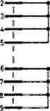
I
I

- GTOUMO 'PLANE
-Lew • ■
I
I
I
iO02 J. era
•47n «4» £7n
-W GAOUNO PLANE
D 0
raoi
>
о
1СЮ2
LSJ73
>
x:
— C1C6 PlOOn
0
cm
ЗЭ0Р "OV
:::o
TfilK
0121 i-------1 LISTEN
0112 i------1 SRO
0111 (=3 LOCAL
0110 I------1 COMPUT1
I IV-.ALlSlT]
I s£.= ■ -вП
V ~ DIOl
CD |  | СЭ ^FilT
Ш1Ш H И !ZD E H
0119
ItbackI s
t—hist! t
1 nullI £.
!°!l
PLAN SHOWING LOCATION OF ANNUNCIATOR LED,
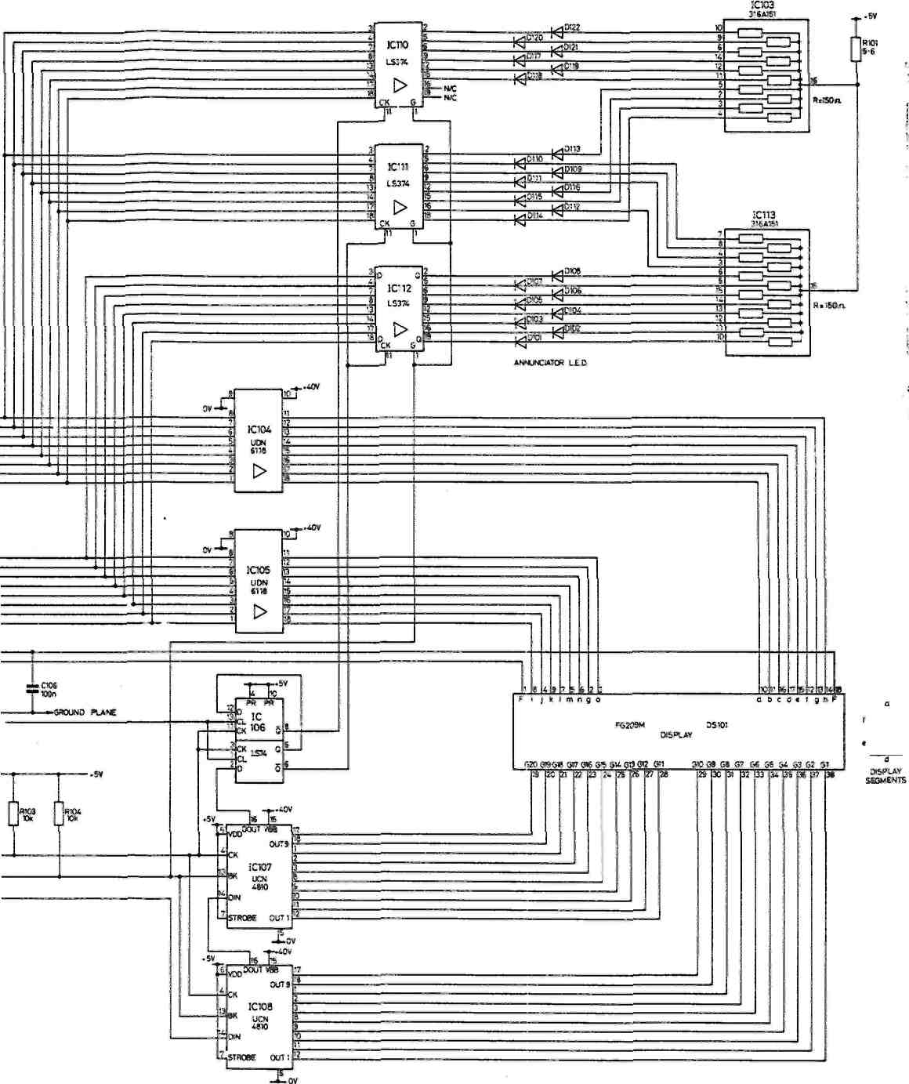
^D | 0119 Dll«  IthackI bwpJ
ШЗ | U-MIStI Ust—1
pa | 1 NUllI NUUCH
D1U OTIS D116
И\к
Г, F1UIMENI SIPPIY ■
/
Display 70817501
I/O CLOCK
Jicoo Ы-

OESi
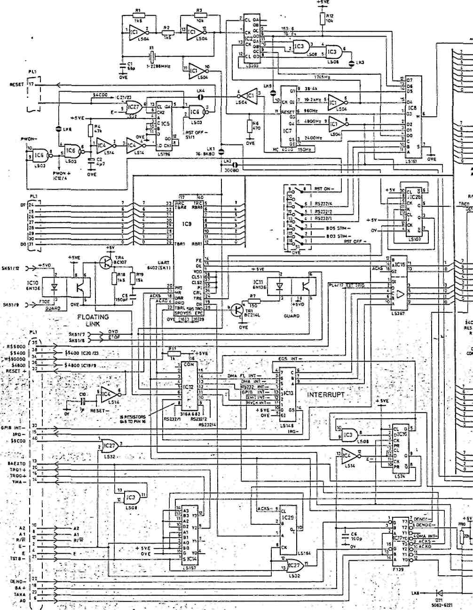
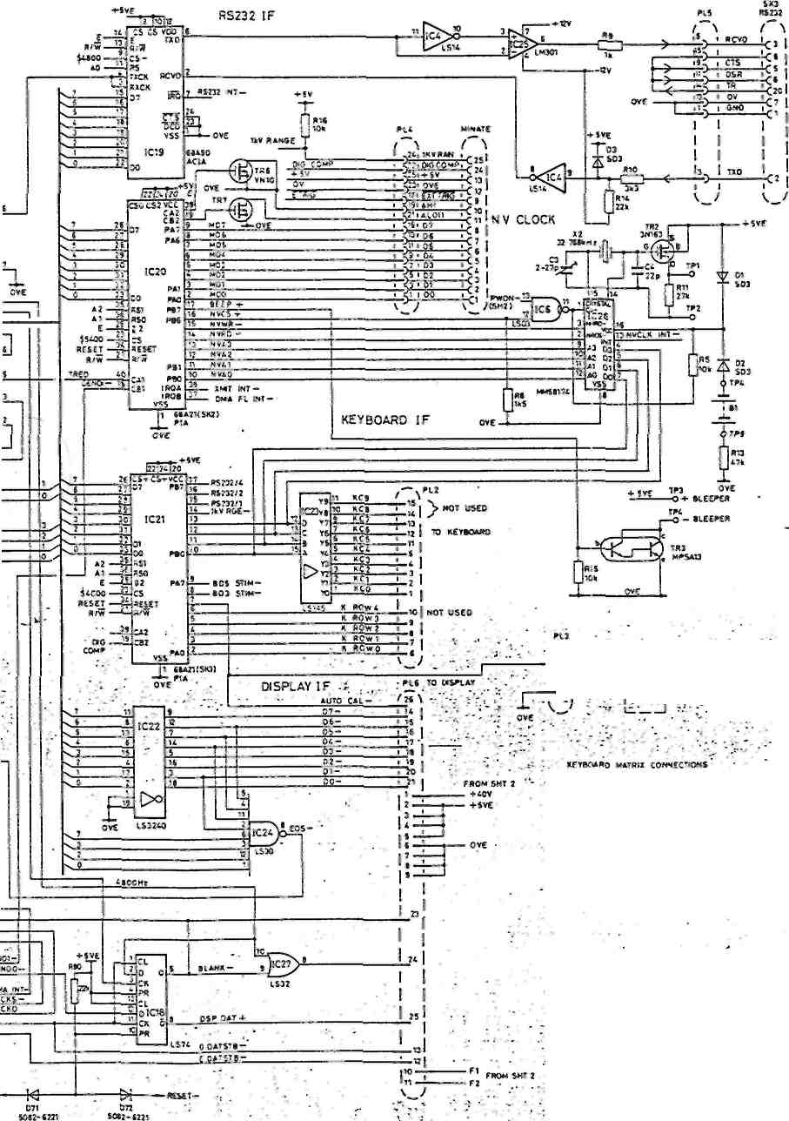

I нотисV kcyswitoi он
О 1<*L :■ X FBOHT F»NCL л..
COLUMN |  | Pi? pin ки>*в£»5 — -
ROW |  | 1 | 2 | Э | a | s | 11 | Q | 0
P L 2  P 1 N  H  • | e | V | RATIO | TRUA | АШО | DIG  тт | NULL OM | WST | SAMPLE
P L 2  P 1 N  H  • | i | Л | л,— | 'V'-iLT | PROO | 5CLF TEST | INIt | MCM | HF
P L 2  P 1 N  H  • | « | v~ | V~ | NF | IMUl | IDCAl | S"0 | HP | NF
P L 2  P 1 N  H  • | 9 | 619 | 5»* | A | »I» | 1Д9 | NULL | HIST | TRAC*
nf«hot fitted
H0ie:-IM.O • * *"E ONLY 8RO"CN FOR TEST PURPOSES . ,
RS232/A | SI | RS232/1 | RS232  UnO С Alt
ON | ON | ON | »o
ON | 3N | OFF | ISO
ON | O/F | ON | 300
ON | OfF | OFF | too
OFF | ON ' | ON | woo
OFF | ON | OFF | 7400
OFF | OFF | ON | teoo
OFF | CFF | OFF | 5600

SOPPl» *OlJS | fU5£ | РАЯТ He. 1
100 V. 1»* | fc00«"* SIC BIO | 360106iCO I
гго*. uov | 200** SLO 8L0 | эммовгво i
COM»ON£NT3
ON
CMS»
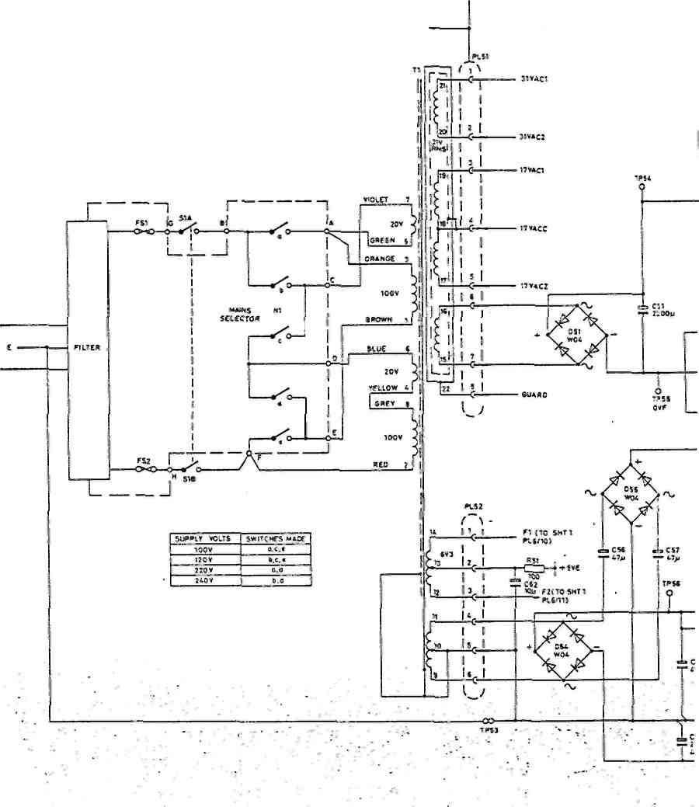

MAINS S€l£CTOR Hi
цедя view
Ult97-1B
2- 0
-9-
1.5 (O I О) Э-0
SOtCCO *'0£ V'€W
!C52
ПС5
5~1~?
Ttr
ТПЯ.54 B01J1
О Ь С .
FLOATING POWER SUPPLY
9*5! TOBO*J)OS
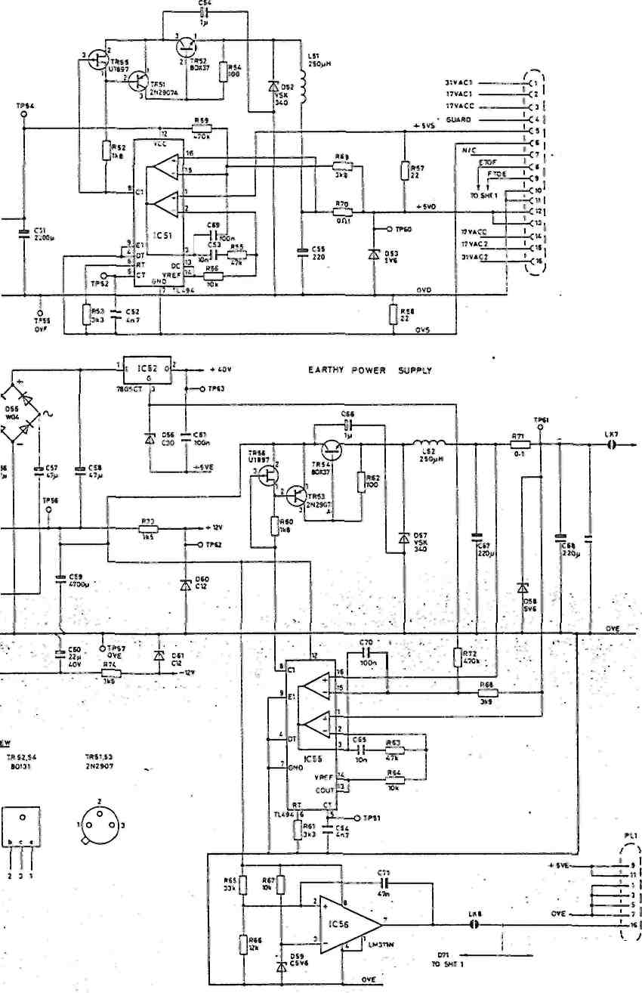
*JY 10 SHI1
C72-C7»
(OSIR<eu1E0) 47«
PW0H-H3SMT1
LKT I I Ofttf BROKEN FOR ItSt Ш9И>5£5
Power Supplies
70817503 Sh.2
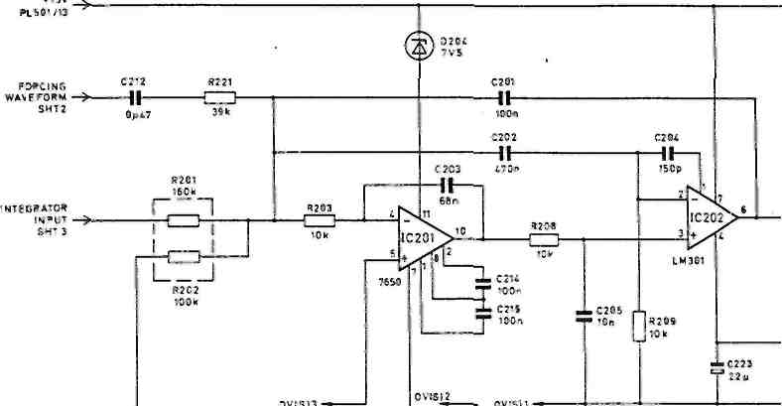
MOV REFERENCE
(21-Э-SHT2
-IOV REFERENCE
12)
SHI 2
PLS0V15 -^
TP20t GLUGS
O20S( 7V5 ^{V}
Г
TR20I VN67AK
TR202 VNS7AK
Г
"1
D-D"
R207I OOk I
IR203 1K1U
TR231 1111(1
REFERENCE SWITCHING
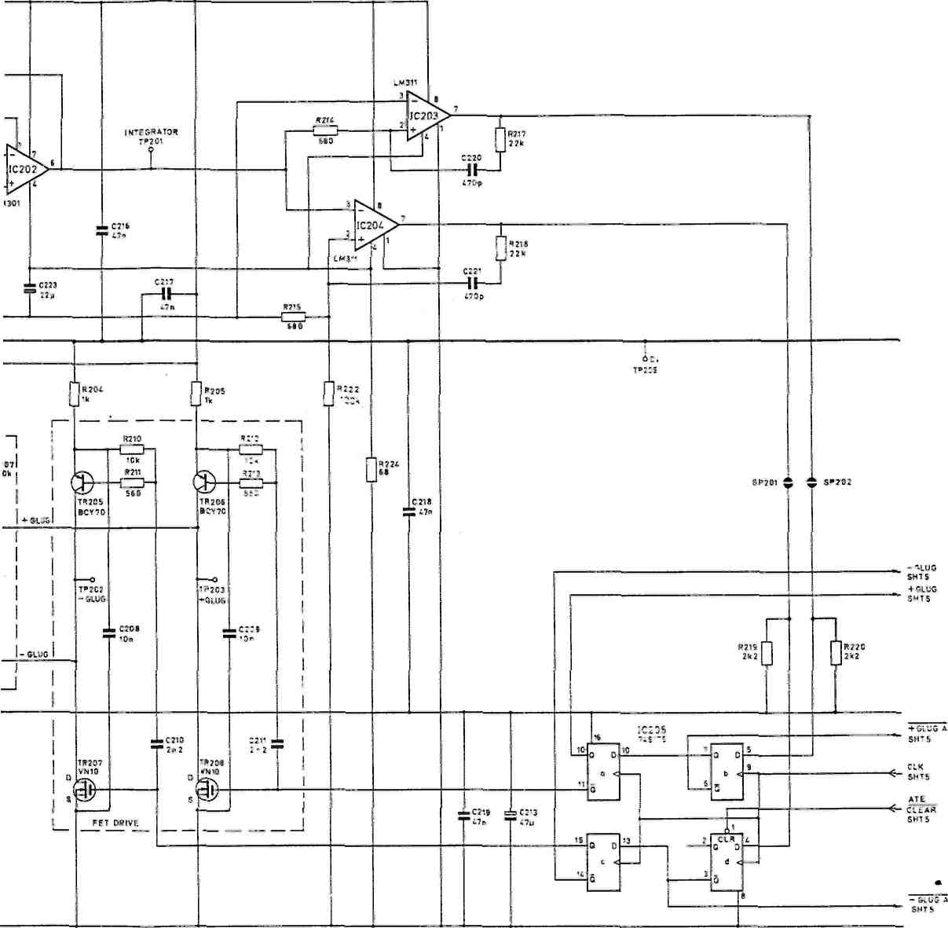
V-to-T Converter (1) 70817505 Sh.l
!
♦ 15V ->
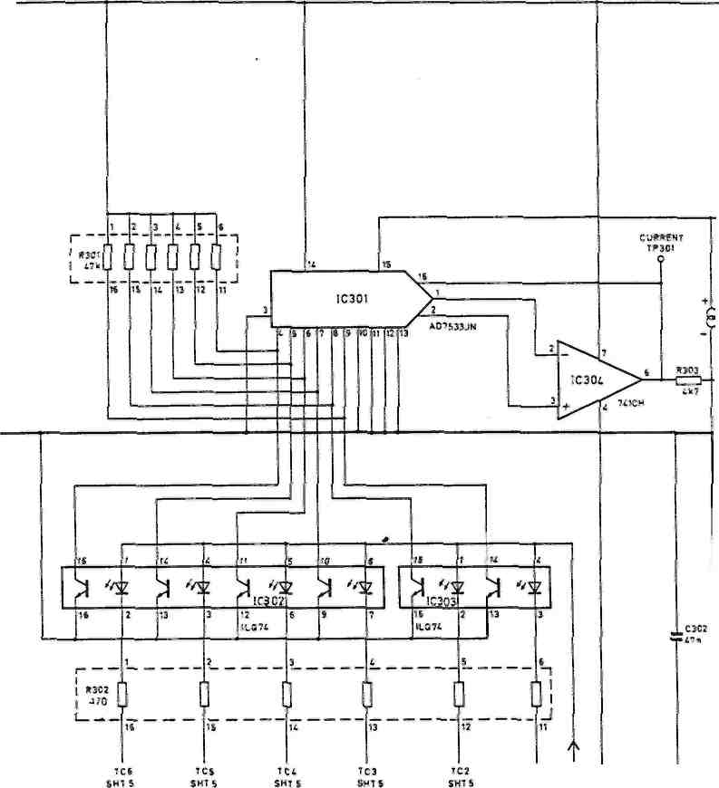
-15V >
IC1 -10V SHTS
♦1CVREFERENCE timS07/2
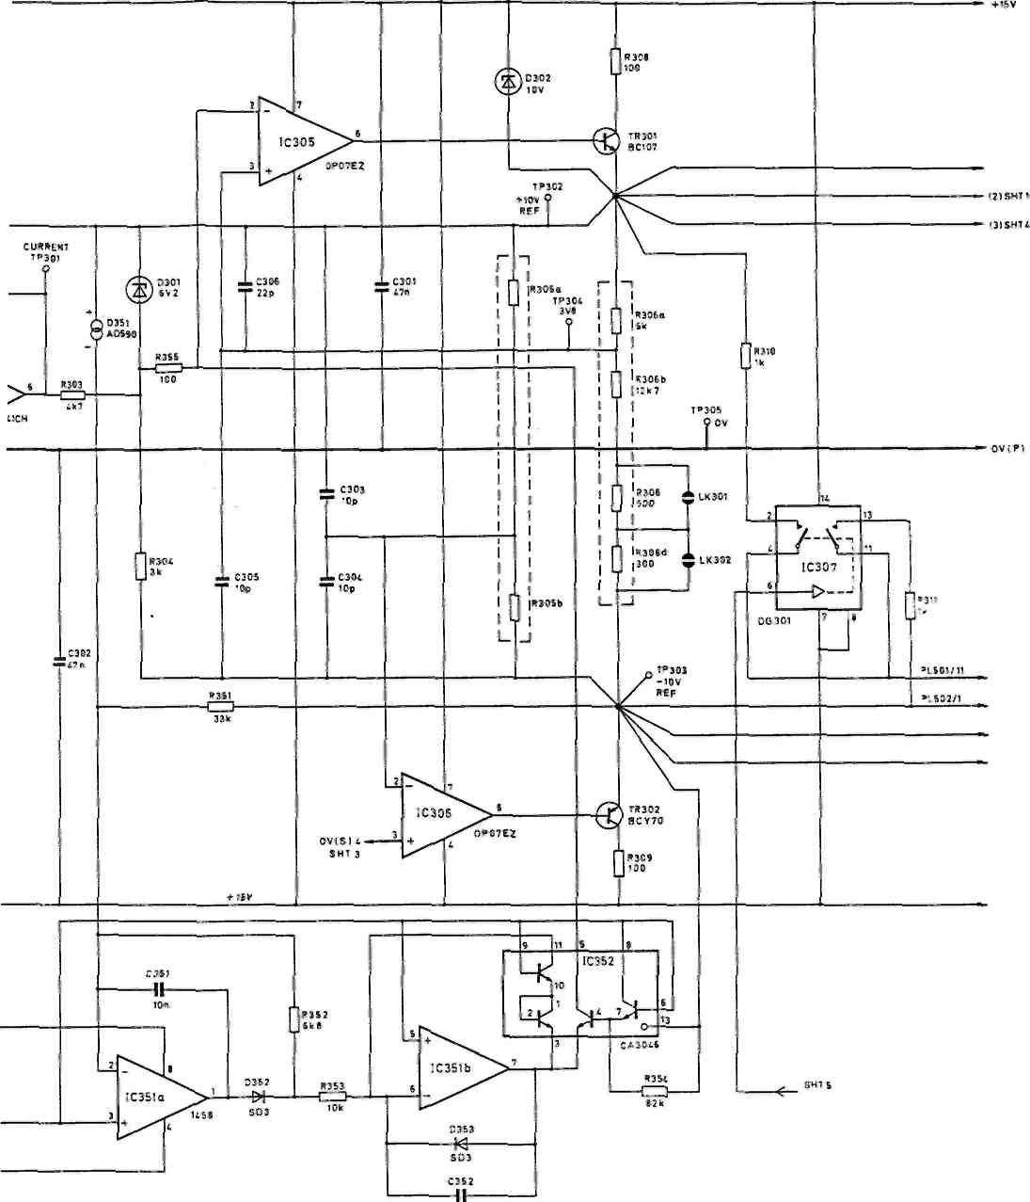
FORCISSWAV=FCR«/ ZPIVE
5HTI FORCING WAVEFORMS (1I-I0V REFERENCE
(JISHT 1
I3JSHT I
Reference (2) 70817505 Sh.2
л 10 I 2 —
I !
v_'
• 2«V —>-
RU
*i----------1-----^_ n lo Shi i
---S*pE
• < л HI SHI. 4
-<— BOOTSTRAP SHI 4
RID I SHI. S
] hi l3'^—
ЙАТ10 LO t 33m
\J
ORS04 101
. . DSO* ( A) 15V
, L \ J isv
i "SO' „ ,. R50l , , RS01
OSOI DPA010
«1

TR518 111699
ф
M-
o*—'s
o,-^s
Vi2/
0502
OPAOIO
№
fc!P 6S0 640
/"г Л 050!
,Zi) 5V6
Qsr
R507
47*
1R5I9 'U1S99
^ .
TRS02 U 235
TR510 U2J5 ^{s}
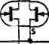
47k
I
OR50I 6.0
5
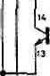
/_{Л} ₇ "'j _{1C}501 110?*
RATIO HI C0NIR01------->-
SHI. 5
«503 4 70
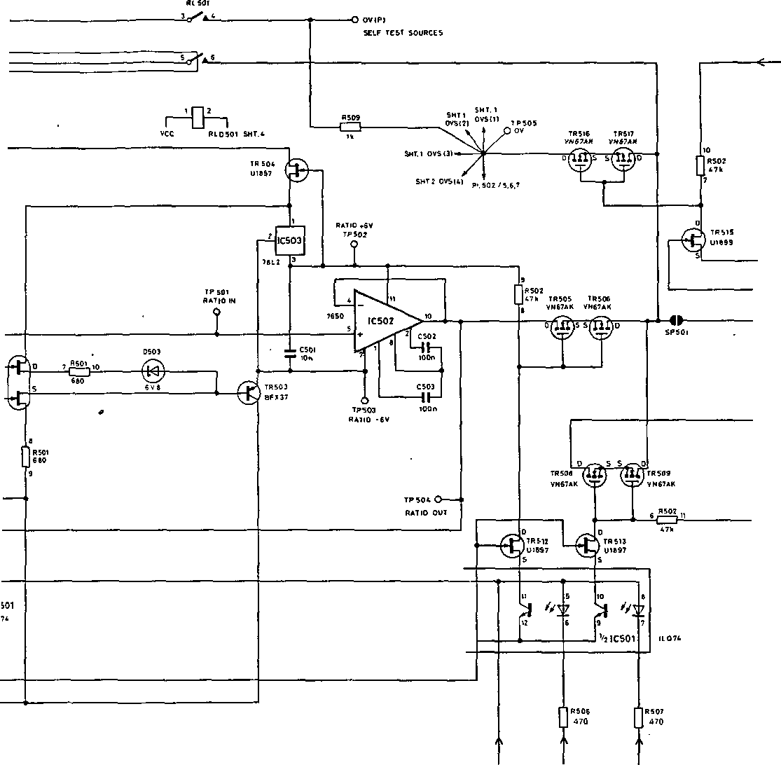
<------ rest zero sht 5
С -isv
^-------- N-EOR4TOR SHI 1
l/P AMP O/P ^------ PL 502/6,9.10
l/P AMP *5V
--£------, 80OTSTRAP
PL 502/)
RATIO CONTROL l/P AMP CONTROL
SHI. 5 SMT.5
Ratio Circuit (3) 70817505 Sh.3
-I5V —>.
-10V REFERENCE (3) ~>
ov <p)->
•OV REFERENCE (3) -=►
SHI 2
-l5V->
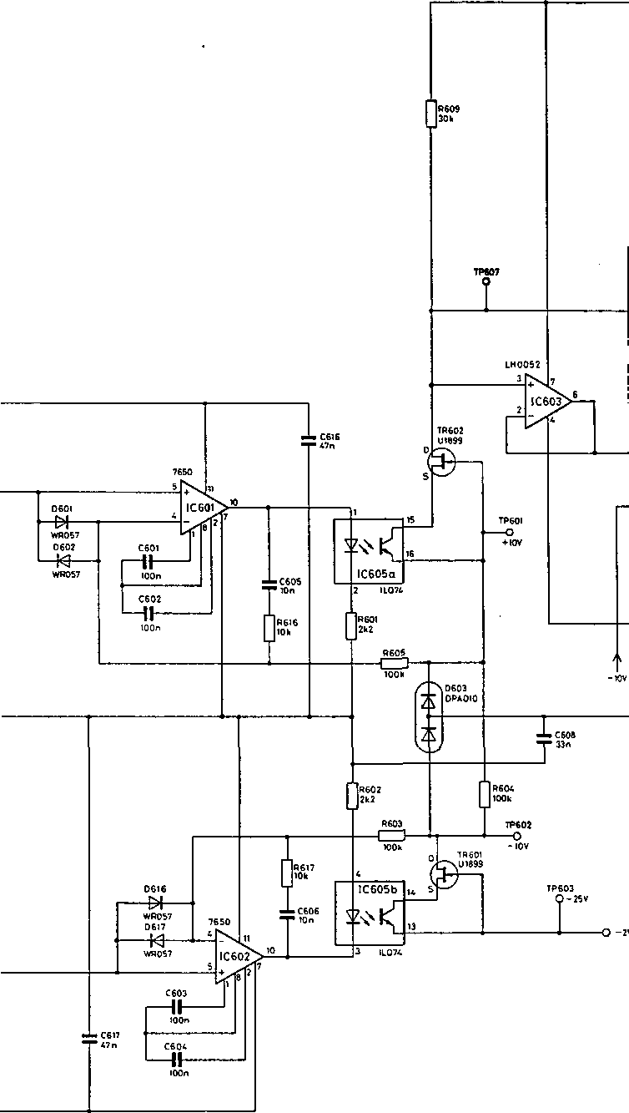
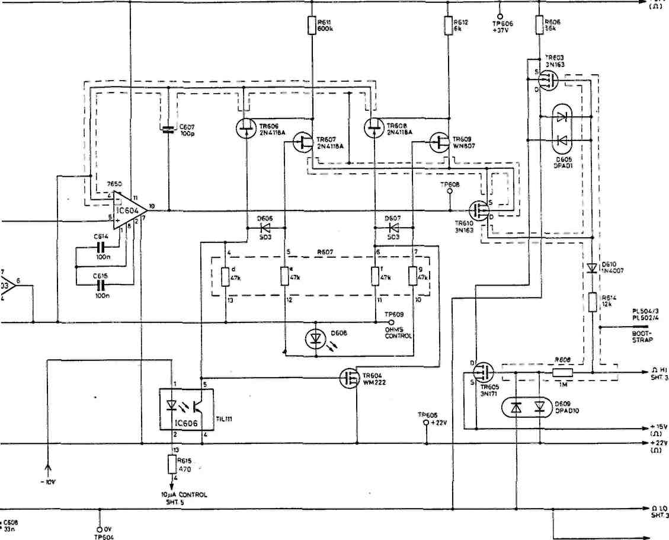
0V(O)
-О -2V<n)
SHT.6 ^
31VAC2 ~
-Й-
9ml 7845
(15mA MAX
IC607
, .. ,0604
iCW9 \1\)ьчг
140SS⁸
1C6IO '47
0612 1Н«0М<т_{т}дмм)
, »Л0613
I ,.\06U
nut
¹ 10n
iC6!2 ' Юп
I
I
.C613
-»■ +37V(I1) -»-+22V<n>
Ohms Circuit (4) 70817505 Sh.4
- iov —f----------------ч i--------vee
iL ceil X сви-6 -L CB16-C
:.ГГГ
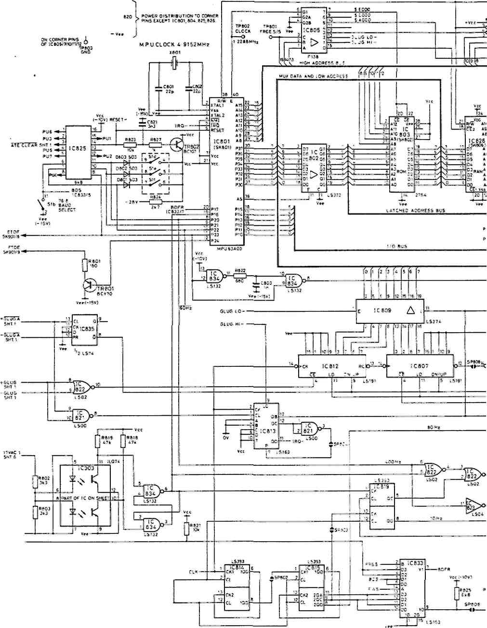
Ov(P)
FR5
Р150П31
SI FACILITIES
BANK | NORMAL SETTING |  | use
S'o | OFF |  | WATCHOOG INHIBIT
S»b | ON |  | ON ,76 8*8 OFF, 3006
s i" | OFF |  | RESET INHieiT
 | 6B01 | 6301 | MP J FUTEO
SM | ON | ON | PORT 20(P»N B)
s w | OFF | ON | PORT 11 (PIN9)
SH | OH | OFF | роят гг (pin ю»
2 SP601 Vm(-ISV)
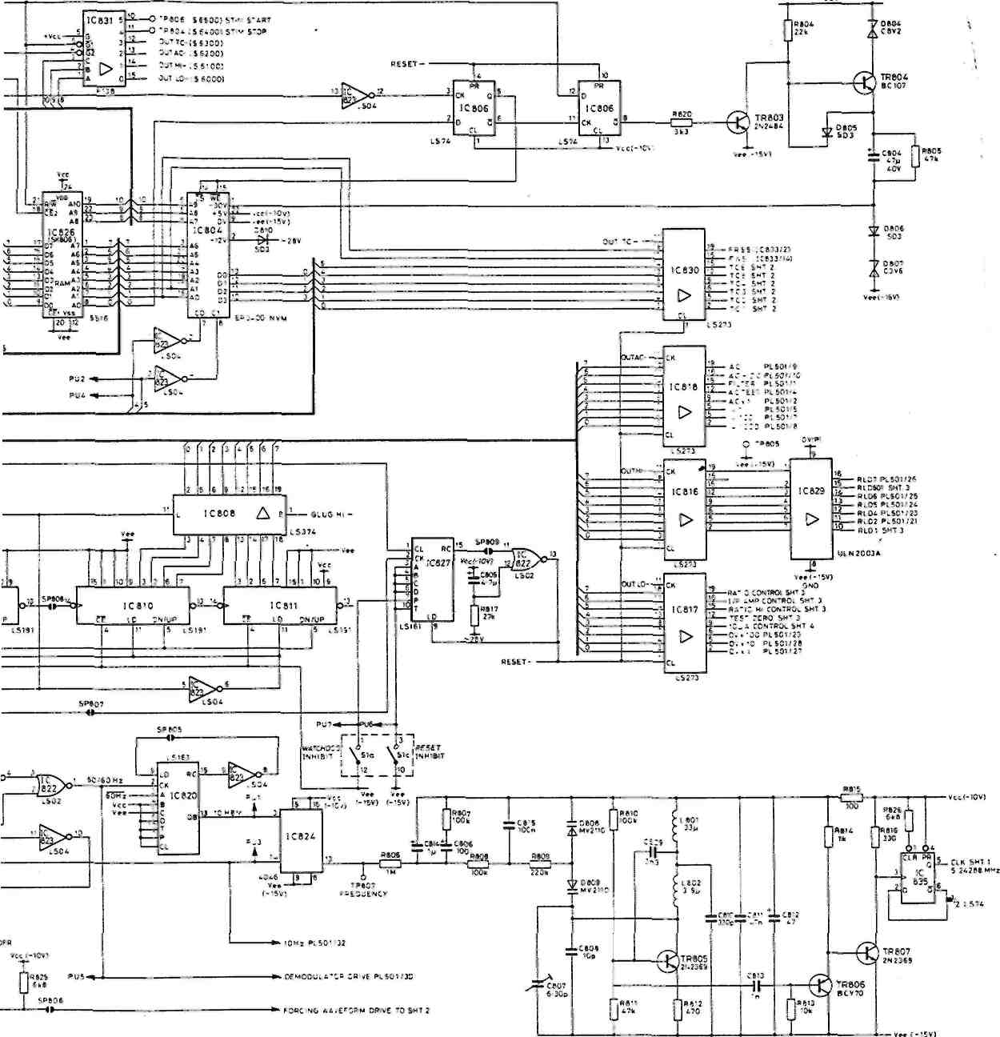
V -T CLOCK 10 i.6576 MHz
ч В SPLIT РД05 0\.- "30HCN FOP TCST PURPOSES
Floating Logic (5) 70817505 Sh.5
31VAC2
•j'S 15
C901 220
- -S902
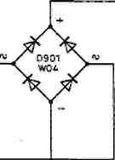
SK901
ETOF
TO I С BOI/11 '
FTOE
10 RBOI'
C902 i 220
"И"
- - 0903 ii IN4004
C904 1000
0905
-M-
:Э06 220
C912 220
-»26V
TP902 + 15V
SP90I
—«I—•■ *2tv
i С 907
ISP902 -----4---------II—+1
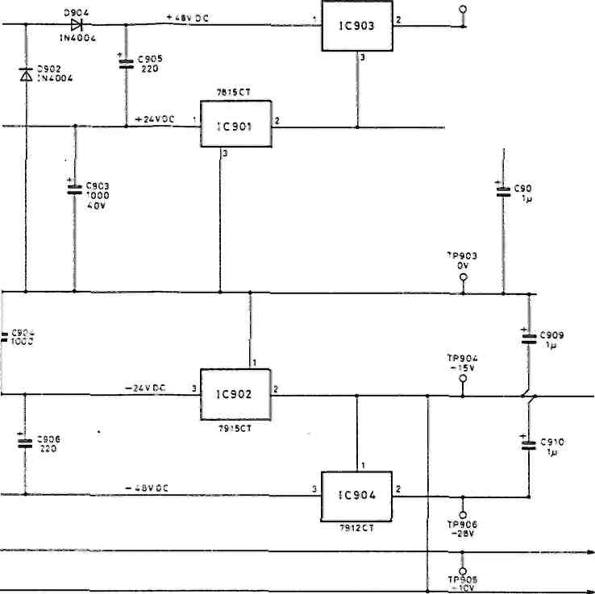
PL501
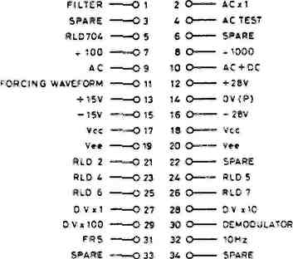
SP903 H»-----»0v(P)
-10VREF
+ 5 BOOTSTRAP
0V(S)
0V(S)
l/P AMPO/P
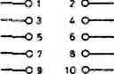
+ 10V REF
BOOTSTRAP
OV(S)
l/P AMP O/P
l/P AMP 0/P
SP904
«»----»-26V
1 1 | 2 | 3
7S: 2 1 GND | IN | Cut
7812 |IHPUT | OUT | o'.D
Vcc(-I0V)
V«(-I5V)
r^
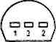
79L-2 BOTTOM VIEW
Floating Power Supply (6) 70817505 Sh.6
'.0 FRONT •
GUARO FRONT •
SHT 3 +I0V . REFERENCE!!)
AC 41 SHT 4
P1601/25 Vcc RIOS
-D-'
RLJ ..
О
■V
L_
SOI
14 00V
RL1
1-°7
0V(0) RL07
PL601I26
RL5
RtS
Vcc RlD5
PL 601/24
CI 22n
= 7 56
, GUARO S*504/l
-GUARO REAR
• FRS P'.501/31 - V»t S>-T 4
О О 0 0 0
Ь 0 О О 0 0 0
SK504 1 |  | О | Сил
2 |  | о | ОН*
3 |  | о | еос
 | A | о | OHh

А С OUTPUT . SHT 5
h
i
3— .
M3 I-------
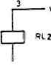
________RLD2
4 PL МП (21 _{RLD1}
vet PL601/23
hi
i_
h
RL05 PI601/24
"1
Г*
'Л foe
■LfrJ.
_!
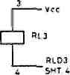
L
'~l
J
r
DC HI SHT 3. BOOTSTRAP SHT. 3
FRONT INPUT SOCKET /РЕАЯ SOCKET CONNEC*INS (EXTERNAL VIEW)
OHMS LO LO
-OVISIIO SHT Э.
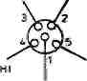
OHMS HI GUARD
OOO OOO OOO
Ь d f
OOO OOO OOO
GUARD OHMS LO BOOTSTRAP OHMS HI
OHMS Ml FRQNT
OHMS LO FRONT
r^:
OHMS HI SKS04/4
OHMS HI REAR
OHMS LO SK504/2 OHMS LO REAR
FUNCTION | RELAYS ON
AC | »L3
•IV IV. 10V D C. | RLS
100V, 1000V. 0 С | «11 RL6
CONDUCTANCE | Rl2 RLS RL6
10V TEST | RL2 RL4
OHMS | RL5 RL1
RL7 CLOSED WHILE PL5 OPENS OR CLOSES
Attenuator (1)
70817506 Sh.l
-I5V Pl«0VI3⁴
^{L0}*
SMT3
ч '0*01 : "Oioe
FQ
IP402
33«
IC401 o.b .
«■
*€
TR401
2___. wo&oi
G
0'
R&05
151
IC'OI PIN 5
сллез
SHI 3
Cut
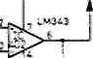
0
CO' ¹ ЗпЗ
ЕЯ

иЮЗЯ⁰
IR4I2 2NS905
«■
0106 15b
•CtOi ■ 22n
0ЕМО0Ш.АТОЯ O/P
ТР40Э
О
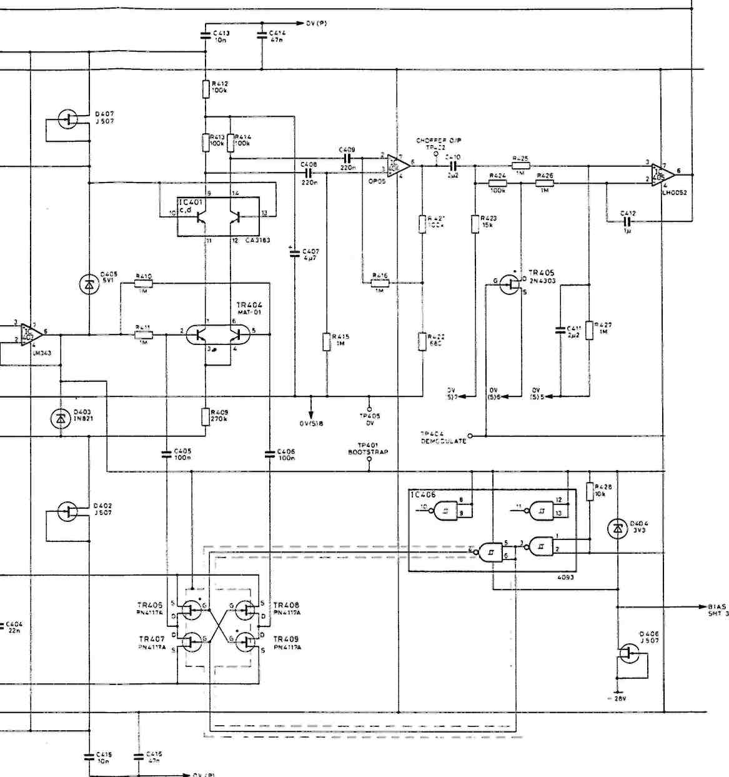
«-DEMODULATOR
BOOTSTRAP SHT.3.
«-MODULATOR SHT 3.
Input Amplifier (2) 70817506 Sh.2
f \
RATIO HI |3t-
RatiO LO 33-+ 2Bv|l2 -
L.
OCMI ^
SHIl *~
VIE* FBOM REAR INSTRUMENT
PATIO S"T

£
V -
1^
\1
•ic.
"3,
°\ AUXILIARY SKT
4<-
v у
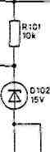
2k
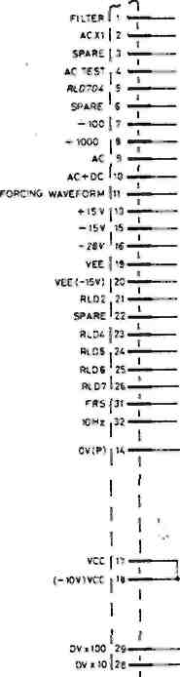
T
с юз
ЮООр
I \ DIOI 0РД01
ft
гЬ0Ю9 4-JLWB057 A
0110
WR057
140?™
D
R103 10«
OV.l ,17-OEMODULATOR 30-
V J
BOOTSTRAP QTP104
R110 f! й -.С7
U"^{k}
ТРЮ1
Oh:
W тршз
R105
-4=>^
-czH^
тем

♦зг
M
OOmV CONTROL
10V CONTROL
DEMODULATOR ORIVE
IIP AMP
«5 BOOTSTRAP
+ 10V REFERENCE (I)
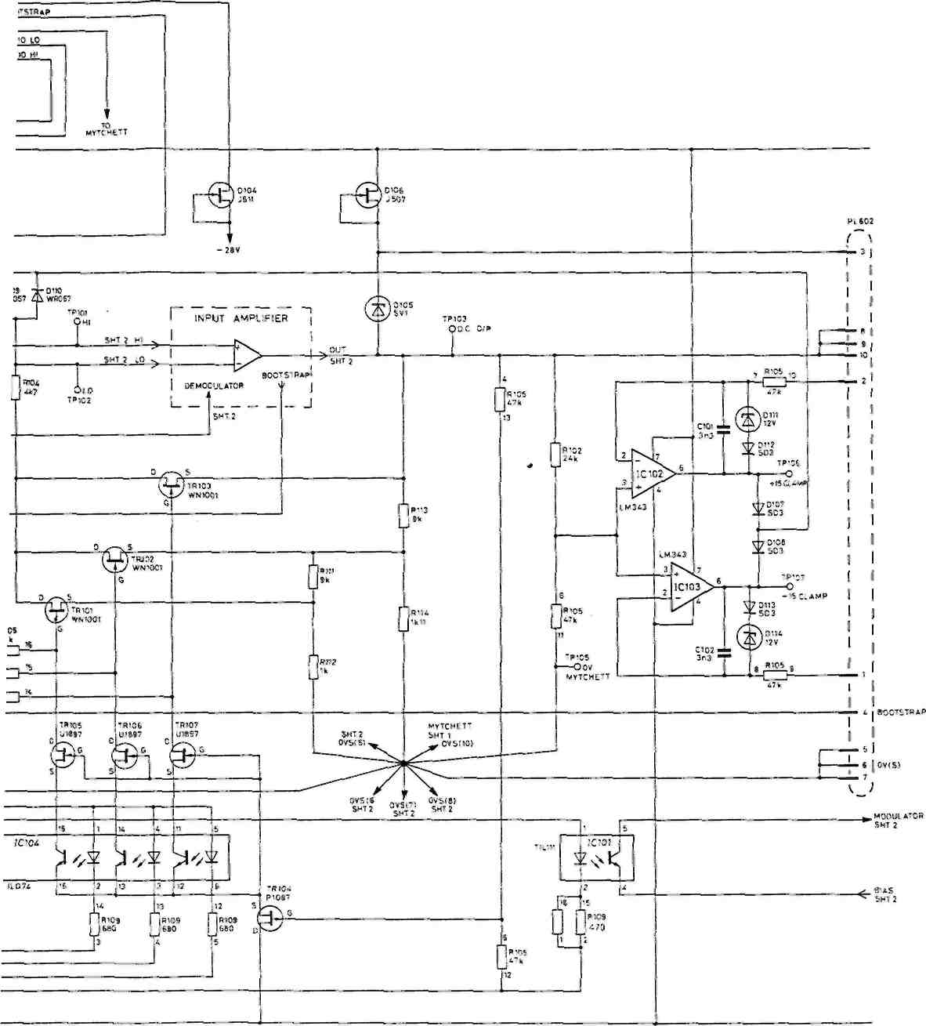
-10V REFERENCE
DC Ranging (3) 70817506 Sh.3
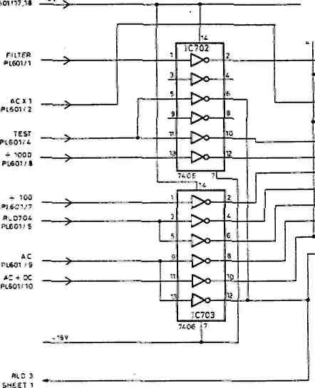
Р1601719,20
ДСН1 SHEET 1
FORCING
WAVEFORM
PL601M1
^RLTOI -*⁴©------
С 701
C720
iAA.AA.Ai
|R7tl R722 1M I in
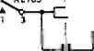
0
И1СЗ 990 k
RL705
COTO
CR-4002-5-1011
^
22M
*-*■
0709
-CD-
I
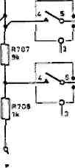
BL70« COIO CR-100Z-S-1011
•■' H170J
GENTECH ИО A-« 831C-S
IB710 •*• C70»
Jsh т ion
*' T'
I-

0712 IN3E9:
"7Г
0713
IN35S5
Ф&7' fc:

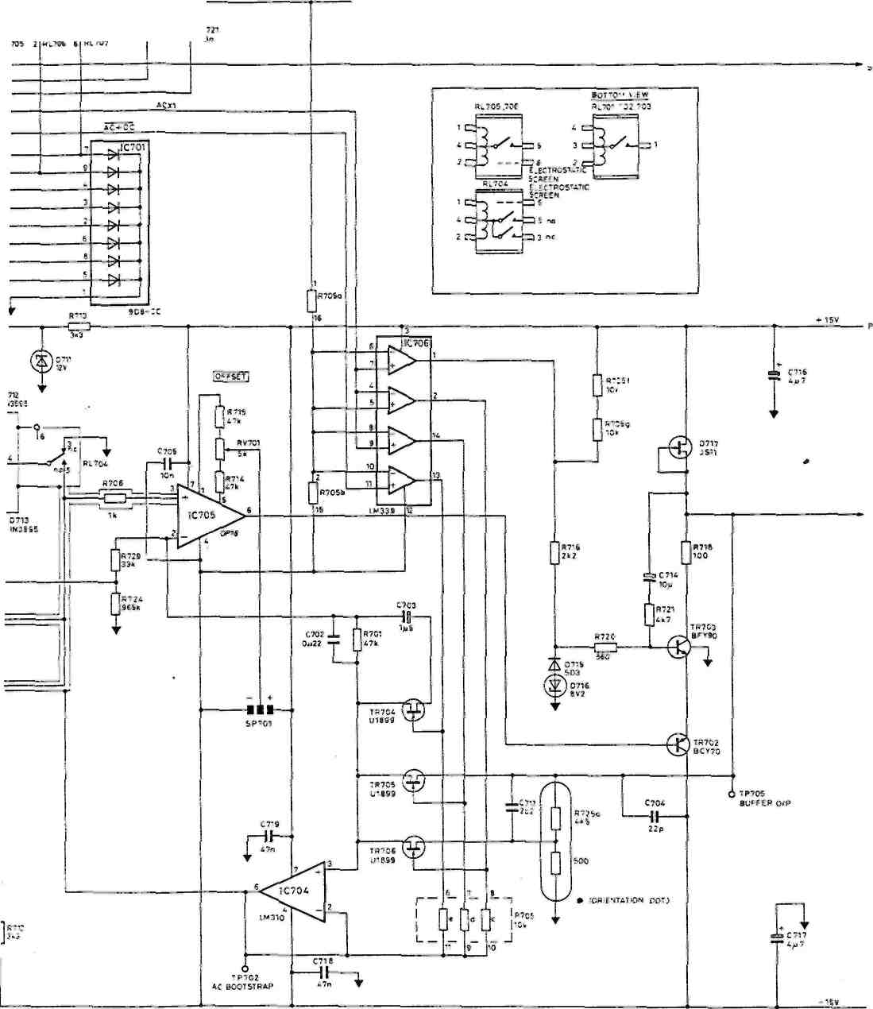
P>;?ER DRIVE
Sf.'S 04IVE S*-£iT 5
AC Attenuator and Buffer (4) 70817506 Sh.4
RMS DRIVE -
SMT t ■^
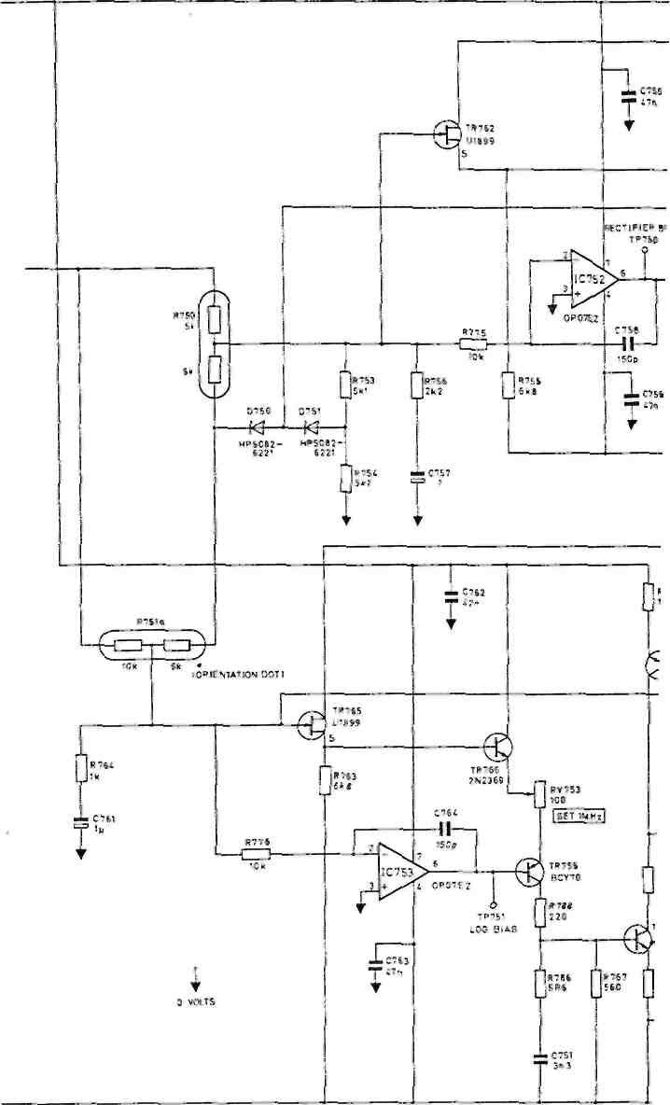
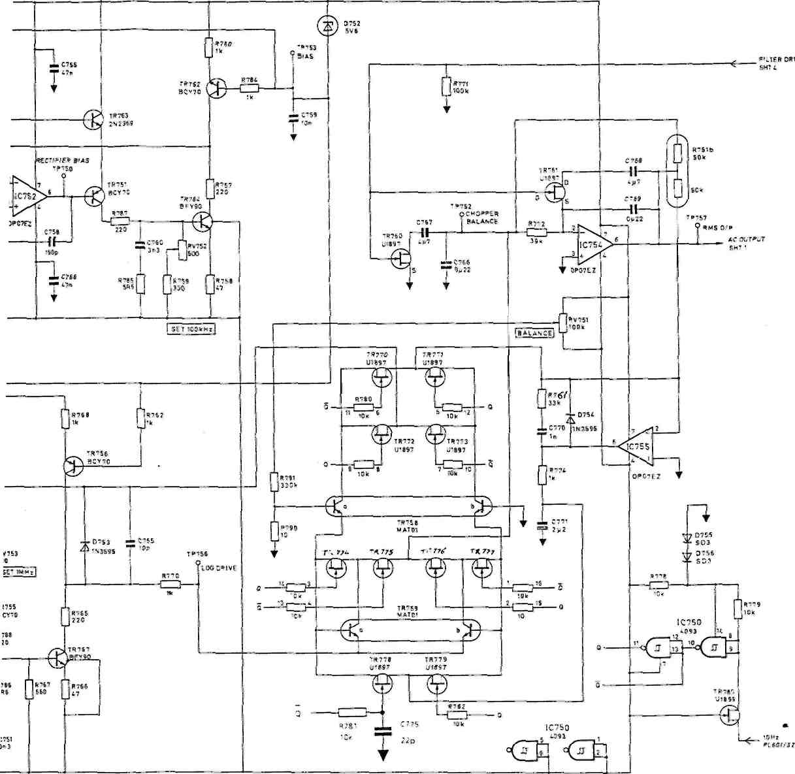
AC RMS Converter (5) 70817506 Sh.5
RA
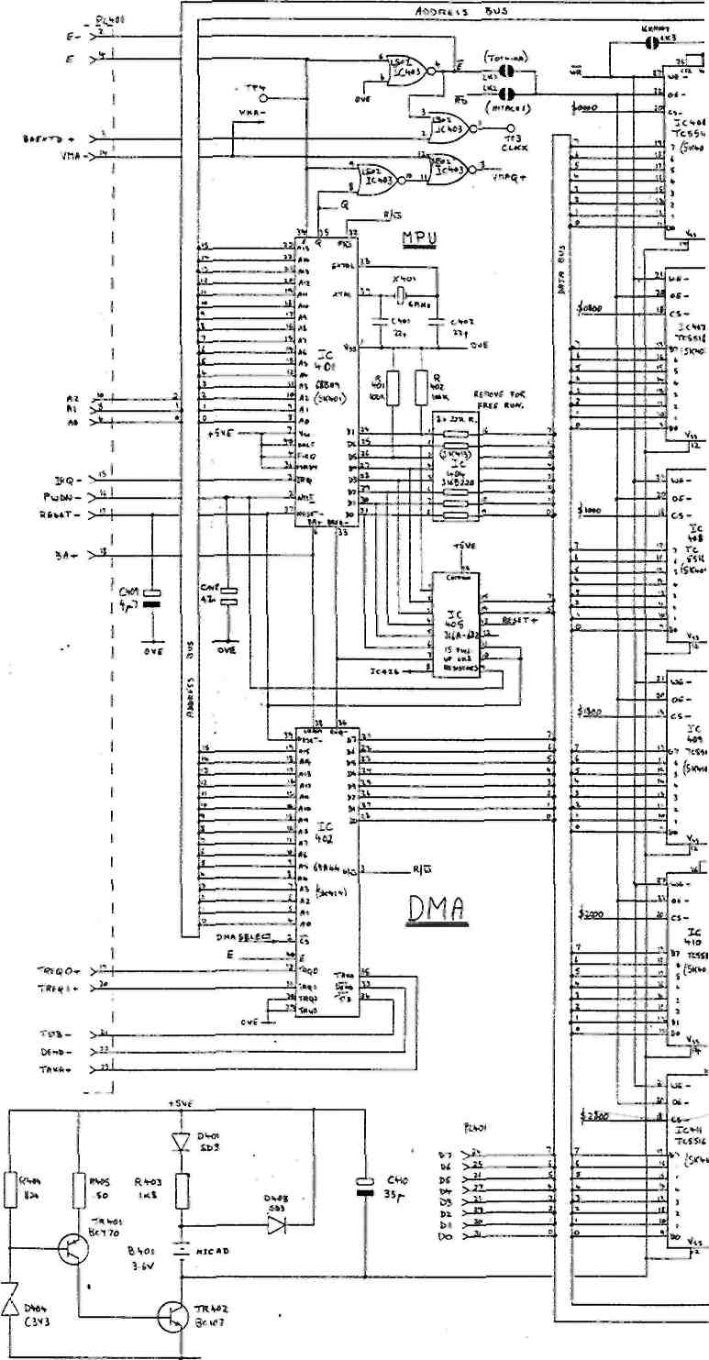
6VlT
ниев
ниев | i | -
TtSJUP | •
ни (1U? |  | --

RAM
If  1—f—**^{v(}  »гуг , |  |  |  | '
L— |  | ** JU | 1Д
 |  |  | l*—
 |  |  | 1*
 |  |  | 1
 |  |  | 1--------
— |  | i(S^«i) * | *
 | ' | t | I
 | 1 | : | T | )
 | 1 | : | L_ | I
 | . .J | ■ | 1
 | . ' ч | : « |  | '
 | " | : «
 |  | * *,
 |  | •i | vfi
 |  | # | vfi
 | _{r} ,i' |  | «1, .
 | . —*- | * | 4.*
 | 11
 | , «
 | , « |  | »
 | , « |  | ь-
 | ____и, | * t | s_.
 | * | * t | ь
 | - h | fc 1 | T
 |  | fc 1 | \ | Q
 |  |  |  | *
 |  | "v., |  | *
 |  | 1 a | *C | *
 | __Н | **~ ** | И | *
 | К | **~ ** | И | *
 | К | AC. * | J?.._
 | it |  | H
 | it |  | J-.,..
 | <i |  | J-.,..
 | <i |  | 1
 | <i | »^{r}<- i | *
 | V | »^{r}<- i | *
 | V | i Я» | *
 |  |  | *
 | n |  | *
 | n |  | J
 | . ч |  | J
 | . ч |  | 1___
 | -
 |  | * V.»
 |  | 1" | VF
 | i |  | «v
 | I» |  | «v
 | •> |  | «v
 | •> |  | » | ч
 | " | TC » | *\
 | " | TC » | ,
 | " | TC » | j
 |  | S *  ft 1 | 1
 | к | S *  ft 1 | V
 | к | S *  ft 1 | 1_
 | __a | S *  ft 1 | l
 |  | S *  ft 1 | J
 |  | S *  ft 1 | Д
 | * | S *  ft 1 |  | ;
 |  | - v„ |  | ;
 |  | is | Г« | ;
 |  | «ГТ7 | Г« | ;
 | T> | •■• z  es- ч  1С »  me »  *> Ttttll i  * ! J * a i li АО | * | ;
 | w | •■• z  es- ч  1С »  me »  *> Ttttll i  * ! J * a i li АО | !• 4
 | w | •■• z  es- ч  1С »  me »  *> Ttttll i  * ! J * a i li АО | J» «
 | I'- | •■• z  es- ч  1С »  me »  *> Ttttll i  * ! J * a i li АО | 1< *
 | I'- | •■• z  es- ч  1С »  me »  *> Ttttll i  * ! J * a i li АО | 3 1
 | I'- | •■• z  es- ч  1С »  me »  *> Ttttll i  * ! J * a i li АО | \ .
 | ll | •■• z  es- ч  1С »  me »  *> Ttttll i  * ! J * a i li АО | S 3
 |  | •■• z  es- ч  1С »  me »  *> Ttttll i  * ! J * a i li АО | I
 | и | •■• z  es- ч  1С »  me »  *> Ttttll i  * ! J * a i li АО | 7 1
 | __b. | •■• z  es- ч  1С »  me »  *> Ttttll i  * ! J * a i li АО | 1 I
 |  | •■• z  es- ч  1С »  me »  *> Ttttll i  * ! J * a i li АО | 1 1
 | ,. | •■• z  es- ч  1С »  me »  *> Ttttll i  * ! J * a i li АО
 | ■ „ | •■• z  es- ч  1С »  me »  *> Ttttll i  * ! J * a i li АО
 |  | I* | *
 | a> |  | ■ 4 ■
oc-
1
 |  | oc-  1 | 11 I
 | fl | oc-  1
 | fl | oc-  1 | 1 " ->
 | g | Xcv<i i | _{v} j
 | g | Ti«ii ,
 |  | *! в*ч; | * 1
 | ,, |  | ( 1
 | к | » я» | T 1
 | ..'* | » я» | I e
 | _u | » я»
 | _a | » я»
 |  | ^{w} *.
 |  | f*
ЬЛТП »**
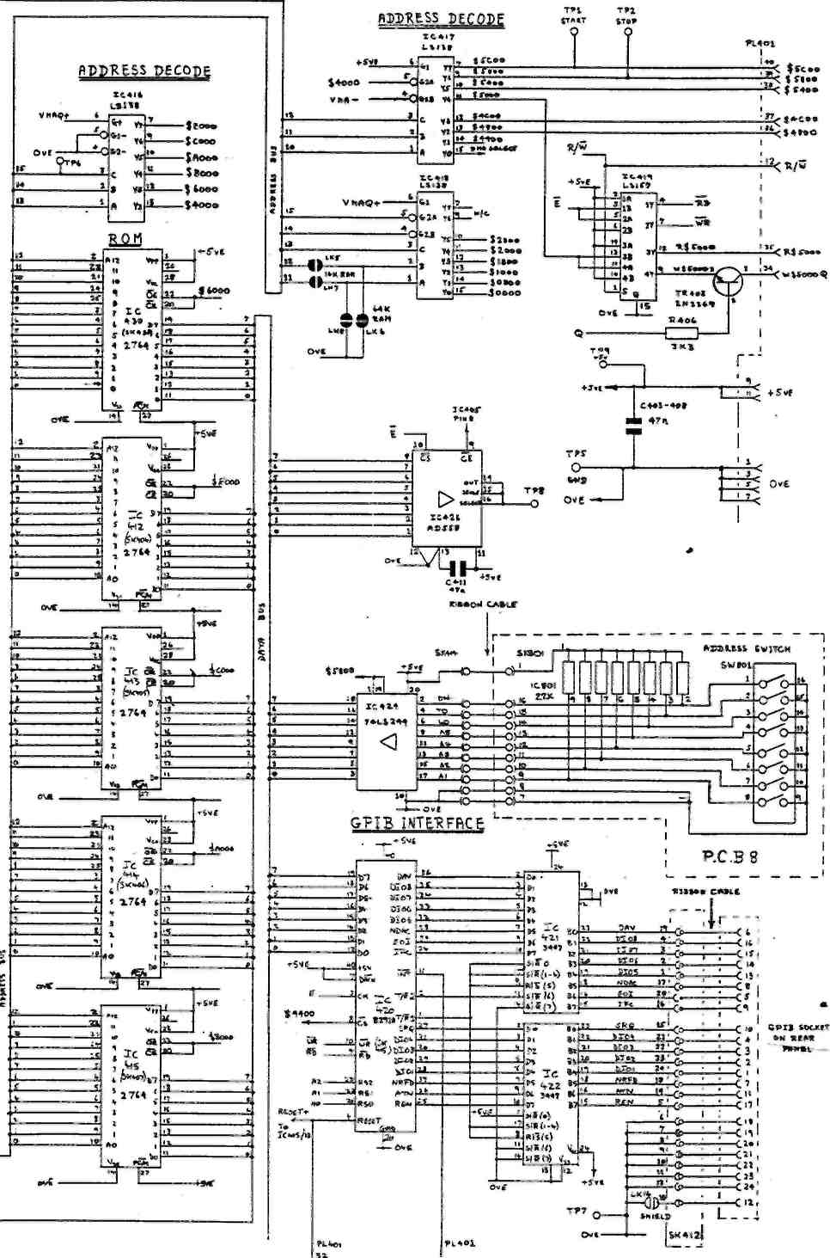
Л RC- И Т »-
n |  |  | SPLIT PBDS
-» | I | 1 | s | * | 4" | ( | 7 | t
IP | • |  | • |  | • |  | •
IT |  | • | • |  | • |  | •
4« |  | • |  | у |  | • |  | •
Л ini ivrefcAurr
S/c LK 14 TO t»«TH SHIED.
Earthy Processor
7ПЙП^1 4/7ПЙ175ПЯ
CI05
fc-
MOS-AVOID STATIC |  |  |  |  |  | DSI0I
MOS-AVOID STATIC | С | ) ) |  |  | ( |  | -—* | )
 | 0101  о | 0102  О  SOL'STROH | | 0103 _{СЮ4}  о -, |  | 0104 CI0S  О PLI0I О |  |  | DIOE  О | 0107  ICII3 О
 |  | 0102  О  SOL'STROH | | 51  О |  |  |  |  | DIOE  О
 |  |  |  |  |  | м |  | + | ~|
MOS-AVOID STATIC
ТРЗ
"°ГР4
»- 0^{TR3}
IC56
3i€
SOLARTRON
гЧТ),
II
708Ю503Х ^{s}*
IIS
PL6 i г
C72
о ел
г >
ICI8
€
IC22
•ЕЛ
. J
ICI7
25 2S
PL2
i
IC2I
Г
IC23
PL3
■Е
IC27
о,зз,
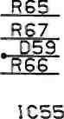
TR54TR56TR53 L52
pOQ
О)
'го 3Ji
(Л
Р57 °'
,С66
С67
IC29
€
₀С65 —
00 I
III
С73
IC24
_{тр5|}Св4«
С74
о
(Л со
R7I
TP6I
R68
С68
о
(Л СП
я|
IC3
+ | 1
 | ICI
+
 | ICI4
-"
С
IC4
IC5
IC6
SK3
LKS
0ОШ1С25
я In 31||2 -Mro Ms.
2 Г" I U
LX7
ГО
-п|0
^{л} <Л
М'о.
IC2
С75
из
Г)
СП
-I С
ГО L—
¹⁰ ел
S
IC7
-ЕГ
XI
IC8
■ЕЛ
ICI3
■EZ
о
Ч m
гп я *
ICI9
SK4
-о
m
с ^{z} о
33 -n Z
■0о^{г} О зз Ч (Л
m PLI (л
§8"
С4 "Ч -
X?
___40_ ^{1Ив} ___ р
R5 с ----------- Я
0107
I CI 13 °
СЮв СЮ7
яюг в юз
оюа О
708I050IY^
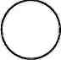
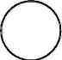
0120  О  9? С102 | ICI02 | DIM  ° icioi o. | 03  _J
0120  О  9? С102 | + | ^{I}" ri
О¹² 1С 107 1С 105 |  | С I  ICIM  ICI04 J^_  l+ I
Dili Т Т |  | С I  ICIM  ICI04 J^_  l+ I
U  0122 ОНО ICI08 ICII2  °+------1°*----- |  | DII7  О  ICIIO |  | I03
 |  | l+ |  | l_>
0109 oil  ° RI0I° | &** | О О oiis | +
0109 oil  ° RI0I° | * | "I
 | Component Location: Pcb 1
L52
—• °l <">
Ul (Л
8
TJ ISJ
IC52
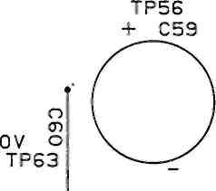
C58
TP57
/--ND54 [Г)
— +W21 is
C56 ( V^{м} C62 2S'
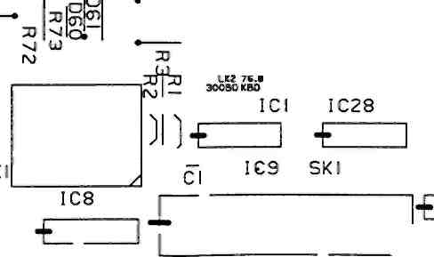
A
m о» о __ •»
wails
-n^{K} ^{ь} — м j. n -n
CI3
EI
C76
Component Location: Pcb 3
PL5I
SO
TP54
^___ + i3J
^{5T}*V^ X |сл
TR55 "Щ52
О
i €
•E
4бо^о"⁺ -f Ydtt¹
CI9
I C 12
IC20
ICI5
D€
C4 TR2
4 - X2/^S
SK2

CD
3D
x; i2i
CO r-
ТЯв TR7
TPI
327C«HZ
TP2
IC2S О
—г ^{г}^ R5 o_{H}
D2
-di с С ^{ov}- ^-³
"0
r
о о
35
о
RI6
TP55⁴--------<
0V F
L5I
R56
* C55
R70
о о
о
IC5I
ел
€
SK5I
^{С53} - .я * ТР52 Ц
I ^ (Л
25 2S 25 2С
О 33
ТР60
D ггО.
g TPS08 DSOS
IC604 ««"«-1С60Э ^{т}™ т>воГ-,о» г-
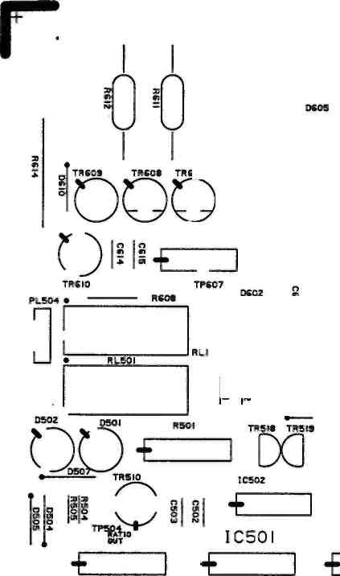
ТИ60Э1 ) Ij
QO
0БО8 ^_^ _
*^{H}-E
R 353
*P606. "[)607 IS о
0353* СЗЫ ^U
— iceoe -о « . Я
TR602 TR60I D603 TR604 ■
5CfY|*P;:
D -EZZ
Si I, L-J»-
0
■E
nj,
Щ
€1
IC302 ^{wa}- «» -
СЭ52 R3S4
R30I
ГСЭ02
____R603
RS05
€
__, si-i
if 1 I --------j |ч сбое сел
Ч_х icsoi oeie4^_y
n In X л lff> ^ 5 ю L.
TP3043V» 5 -БОС CGI7 СЭОв C30S
С 301
— R30C R30S
одоэ -л, «вэ_ !свог
TRS03S
IC305 о
^{v}-f-^TR504V я ТР505 ТР302-™. „
>liQl⁵Qi|Q2
т-n
сэоэ своз
R822
1СЭ06
Нв1? 1СЭ0
[С8Э
СЭОв I ^
О II
to
-J p.
ratio
ТР502 ТР50 Й»ТЮ
ГР 503 ^{lcs03}
пай -«у _{1вв|}
35 UOOI
ГЭ01
0V 1СЭ04
TP_30S R3ll
«эовсшог _{СЭ04} ' сэог '--------'
R30«0
R304 R3I0 " R3SI
Ofet
R502 TR5IS _{R503} R5Q6
r\ ---------- R507
OQ
TR5IS TR505
C2I4 C2I5
m
^{s}i
■ lii|€
'-E
Я
2 S
204 IC307
]|1
IC202 C223 >сгоэ ТР205 __{S2!}s _
'*— TWOI R2I4
3 UTORATOR SP201,,., "S?
3 — cue — C2is 22П- ~»,
Г- «U Jilt.
¹ R'io нгго
C220 C22I
TR203 _{R2M} -—у _,•
\^S R205 R2I2 _{IC2}
s .
ICE
TP204
OLUOS
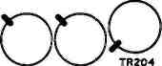
C2II
TR202 TR20!
C203 ^{ТВ}Д25, ^-,TR20e
708I0505Y \Й\
V
PL502
'ТР20Э -•0LU0_{CJ17}
|M0S-AVOID STATICl
MOS DEVICES USED ON THIS BOARD
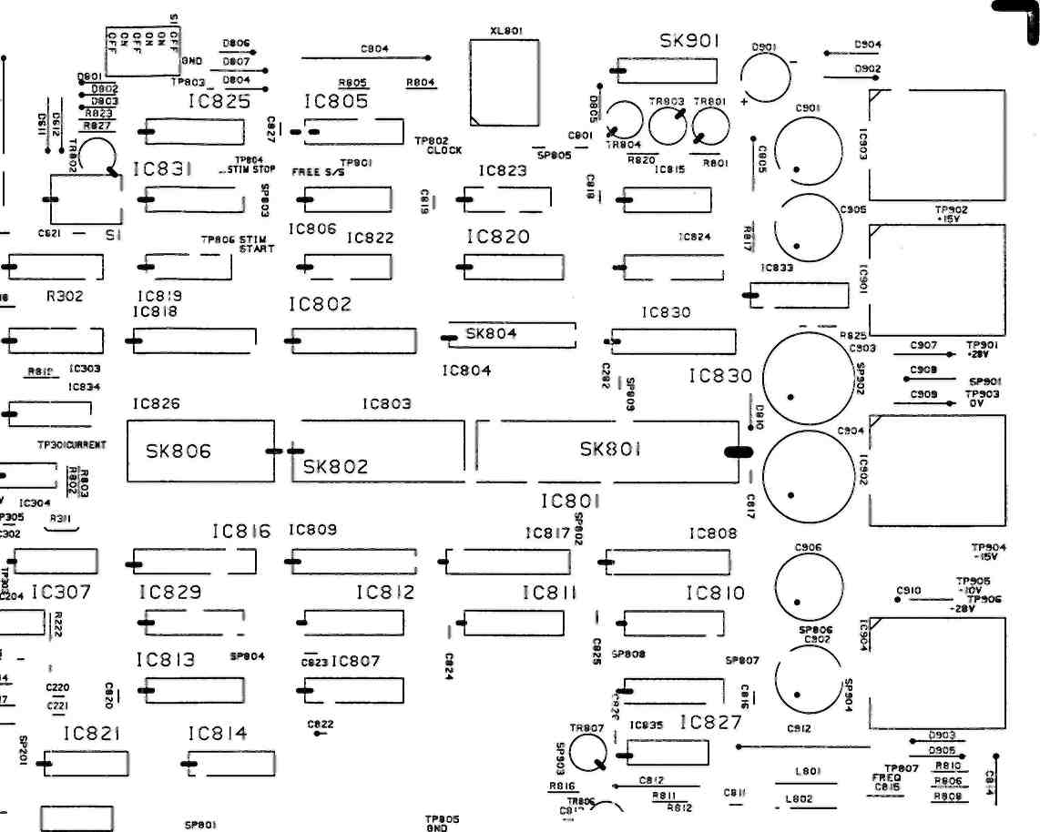
и
PL50I
V
si-*do 2? ?ф
______ ________ TR«05 C80B
~2 ^П
^{R803} R807
С80Б
J
70819505 -H NOTATION
Component Location: Pcb 5
C70I
RL70I
- | -
-
R703
708I0506A И / jJU| \
RL702
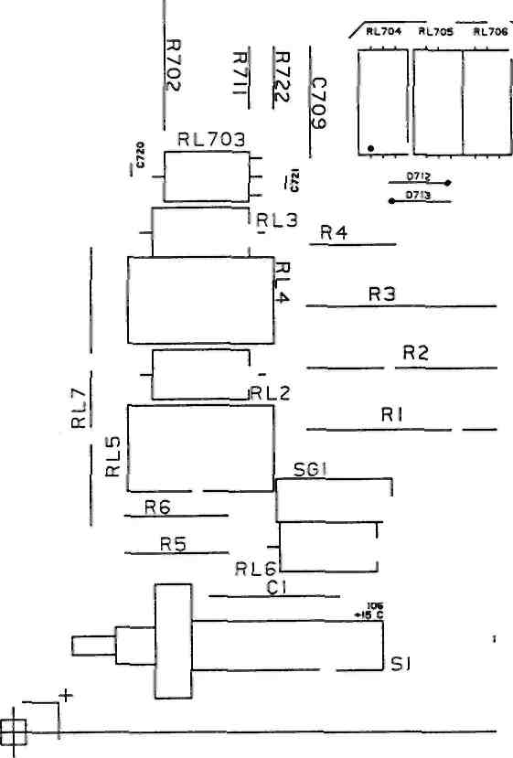

а ы ю
С7С
olul
Sac bootstrap Ut
о HL707 TP702^{b}
>
HI
TPIOI
О
is
DIO
Г
40в|"
I^{s} Di
о ~
_TR40/|
Я71г О
IC102 ICI03
TP4C
0EU0DO
Г^-. II ^_ I TRIOS TRIOS TRI04
cim— сюг-7^ '07VJ VJ L_X
CIM—CIM , j.,₅
•иг. _{t}_sMl^{LAUW} _ ^Ж— _{n9}W2- bootsth
TP /—\ 0107 "■"•
S" °¹⁰⁷. ^{Dip}'_. №—
p_{R7} ~L602 тр^,1Г1
rEZI
70819506-J MOS DEVICES ARE USED ON THIS BOARD NOTATION
OSP702
IC706
P775 | IC752
 | D
C758
TR77STR778
MOS-AVOIO STATIC!
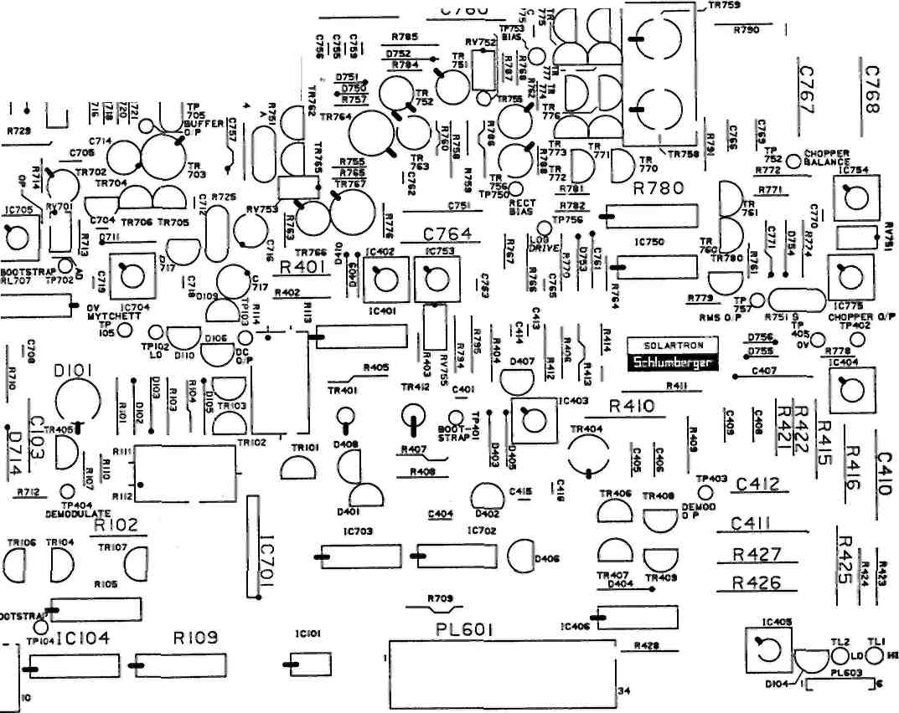
Component Location: Pcb б
СП
-а
CD
гп
-о о
аз
п
5801
^{|С80}' «а
■ю
оэ •
SK80I
/V
Component Location: Pcb 8
г
Г
i
Ю
V
со
СМ Г—
QLKI7
SK4I4
•Ч"
o
■ч-о
— 10
+¹
?|?
Я CC40J
C40I C4IZ
со
о
■ч-о
о m •ч-
ел
С404 Ю.
~§8
/
ч-о
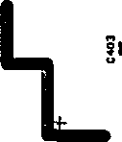
Юа
р.'
1Л О
■ч-
о
о ♦ ^{и}
со
-ч-
U
СП
ч-а
 | Г" |  | 1
о
ч- | — [ |  | |
о | SK40
 |  |  | SK4I4
t | —1— |  | —1—
=0
id*
(\1
о
ч-о
I 4-
ч-о
гп ч-
/2
о ч-
ел
ю о
ч-
ел
I— -
1Л
о
ч-
(Л
гп о ч-
(Л
ч-
1Л
-----1- - О "405
СП
о
ч-
1Л
С408!
IX W403 ^---
"о;
1Л
ч-
(Л
ч-о
ч-о ч-
(Л
со о
■ч-
(Л
г*
ч-м ч-
U
Гк
5
ш
о
(М
ч-о
SK4I2
■ч-о
'
(М
ч-о

o6i
ГМ —
ч-
U
•ч-
1Л
о ч-
IC407
О
ч-
IS)
24 »1М
4=н
-_____I
^{J}SS_{a} 352;
СО
о •ч-и
,0,
------ + ------ а |M0S-*yQID STATICI
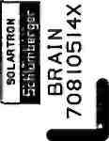
о се <
о
со
(Л
Z
о
а ш ел
ш
<
ел ш о
>
ш а
ел о
Component Location: Pcb 14
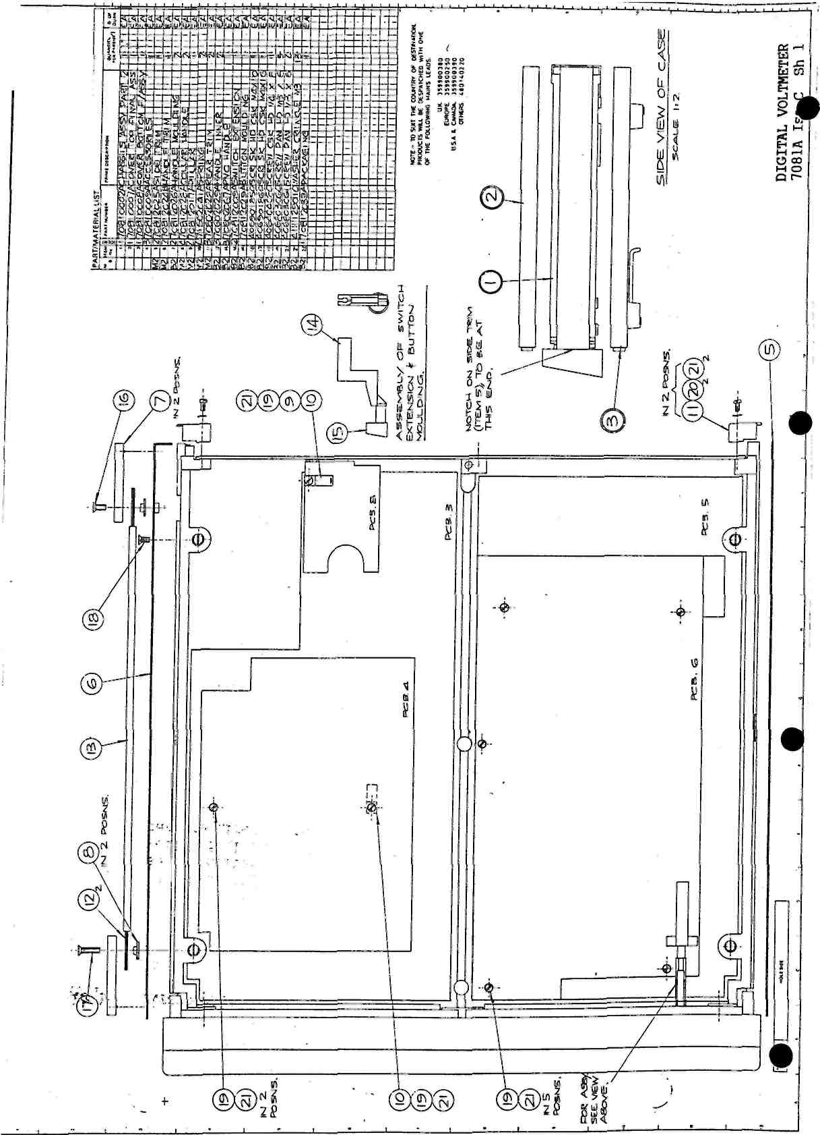
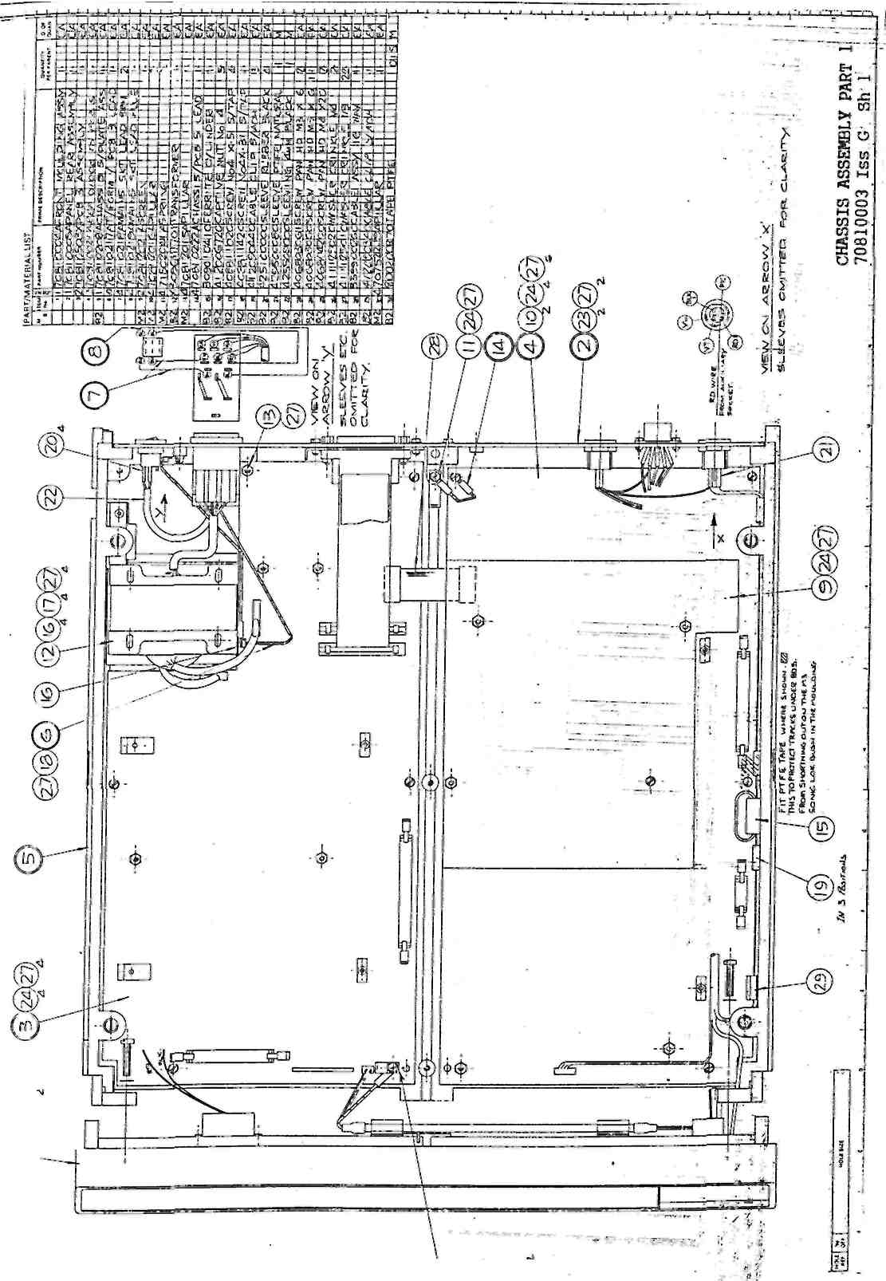
«ОТ
О
©®®©.
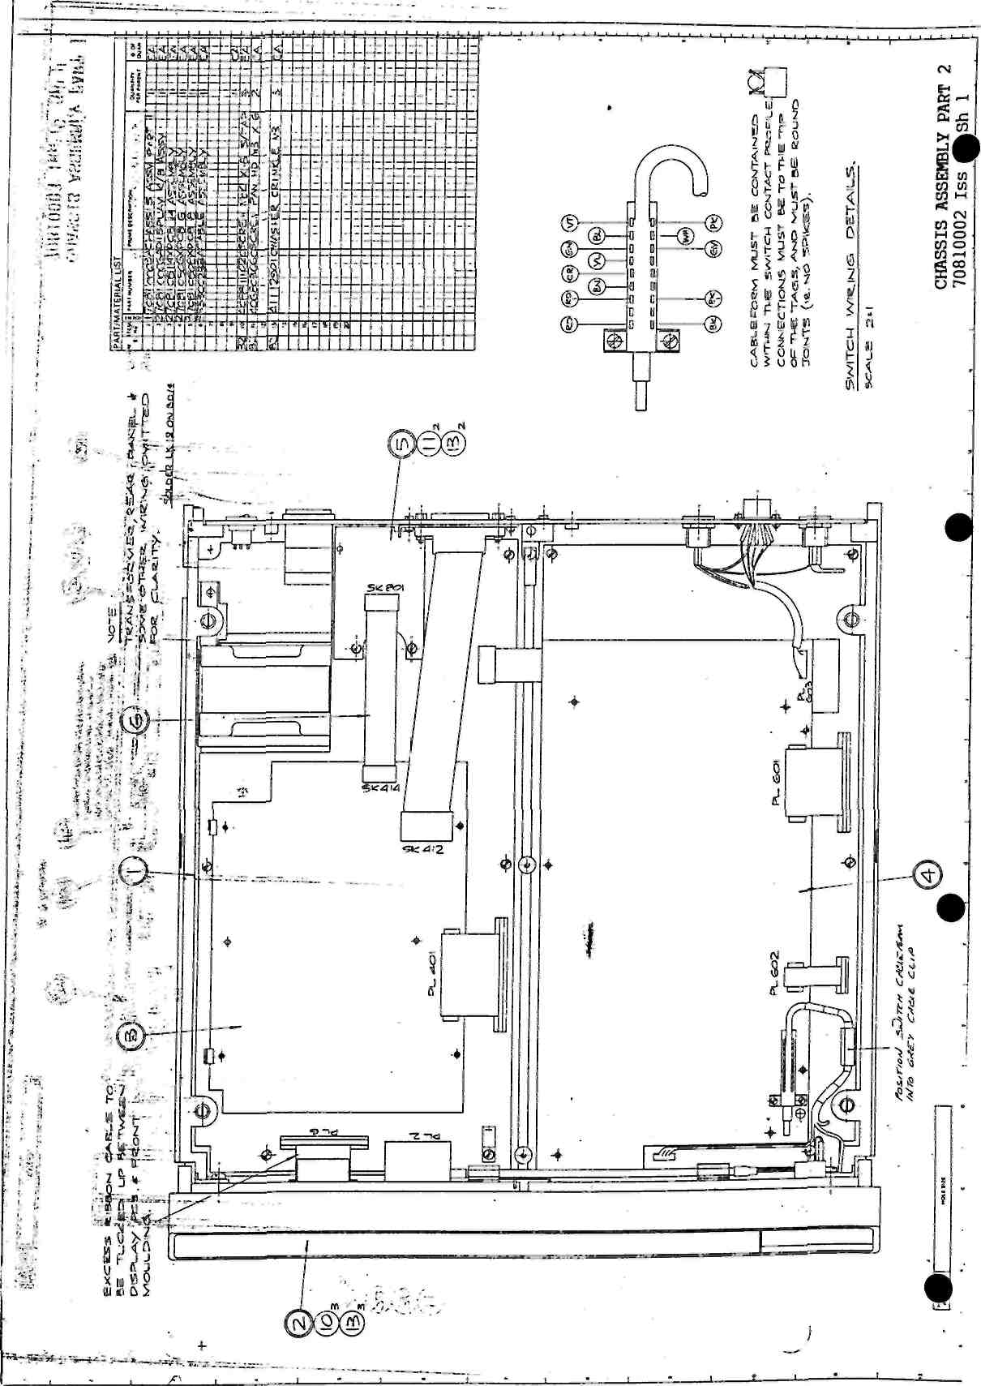
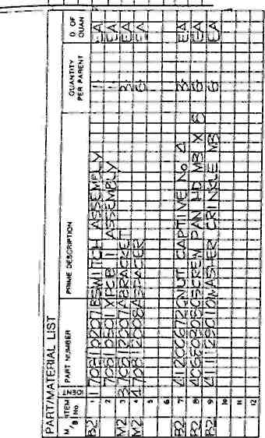
I Г ' I I I ' '
I I I I I
»Нк**»
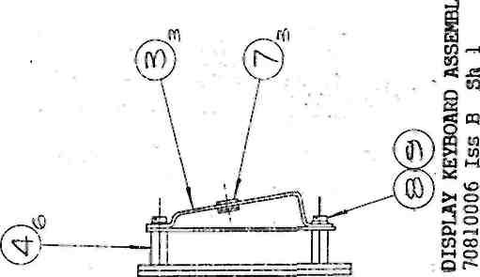
-ffl
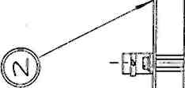
\

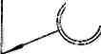
i. • ^ v.
j -
J *
li
i,.'

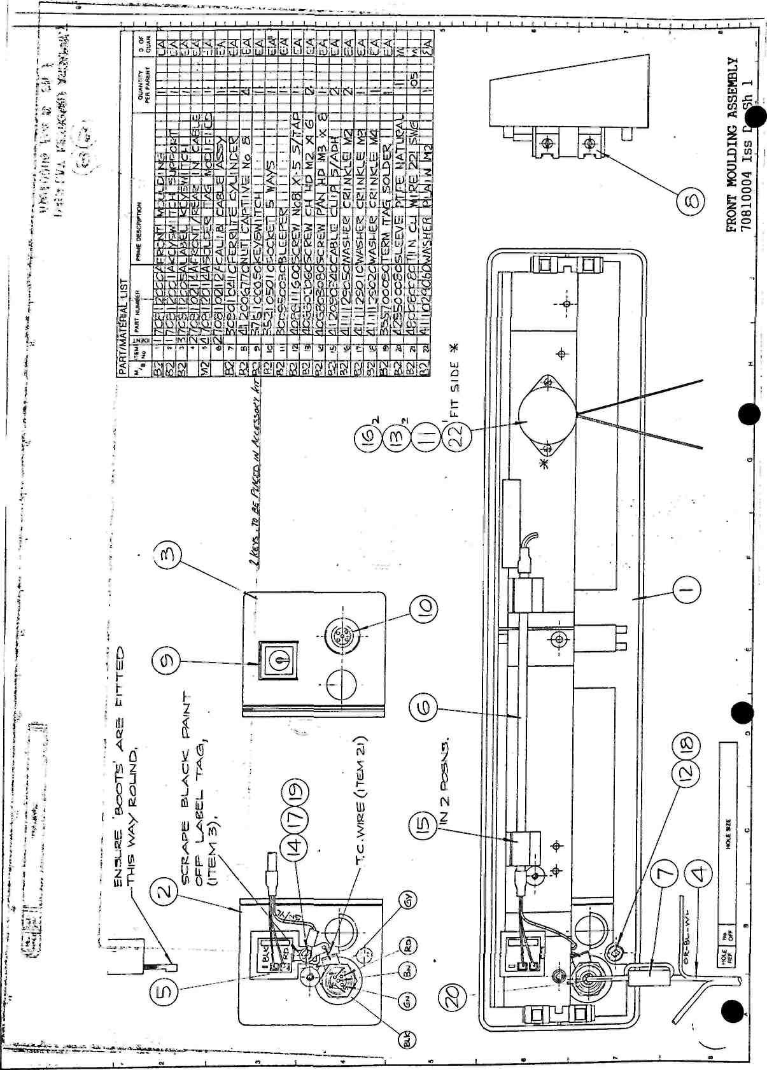
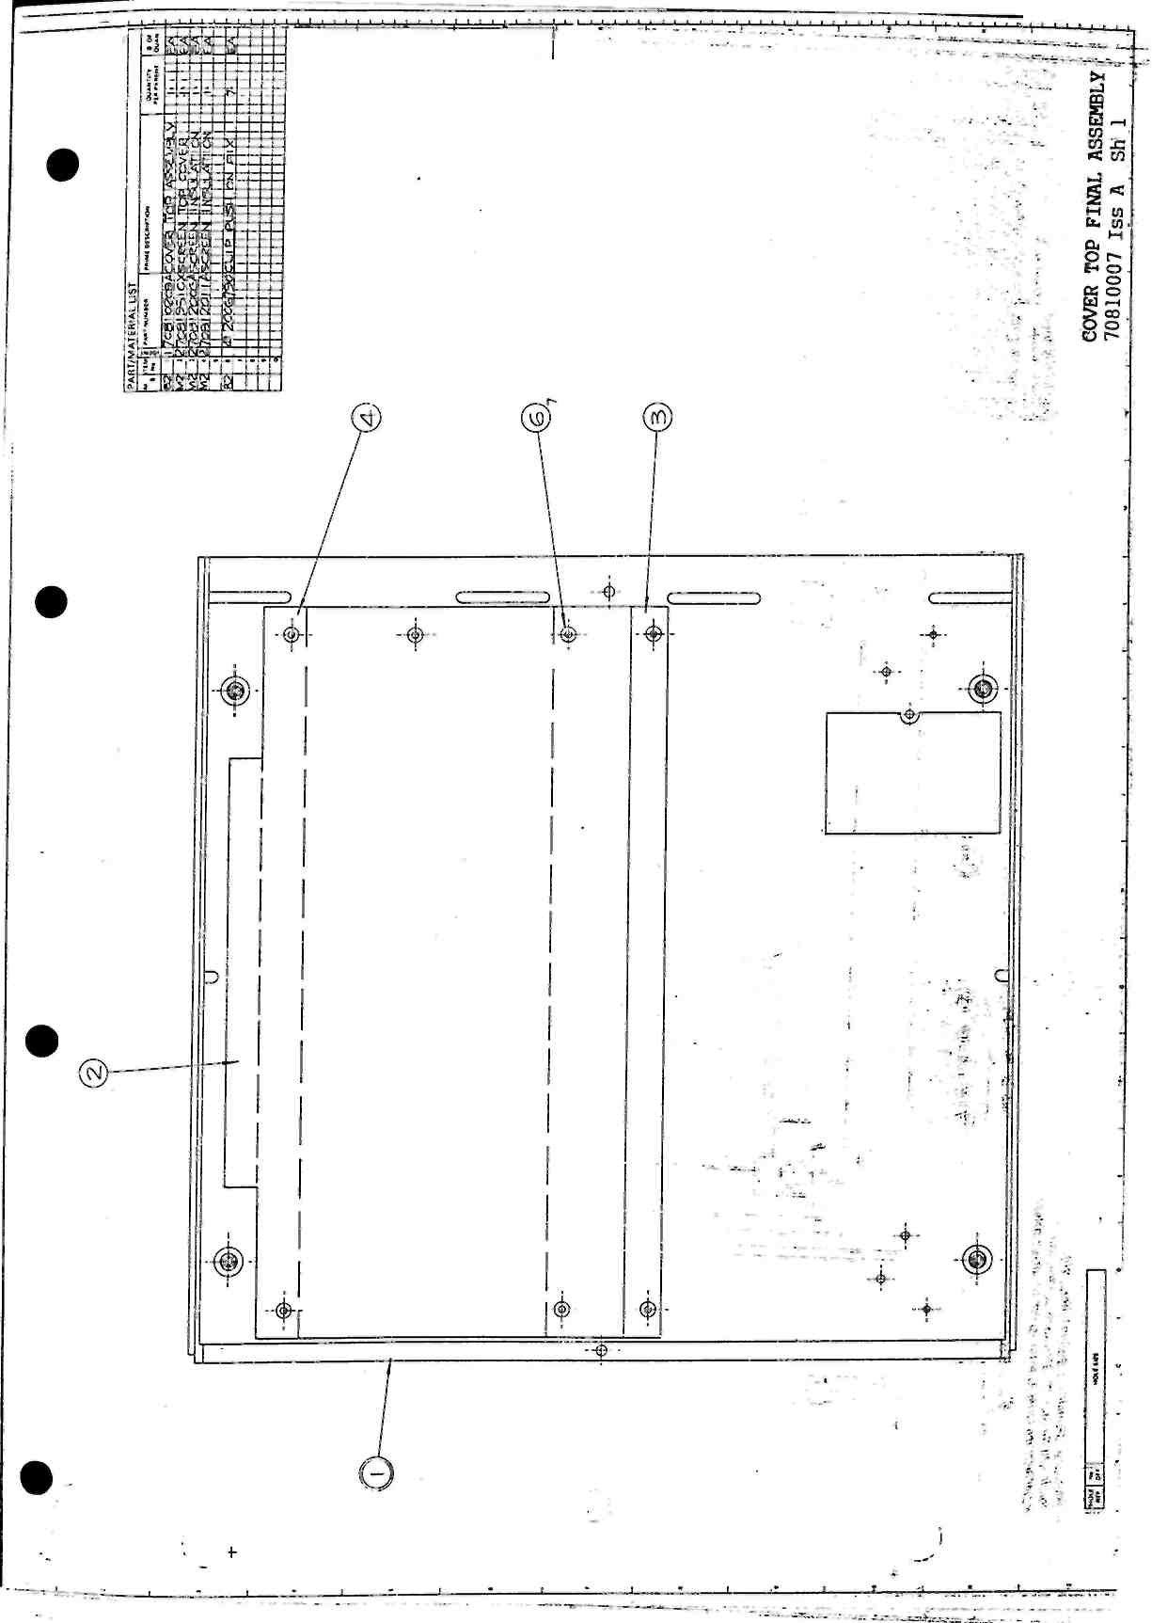
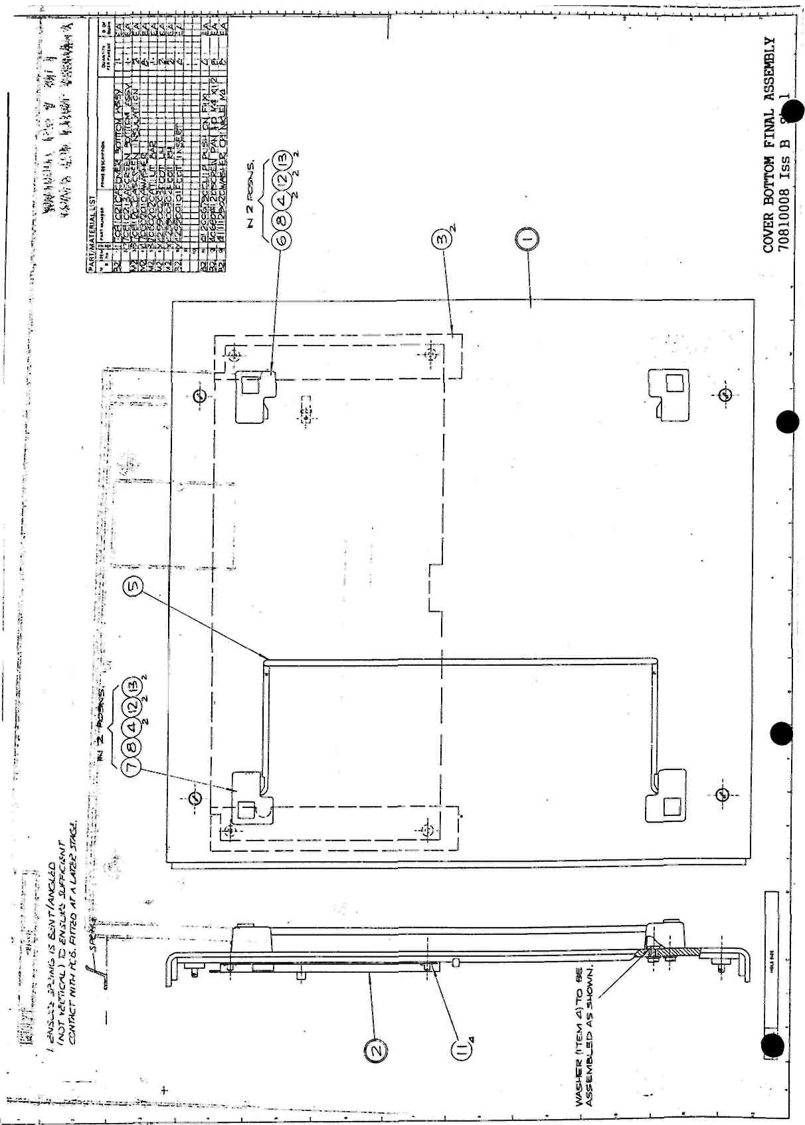
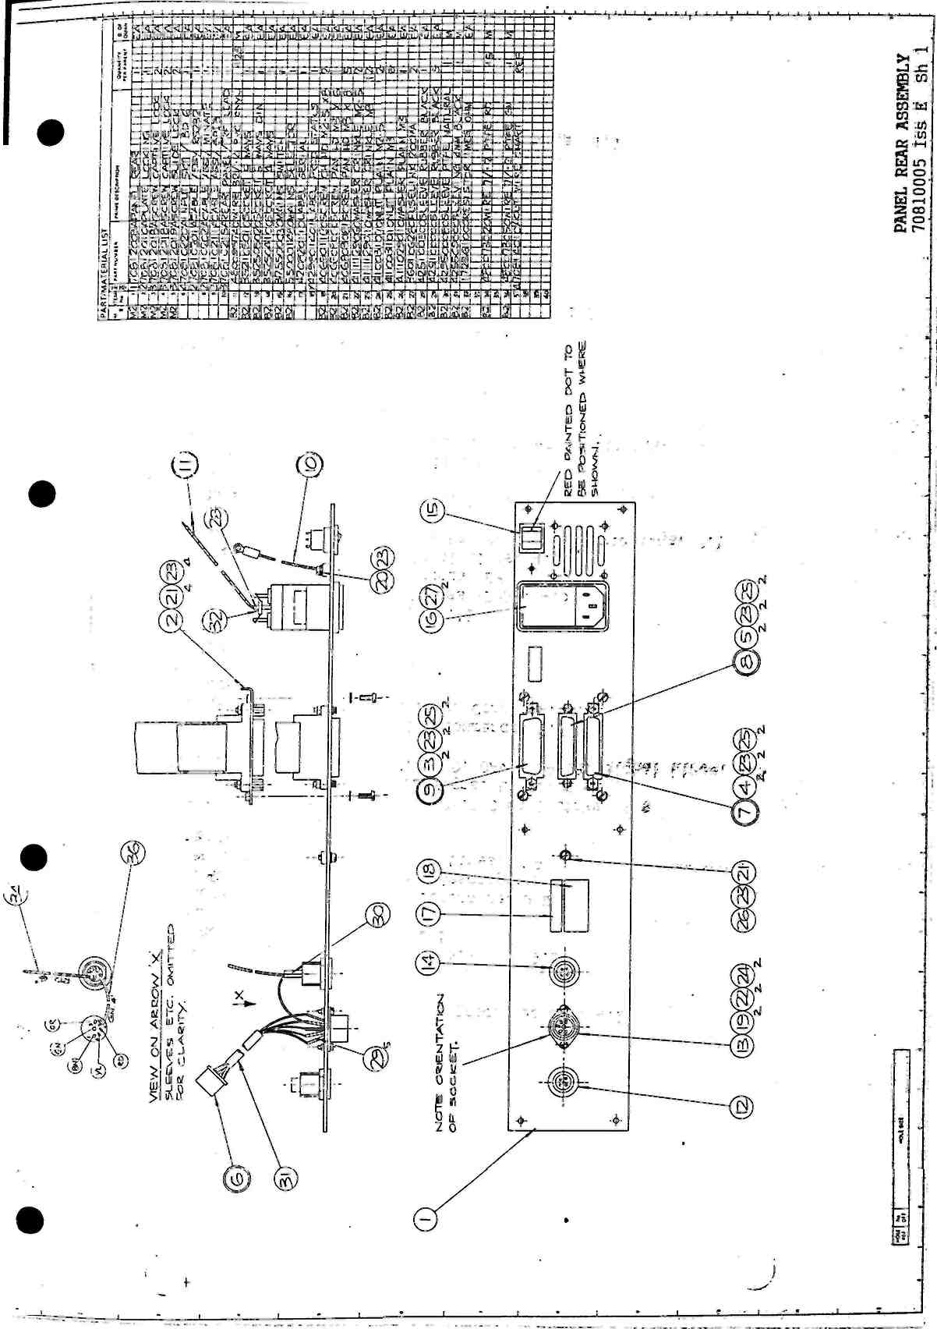
CHAPTER 8 Montlor, Calibration and Self Test
CONTENTS
Page
8.1 Monitor Command 8.1
8.1.1 Earthy Monitor 8.1
8.1.2 Floating Monitor 8.3
8.1.3 Interpreting Calibration Constant Data 8.4
8.2 Calibration Messages 8.6
8.3 Calibration Commands 8.7
8.3.1 CALIBRATE, DUMP 8.7
8.3.2 CALIBRATE, REFRESH 8.8
8.4 7081 Calibration 8.9
8.4.1 Complete Re-calibration 8.9
8.4.2 Partial Re-calibration 8.11
8.4.3 GP-IB Calibration Program 8.11
8.5 Self Test 8.13
Figures
8.1 CALIBRATE, DUMP Output 8.7
Tables
8.1 Earthy Monitor Address Locations 8.2
8.2 Floating Monitor Address Locations 8.4
)
0053g/0825g/GAM

8.1 Monitor Command
The MONITOR command enables the user to access the address/data space of both the "earthy" and "floating" processors of the 7081. The command should only be used by qualified service personnel and requires the use of an RS232 terminal operating at a preferred baud rate of 9600. The Reset Inhibit switches on printed circuit boards 3 and 5 should be set to ON. whilst the MONITOR command is being used, and the baud rate switches set to match the baud rate of the terminal.
WARNING: 1. The Reset Inhibit switches must be set to OFF when returning from MONITOR, ie. before the instrument undergoes a Device Clear, Power Off/On or Initialise.
2. Great care must be taken when writing data into the unit using the MONITOR command as incorrect use may result in confused operation and/or loss of calibration constants.
8.1.1 Earthy Monitor
To access the "earthy" processor, enter:
MONITOR Carriage Return (CR)
The 7081 will respond with:
M
Facilities To inspect an address location, enter:
aaaa.
where aaaa is the address in hexadecimal
The 7081 will respond with the contents on the same line, ie;
M 0000. 07-
To inspect the next location, enter:
r
To change the existing value, enter:
dd, CR
ie; M 0000, 07-08
To inspect a new address, enter:
CR
bbbb.
where bbbb is the new address
0053g/0825g/GAM
8.1
To initialise the NVM (Non-Volatile Memory), enter:
I CR
This command writes a chequer board pattern into the NVM together with a checksum. Any calibration constants present will be lost.
To transfer to the "floating" processor, enter:
T CR
To exit from MONITOR back to normal operation, enter:
CTRL X
Note: Any alpha hexadecimal characters must be entered in capitals.
Refer to Table 8.1 for a list of the main address locations for Earthy Monitor.
Table 8.1 Earthy Monitor Address Locations
Location | Address |  | Comments
 | Software | Software
 | to AE | from AF
MEMORY | 2F1D | 2F2E | Used for establishing constant values (see 'Interpreting Data')
 | 10E0 | 10F1 | Negative acknowledge from floating error counter
 | 10E2 | 10F3 | Floating to Earthy receive error counter
MAINS FREQUENCY | 0F64 | 0F75 | Produces the following possible values:  31 = 50Hz  32 = 60Hz  33 = 400Hz
DUMP OF NVM | 1071 | 1082 | Produces the following possible
CONTENTS |  |  | values:  0 = Dump OK  1 = Overrun Error  2 = Underrun Error  3 = Message checksum error
NVM PAGE | 1070 | 1081 | Produces the following possible values:  0 = Both pages failed, page 2 used  and defaulted where necessary  1 = Page 1 in use  2 = Page 2 in use, page 1 failed
VDC Constants | 0F70 | 0F81 | 10 constants, ie 5 ranges, 2 constants per range
VAC Constants | 0FA2 | 0FB3 | 5 constants, ie 5 ranges, 1 constant per range
0053g/0825g/GAM 8.2
Location | Addres Software to AE | ps Software  from AF | Comments
Ohms Constants' | OFBB | OFCC | 10 constants, ie 5 ranges, constants per range | 2
Top Ohms  Range Constants | OFED | OFFE | 3 constants, ie 1 range, 3  constants
Ratio Input Constants | OFFC | 100D | 1 constant, ie 1 range, 1 constant
Zener Temperature coefficient | 106E | 107F
Page Checksum | 106F | 1080
8.1.2 Floating Monitor
Access to the "floating" processor is only possible via the "earthy"
processor. (See previous section).
Once the transfer command has been entered, the unit will respond with the sign on message "DIS EM FLOAT" followed by the prompt !, indicating that the unit is in the RAM/ROM mode.
Two modes are possible:
* To change to RAM/ROM mode, enter:-R CR
The 7081 will respond wlth:-
* To change to NVM mode, enter:-N CR
The 7081 will respond with:-
Facilities To inspect an address location, enter:
aaaa
where aaaa Is the address in hexadecimal.
To change the value, enter:-
dd CR
0053g/0825g/GAM 8.3
Note: If the NVM mode is enabled, addresses 0 to 3FF only have any meaning.
To print a block of memory, enter:
P SSSS, FFFF
where SSSS, is the start address in hexadecimal and FFFF is the end address in hexadecimal e.g.
"PO.AO
0000 | 0A | 05 | 0A | 05 | OA | 05 | OA | 05 | OA | 05 | OA | 05 | OA | 05 | OA 05........
0010 | 0A | 05 | 0A | 05 | OA | 05 | OA | 05 | OA | 05 | OA | 05 | OA | 05
0020 | 0A | 05 | OA | 05 | OA | 05 | OA | 05 | OA | 05 | OA | 05 | OA | 05 OA
0030 | 0A | 05 | OA | 05 | OA | 05 | OA | 05 | OA | 05 | OA | 05 | OA 05 |  | OA | 05........
0040 | 0A | 05 | OA | 05 | OA | 05 | OA | 05 | OA 05 |  | OA | 05 | OA | 05 | OA | 05 ........
0050 | 0A | 05 | OA | 05 | OA | 05 | OA | 05 | OA | 05 | OA | 05 | OA | 05 | OA | 05........
0060 | 0A 05 |  | OA | 05 | OA | 05 | OA | 05 | OA | 05 | OA | 05 | OA | 05 | OA | 05........
0070 | 0A | 05 | OA | 05 | OA | 05 | OA | 05 | OA | 05 | OA | 05 | OA | 05 | OA | 05 ........
0080 | 0A | 05 | GA | 05 | OA | 05 | OA | 05 | OA | 05 OA |  | 05 | OA | 05 OA |  | 05........
0090 | 0A | 05 | OA | 05 | OA | 05 | OA | 05 | OA | 05 | OA | 05 | OA | 05 | OA | 05 ........
00A0 | 0A 05 |  | OA | 05 | OA | 05 | OA 05 |  | OA | 05 | OA | 05 | OA | 05 | OA | 05........
To return to the "earthy" processor, enter:-
CTRL X
WARNING: Writing to the NVM will destroy the calibration constants.
Refer to Table 8.2 for a list of the main address locations for Floating Monitor.
Table 8.2 Floating Monitor Address Locations
Location | Addres Software to AE | SS  Software from AF | Comments
Link Receiver Error Counter  Link Transmit Error Counter  ROM Ident | 0068 0084 | 002E  0030 FFDA | Earthy to Floating link receive error counter.  Floating to Earthy Link counter
8.1.3 Interpreting Calibration Constant Data
Each calibration constant consists of a packed binary number of 5 bytes
in the following form:-
Byte No. sign bit
7 bit 2's
complement exponent
1 32
bit
3 4
mantissa
0053g/0825g/GAM
8.4
The easiest way to interpret the value of a constant is to write the number into the 7081 memory, come out of monitor, turn on the RS232 output and type MEMORY? The value will be output at the terminal In engineering format. For example:
M 0F70,71-,AA-,80-,00-,00-
M 2F1D,00-71,18-AA,0A-80.18-00,00-00
M
OUT,RS232,ON
OK
MEM?
OK
Memory contents = 20.3251838E-06
When inspecting the NVM, each location is only a nibble wide. Therefore, each constant occupies ten locations not five as In the RAM copy on the "earthy" side. The NVM has two identical pages: locations 0 to IFF are page 1 and locations 200 to 3FF page 2. In order to interpret a number it is first necessary to reform the bytes from the nibbles. The first nibble of a byte pair is the most significant nibble, the second nibble the least significant. Once reformed the five byte number can be put into the memory as before, e.g.
M T
* DIS EM FLOAT *
!N
"0,07-,01-,OA-,OA-,08-,00-,00-.00-,00-,00-
II
M 2F1D,00-71,18-AA.0A-80,18-00,00-00
M
OUT,RS232,ON
OK
MEM?
OK
Memory contents = 20.3251838E-06
Constants are given in ascending range, all the constants for each range being grouped together in the order (where applicable) of Zero, High, Open.
0053g/0825g/GAM
8.5
8.2 Calibration Messages
The responses to the CALIBRATE? command are described below. Reference should also be made to the MONITOR command for a further breakdown.
FAIL 1 - this message is output if the checksum in page 1 and/or page 2 of the NVM has failed. It is equivalent to the front panel 'NVM FAIL' message, which could appear at power up.
FAIL 2 - if a failure occurs during the transfer of the calibration constants from the NVM to the RAM, this message is output. It is equivalent to the front panel 'DUMP FAIL' message, which could appear at power up.
FAIL 3 - this message is output if some of the calibration constants are out of range and default values have been susbstituted. It is equivalent to the front panel 'CAL INCOMPLETE' message, which could appear at power up.
OK - if this message Is output, the transfer of the calibration
constants has been successfully completed and no errors have been found.
0053g/0825g/GAM
8.6
8.3 Calibration Commands
Two commands are provided to enable inspection or refresh of the unit calibration constants. They can both be activated via the RS232 or GP-IB interfaces.
8.3.1 CALIBRATE, DUMP
This command enables an output of all the calibration constants, with headings,
and the zener temperature coefficient current token.
To activate a calibration dump, the following procedure should be used. (It is assumed that an RS232 terminal is connected to the voltmeter).
* Turn the front panel calibration key to the CAL position.
* Enter, Output,RS232,ON CALIBRATE,DUMP
* The voltmeter will respond with the output shown in Figure 8.1.
VDC CALIBRATION CONSTANTS
8.04662704E-06
164.224612E-03 -834.465026E-09
1.64196003E+00 -953.674316E-09
16.4218391E+00 -298.023223E-09
164.185607E+00 -774.860382E-09
1.64381286E+03 VAC CALIBRATION CONSTANTS
327.550067E-03
3.27523722E+00
32.7807025E+00
328.446396E+00
3.29051217E+03 KOHM CALIBRATION CONSTANTS
8.04662704E-06
165.944119E-03 -834.465026E-09
1.65961519E+00 -953.674316E-09
16.5984867E+00 -834.465026E-09
165.980795E+00 -953.674316E-09
1.66008452E+03 TOP OHMS RANGE CALIBRATION CONSTANTS -953.674316E-09
9.90188959E+03
602.393984E-03 RATIO TERMINALS CALIBRATION CONSTANT
16.4375923E+00 ZENER CURRENT TOKEN VALUE 068
Fig. 8.1 CALIBRATE. DUMP Output
0053g/0825g/GAM
8.7
Vdc Calibration Constants These constants are given in the following order: 0.1 Volt range zero. 0.1 Volt range high, 1.0 Volt range zero, 1.0 Volt range high, etc., up to 1000 Volt range high. The values take into account the range factor and the digital full scale constant value of 16777216. As the 7081 is designed to produce slightly high results before calibration, the high constants are slightly less than the full scale value, i.e. l.OVolt range high = 1.64196003, 10 Volt range high = 16.4218391, etc.
Vac Calibration Constants The Vac mode has high calibration constants only, given in the order: 0.1 Volt range, 1.0 Volt range, etc., up to 1000 Volt range. The constants are measured at half the full scale value and so are equal to twice the nominal values expected, i.e. 1.0 Volt range constant = 3.27523722 which is approximately equal to 1.64 x 2.
Kohms Calibration Constants These constants appear in the following order: 0.1k ohms range zero, 0.1k ohms range high, 1.0k ohms range zero, 1.0k ohms range high, etc., up to 1000k ohms range high. The zero constants are obtained from the Volts dc set according to the range on which the ohms measurement is taken. The zero constants are transferred to the к ohms set when an NVM dump is performed.
Top Ohms Constants The three constants for the M ohms range are given in the order: zero, open, high. The zero is taken from the 1000k ohm range and the open value is derived from the reference circuit.
Ratio Constant The Ratio has a calibration high constant but no zero as any zero offsets in the circuit would be cancelled out by the subtraction of Ratio Lo from Ratio Hi. The constant is measured on the Ratio 10 Volts range.
Zener Current Token Value This value represents the code sent by the microprocessor to set up the reference zener current. It is designed to give the diode the lowest temperature coefficient.
8.3.2 CALIBRATE, REFRESH
This command enables a refresh of the NVM, i.e. the present calibration
constants are written back into the NVM. The sequence of operation is as
follows:
* Microprocessor checks both pages of the NVM.
* First correct page is down-loaded to the RAM.
* Microprocessor checks the RAM
* RAM contents are written into both pages of the NVM.
* Microprocessor checks both pages of the NVM.
To activate a calibration constants refresh, the following procedure should be adopted. (It is again assumed that an RS232 terminal is connected to the voltmeter).
* Turn the front panel calibration key to the CAL position.
0053g/0825g/GAM
8.8
* Enter, Output,RS232,ON CALIBRATE,REFRESH
* One of the following messages will appear:
REFRESH COMPLETE - refresh has been successful and no faults have
been found.
REFRESH COMPLETE NVM PAGE 1 WAS FAULTY
- refresh has been successful. Page 1 of the NVM was originally faulty but is now correct.
REFRESH COMPLETE NVM PAGE 2 WAS FAULTY
- refresh has been successful. Page 2 of the NVM was originally faulty but is now correct.
REFRESH FAIL RAM COPY FAIL
- refresh has been unsuccessful as the RAM copy is faulty.
REFRESH FAIL NVM PAGE 1 IS FAULTY
- refresh has been unsuccessful. Page 1 of the NVM is faulty.
REFRESH FAIL NVM PAGE 2 IS FAULTY
- refresh has been unsuccessful. Page 2 of the NVM is faulty.
REFRESH FAIL NVM PAGE 1 & 2 ARE FAULTY
- refresh has been unsuccessful. Both pages of the NVM are faulty.
Note: The 7081 display outputs either REFRESH COMPLETE or REFRESH FAIL.
8.4 7081 Calibration
The 7081 is sent from the factory in a fully calibrated state but, if the unit is damaged or the specifications exceeded, re-calibration may be required. Owing to the high accuracy of 7081, the calibration reference values entered should be very precise. Solartron will re-calibrate the unit if the user is unable to supply precise references.
Note: All calibration should be performed in a stable temperature environment, i.e. variation of less than ±1°C.
8.4.1 Complete Re-calibration
If a new Non-Volatile Memory (NVM) is installed in the unit, it is necessary to perform a complete re-calibration of 7081 using the procedure given below.
It is assumed that an RS232 terminal device is connected to the 7081.
0053g/0825g/GAM . 8.9
With reference to Section 8.1, set the Reset Inhibit switches to ON and initialise the NVM.
Exit from MONITOR and set the Reset Inhibit switches to OFF.
Turn the front panel key operated switch to the CAL position.
Insert a short circuit plug into the input socket and enter the following command:
CALIBRATE, VDO0.1, ZERO
Wait a few seconds for the unit to complete the 'zero' calibration, then remove the short circuit plug and connect a reference supply of approximately 0.1 volts dc to the input.
Enter:
CALIBRATED, VDC=0.1, HIGH=0.100012
where 0.10012 is the 'exact' value of the reference supply.
Repeat the previous three steps for each of the volts dc ranges, using a suitable reference input.
Connect an ac reference supply of approximately 0.1 volts to the input.
Enter:
CALIBRATE, VAC=0.1, HIGH=0.100012
where 0.10012 is the 'exact' value of the reference supply.
Repeat these two steps for each of the volts ac ranges, using a suitable reference input.
Remove the input lead and leave the input open circuit.
Enter:
CALIBRATE, KOHH = 10000, OPEN
Wait a few seconds for the unit to complete the 'open' calibration, then connect a reference supply of approximately 10000 kohms to the input.
Enter:
CALIBRATE, KOHM = 10000, HIGH = 10000
where 10000 is the 'exact' value of the reference.
Connect a reference supply of approximately 1000 kohms to the input and enter:
0053g/0825g/GAM 8.10
CALIBRATE, KOHM = 1000, HIGH = 1000
where 1000 Is the 'exact' value of the reference.
* Repeat the previous step for each of the remaining kohms ranges, using a"suitable reference Input.
* Connect a reference supply of approximately 10 volts dc to the input.
* Enter:
CALIBRATE, REFERENCE, HIGH = 10.000012
where 10.000012 is the 'exact' value of the reference.
* Do not attempt to re-calibrate the zener diode. Refer to Solartron.
8.4.2 Partial Re-calibration
If a particular range or mode requires re-calibration, it is recommended that the NVM first be refreshed using the procedure set out in Section 8.3.2. The range/mode can then be re-calibrated as described in the previous section.
Whenever calibration is being carried out, reference should be made to the CALIBRATE command described in Chapter 3, of 7081 Operating Manual, Part 2.
8.4.3 GP-IB Calibration Program
When calibrating the 7081 over the GP-IB a program is required which (a) commands the 7081 to calibrate the necessary ranges/modes and (b) tells the operator when to connect the reference supplies, etc. The following example program, written In HP9835A Basic, calibrates the 10 Volts dc range and could be adapted or expanded for other modes/ranges. To use a program of this type, the controller must be able to perform both a parallel and a serial poll.
10 'EXAMPLE CALIBRATION OF 7081
20 !set up program parameters
30 S=0
40 P=0
50 Waiting=0
60 Signal=0
70 Rqs=6
80 Rdy=4
90 'INITIALISE 7081
100 RESET 716
110 OUTPUT 716;"INITIALISE"
120 WAIT 3000
130 GOSUB Setremote
140 PRINT "TURN KEY TO CAL ON 7081"
150 DISP "PRESS CONTINUE WHEN READY"
160 PAUSE
170 ON INT#7 GOSUB Intserve
0053g/0825g/GAM
8.11
180 CONTROL MASK 7;128
190 CARD ENABLE 7
200 OUTPUT 716:"CALIBRATE,REFRESH"
210 OUTPUT 716;"SRQ,READY.ON"
220 Signal=0
230 GOSUB Waitsignal'.WAIT FOR REFRESH END
240 OUTPUT 716;"SRQ.OFF"
250 PRINT" CALIBRATE.VDC.10,ZERO"
260 GOSUB Shortcircuit
270 OUTPUT 716;"CALIBRATE,VDC.10,ZERO"
280 OUTPUT 716;"SRQ,READY,ON"
290 GOSUB Waitsignal'.WAIT FOR COMPLETION
300 OUTPUT 716;"SRQ,OFF"
310 PRINT" CALIBRATE.VDC,10,HIGH=[re£.value]"
320 GOSUB Connect
330 OUTPUT 716;"CALIBRATE.VDC,10,HIGH=10.0"
340 OUTPUT 716;"SRQ,READY,ON"
350 GOSUB Waitsignal!WAIT FOR COMPLETION
360 OUTPUT 716;"SRQ,OFF"
370 DISP"10VDC RANGE CALIBRATION COMPLETE"
380 STOP
390 Shortcircuit:!
400 PRINT"INSERT SHORTING PLUG INTO 7081 INPUT"
410 DISP"PRESS CONTINUE WHEN READY"
420 PAUSE
430 RETURN
440 Connect:!
450 PRINT"CONNECT REFERENCE TO 7081 INPUT"
460 DISP"PRESS CONTINUE WHEN READY"
470 PAUSE
480 RETURN
490 Setremote:!
500 Remote=l
510 REMOTE 716
520 LOCAL LOCKOUT 7
530 RETURN
540 Intserve:!
550 Int=Int+l
560 PRINT"INTERRUPTS";Int
570 PPOLL CONFIGURE 716;"00001011"
580 P=PPOLL(7)
590 GOSUB Remotelocal
600 IF BIT(P,3)<>1 THEN GOTO Endpol
610 STATUS 716 ;S
620 IF BIT(S,Rqs)ol THEN GOTO Endpol
630 IF BIT(S,Rdy)=l THEN GOTO Endtry
640 Signal=l
650 Waiting=0
660 Endtry:!
670 Endpol:!
680 PPOLL UNCONFIGURE 716
690 GOSUB Remotelocal
700 CARD ENABLE 7
710 RETURN
720 Waitsignal:!
0053g/0825g/GAM 8.12
730 Waitings
740 ldle=0
750 Repeatwalt:!
760 Idle=Idle+l
770 DISP "StatusrWaiting for interrupt";Idle
780 IF Signal=0 THEN GOTO Repeatwalt
790 Slgnal=0
800 PRINT " "
810 RETURN
820 Remotelocal:!
830 IF Remote=0 THEN GOTO Elseremote
840 GOSUB Setremote
850 GOTO Endremote
860 Elseremote:!
870 GOSUB Setlocal
880 Endremote:!
890 RETURN
900 Setlocal:!
910 Remote=0
920 LOCAL 7
930 RETURN
940 END
Lines 10 to 80 - set up the program parameters. I.e. serial poll and parallel poll registers, waiting flag for the background routine, interrupt acknowledge flag and serial poll bits.
Lines 90 to 130 - Initialise the 7081 and set it to remote.
Lines 140 to 380 - calibrate the 10 Volts dc range.
Lines 390 to 430 - 'Shortcircuit' subroutine to tell the operator to insert the shorting plug.
Lines 440 to 380 - 'Connect' subroutine to tell the operator to connect the reference supply.
Lines 490 to 530 - 'Setremote' subroutine to put 7081 into remote.
Lines 540 - 710 - 'Intserve' subroutine for servicing interrupts.
Lines 720 to 810 - 'Waitsignal' subroutine which is a background routine used when the controller is waiting for 7081 to produce interrupts.
Lines 820 to 890 - 'Remotelocal' subroutine which decides If 7081 was in remote or local and returns to its previous state.
Lines 900 to 940 - 'Setlocal' subroutine which sets 7081 to local.
8.5 Self Test
If 7081 fails the self test, initiated by either pressing the front panel self test control or sending the Test command via one of the interfaces, the area of failure can be investigated using the MODE Command.
0053g/0825g/GAM 8.13
MODe.TEST Ovdc - measures the integrator zero and outputs the
results.
MODe.TEST lOvdc - measures the reference voltage. A value of
approximately 10 volts should be output. Values in the region of 9.8 to 10.2 volts are acceptable.
MODe.TEST Kohm - measures a resistor in the V-to-T converter
circuit. A value of 166 Kohros should be output.
MODe.TEST Ac - the reference forcing waveform is attenuated to a
lOOmV square wave and passed through the ac circuitry. Readings of lOOmV + 10% should be obtained if the circuits are operating correctly.
0053g/0825g/GAM
8.14
CHAPTER 9 Setting Up Procedure
CONTENTS
 | Page
9.1 Introduction | 9.1
9.2 Test Equipment | 9.1
9.3 Safety | 9.1
9.4 Printed Circuit Board 4 Test | 9.1
9.5 Printed Circuit Board 6 Test | 9.2
9.6 Assembly Check | 9.3
9.7 Power Supply and Digital Checks | 9.4
9.8 Analogue Checks | 9.5
0053g/0491g/GAM
9.1 Introduction
This chapter provides a comprehensive setting-up procedure which may be necessary after rectification and/or component replacement on the voltmeter.
9.2 Test Equipment
The test equipment listed below should be available to carry out setting-up procedures.
(a) Oscilloscope (20MHz bandwidth)
(b) Digital Voltmeter (eg Type 7060)
(c) Calibrator
(d) Variac Transformer
(e) Silent 700 (or similar RS232 terminal)
(f) RS232 Cable
(g) Frequency Counter (e.g. HP5135A) (h) 240V/400HZ Power Supply Unit
9.3 Safety
The instrument should be disconnected from the mains supply before any attempt is made to remove the printed circuit boards.
9.4 Printed Circuit Board 4 Test
Ensure that the following links are fitted depending upon the RAM used:-
RAM | 1 | 2 | 3 | 4 | 5 | 6 | 7 | 8 | 16
5516/6117 | In | Out | In | Out | In | Out | In | Out | Out
6116 | Out | In | In | Out | In | Out | In | Out | Out
6264 | Out | In | Out | In | Out | In | Out | In | Out
Check that the printed circuit board is correctly connected to the
following:-
Printed Circuit Board 3 via PL1
GP-IB Socket via SK412
Printed Circuit Board 8 via SK414.
* Switch on the voltmeter and check that "INITIALISED" appears in the display.
* Switch off and then on again, and check that "RESUMED" appears in the display. (This assumes a fully calibrated printed circuit board 5).
* Press the front panel "initialise" control and check that "INITIALISED" appears in the display.
* Set the GP-IB address switch to address 7. Switch off and then on again, and press the "local" control. "GP-IB ADDRESS=7" should appear in the display.
0053g/0491g/GAM
9.1
* Set the address switch to address 16. Switch off and then on again, and press the "local" control. "GP-IB ADDRESS = 16" should appear In the display.
9.5 Printed Circuit Board 6 Test
All measurements are relative to OV "MYTCHETT" with oscilloscope settings of [\div]. [\divj, [trigger-}.
* Check that the printed circuit board is correctly connected to the following:
Printed Circuit Board 5 via PL501, PL502 Ratio/Reference socket via PL603
* Switch the voltmeter on and connect an oscilloscope (set to 500mV, 2ms, Line) to TP402 "CHOPPER 0/Р". The observed results should be in the ranges:
spikes <1V peak noise <0.5V peak
* To check the main amplifier offset, connect a digital voltmeter (set to Vdc) to TP403 "DEMOD O/P". The digital voltmeter result should be: -10V < reading < +10V
* To set the ac offset voltage, connect the digital voltmeter (set to Vdc) to TP705 "BUFFER 0/P" and adjust RV701 until -IOOjjV <
reading <+100pV.
* Connect the calibrator Low to Si right second pin back and calibrator High to SI left, second pin back. With the digital voltmeter set first to Vdc, check the ranges shown below:-
7081 Setting | Expected Digital Voltmeter Result
lOOmV, IV, 10V dc 100V dc lOOmV, IV, ac 10V ac | Zero < lOpV, full scale +0% to +4% Zero < lmV, full scale +0% to +4% Zero < 500pV, full scale +0% to +4% Zero < 50mV, full scale +0% to +4%
* Connect a IV, 1kHz source and press the 7081 front panel V~ control. With an oscilloscope (set to 20mV, 5ms, External) connected to ТР752 "CHOPPER BALANCE", trigger from R779, adjust RV751 "BALANCE" until the flattest trace is achieved.
* Connect a IV, 100kHz source and adjust RV752 to give a reading of 1.00000 ± 20 bits.
* Connect a IV, 1MHz source and adjust RV753 to give a reading of 1.00000 ± 100 bits.
* Repeat the previous two steps.
0053g/0491g/GAM 9.2
9.6 Assembly Check
* Ensure that links 1, 3, 4. 5. 6, 7 and 8, on printed circuit board 3. are installed.
* Check that the following split pads, on printed circuit board 5, are made:- 201, 202, 501, 801, 802, 803, 804, 805, 806, 807, 808, 809. 901, 902, 903, 904.
* Set the mains power selector to 240V and check that a 200mA fuse is installed.
* Set the GP-IB address to 18, ie
ON OFF
* Set SI, on printed circuit board 3, as follows:-
xxx
X XX XX
ON
X
OFF
Check that the shorting clip (printed circuit board 3) has been removed from TR2.
Set SI, on printed circuit board 5, as follows:-
6801uP
6303yP
ON
X
OFF
ON
OFF
Check that printed circuit board 3 is connected to the following:
RUN/CAL switch via PL3
Keyboard via PL2
Printed Circuit Board 1 via PL6
Printed Circuit Board 5 via SK51
0053g/0491g/GAM 9.3
RS232 Socket via PL5 Minate Socket via PL4 Transformer via PL51, PL52 Beeper via ТРЗ, ТР4 OV Earth via TP53.
* Check that printed circuit board 4 is connected to the following:-Printed Circuit Board 8 via SK414.
GP-IB Socket via SK412
Printed Circuit Board 3 via PLl.
* Ensure that printed circuit board 5 is connected to printed circuit board 3 via SK901. Also check that the orientation of IC801 and IC826, on printed circuit board 5, is correct, as their orientation should be the reverse of all the other ICs.
* Ensure that the shorting clips are removed from TR203, TR204, TR603, TR605, TR610 (printed circuit board 5).
* Check that printed circuit board б is connected to the following:-Printed Circuit Board 5 via PL501, PL502, PL504.
Ratio Socket (High, Low) via PL603 (TLl, TL2).
9.7 Power Supply and Digital Checks
* Connect the 7081 power input to a variac and gradually increase the input to 240V. "NVM FAIL" should be displayed but "CAL INCOMPLETE", "INITIALISED or "RESUMED" are also acceptable.
* Check that there are no missing or additional display segments.
* Check the keyboard operation by pressing each key and listening for a "beep".
* Ensure that the LED annunciators work.
* Press "initialise" followed by "DIG FILT". The "compute" LED should light.
Press "V—" followed by "V". The second beep should be twice as long as the first.
Connect the 7081 to a variac source. Set the variac first to 216 and then to 264V, and check, using a digital voltmeter, that each of the following test point voltages is within the stated range:-
Printed
Circuit Board | Measure Across | Low Mains Input | High Mains Limit
3 | TP53-56 | 24 | 35
 | TP54-55 | 24 | 35
 | TP53-IC52 pin 1 | 38 | 42
 | TP53-D58 cathode | 4.75 | 5.25
 | TP53-D53 cathode | 4.75 | 5.25
 | TP53-D60 cathode | 11.4 | 12.6
 | TP53-D61 anode | 11.4 | 12.6
0053g/0491g/GAM 9.4
Printed Circuit Board | Measure Across | Low Mains Input | High Mains Limit
5 | TP903-D904 cathode | 29 | 45
 | TP903-901 | 25.6 | 28.4
 | TP903-902 | 14.2 | 15.8
 | TP903-904 | -14.2 | -15.8
 | TP903-906 | -25.6 | -28.4
 | C609 | 36 | 53
 | TP604-606 | 35 | 39
 | TP604-603 | -23.7 | -26.3
Connect normal 240V ac mains power (increase mains from zero using a variac each time) and check that the voltage across IC901 left hand pin and TP903 is not less than +17.5V. Repeat test with 198V ac input on the 220V setting.
* Change to a 400mA fuse and repeat step 8 for 108V ac input on the 120V ac setting and 90V ac input on the 100V ac setting.
* Refit 200mA fuse and return to the 240V setting.
* Connect a Silent 700 to the RS232 port. Set the Silent 700 NUM. LOW SPEED and HALF DUP switches OFF and the ON LINE switch ON.
Type: OUT,RS,ON:MEAS,SING
One result should be printed out.
* Connect frequency counter ground to printed circuit board 3 TP2 and probe TP1. Adjust C3 for a frequency in the range of 32767.99 to 32768.01Hz.
Set up date by typing on the Silent 700, for example: DATE = 14,3,83
Set up the time by typing, for example: TIME = 14,22
Check that the values have been accepted by typing
TIME?:DATE?
* Press "initialise". The display should return with "NVM FAIL". 9.8 Analogue Checks
* Phase Locked Loop Frequency Set a bench supply to +2.5V. Connect the low terminal to TP904 and the high (+2.5V) to the negative end of C806. Connect the low terminal of a frequency counter to TP904 and probe IC835 pin 5. Adjust C807 for a frequency between 5.21MHz and 5.27MHz.
* Using a high impedance voltmeter (e.g. 7060) monitor the voltage at the negative end of C806 with respect to TP904. The voltage should settle to 2.5V ± 0.3. Adjust C807 to correct, if necessary.
0053g/0491g/GAM 9.5
Disconnect the bench supply and switch on the 7081 using 60Hz mains frequency. Check that, after settling, the voltage on C807 is 2.5V ± 0.5.
Reference Voltage Connect the 7060 between TP302(+10V) and TP303(-10V), ensuring that LK301 and LK302 are configured as follows:-
Voltage | LK301 | LK302
19.7-20V 20-20.31V 20.31-20.63V 20.63-20.96V | OPEN OPEN BRIDGED  BRIDGED | OPEN  BRIDGED  OPEN  BRIDGED
D-A Converter Check the operation of the digital-to-analogue converter by connecting a 7060 to TP305(0V) and TP301 "CURRENT". Switch 7081 to CAL (front panel key): Type:
CALIBRATE, ZENER, 064
and wait for the command to be executed.
Press "initialise" on the front panel.
The 7060 should read <10mV
Now type:
OUT.RS,ON CALIBRATE,ZENER,124
and wait for the commands to be executed.
Press "initialise". The 7060 should read -9.18V + 0.2V.
Connect scope ground to the printed circuit boards 0V level, (scope should be set to 5V, 2ms, AUTO) and probe TP204 "GLUGS".
Short circuit the 7081 input. The waveform should have a period of 6.25ms.
Type : MODE,TEST 0:NINES,3
The period should reduce to 1.56ms.
Set scope to 5V, 100ns, AUTO and check that each edge has a rise or fall time of <300ns and that the gap time is 13 ± 3ps.
Check that the voltage across R355 is less than lOOyV at room temperature.
0053g/0491g/GAM
9.6
CHAPTER 10
Instrument Assembly Parts CONTENTS
Page 10.1 Introduction Ю.1
Instrument Assembly Drawings 10.2
Digital Voltmeter Chassis Assembly Part 1 Chassis Assembly Part 2 Displayed Keyboard Assembly Front Moulding Assembly Cover Top Final Assembly Cover Bottom Final Assembly Panel Rear Assembly
2955g/0128g/BRP
Ш1:" INTRODUCTION
This chapter contains detailed engineering drawings for all of the main assembly parts of the 7081/7071 digital voltmeter. The components that make up each assembly part are referenced with an item number.which corresponds to a Solartron part number, given in the Assembly Parts List.
When ordering spare parts it is essential to quote the instrument serial number, located on the rear panel of the instrument, as well a full description of the assembly drawing and the component part required in that drawing.

.2955g/0128g/BRP
•■•&„
INDEX
+5V Supply, Earthy Power Supply, 3.10 ±12V Supply, Earthy Power Supply, 3.10 +40V Suppiy, Earthy Power Supply. 3.10 7081 Calibration, 8.9
Microprocessor Set, 4.2
Absoluter, RMS Converter, 6.5 AC Attenuator and Buffer, 6.4 AC RMS Converter, 6.5 Address Bus and Data Bus, Address Decoders, 4.2
Amplifier Output Limit, 6.3 __fr;
Analogue Checks, Setting Up Procedure, 975- ' Annunciator Clock Signals, 2.1
Annunciators , 2.1 ^--- .....--, ,
Assembly Check, Setting Up Procedure, 9.3 i A-to-D Converter, Functional Description,-*^ Attention (ATN), GP-IB Signal Lines. 4.9 ,._{r}--Attenuator, 6.1
4.8
Bidirectional Data (D0-D7), GP-IB Signal Lines,
Bus Management Lines, GP-IB Signal Lines, ,4.9;
Byte Transfer Lines (NDAC, NRFD, DAV)y GP-IB, ■"signal Lines,
CALIBRATE, DUMP. Calibration Commands; U.l0 1 j CALIBRATE, REFRESH. Calibration Commands,-#.d; < Calibration Commands, 8.7 ;' '''"•
Calibration, Complete, 8.9 : П ^^ч,
Calibration Messages, 8.6 ; J
Calibration, Partial. 8.11 : ,^._._.^_____
Calibration Program, GP-IB._8.11 . ;/
Channel 0, Direct Memory Access (DMA), 4.5 /""
Channel 1, Direct Memory Access ФМАУг^-.ЧИтт*'-
Chip Select (CS), GP-IB Signal Lines', .4.8
Circuit Reference, Component Parts List Abbreviations, 7,1
Clock Divider, 5.6 .--..-
Clock Input (CK), GP-IB Signal Lines*- 4.9 -----
Clock oscillator, 5.7
Component Parts List Abbreviations, 7.1
Component Types, Component Parts List Abbreviations, 7.1
Converter, RMS, 6.5
f'K
I"
'If* :f
I
ti\
4.9
■I*

D-A Converter, Analogue Checks, 9.6 Data Input, Display, 2.1 DC Ranging ,6.2
DI01 to DI08, GP-IB Signal Lines, 4.9 Digital Section, Functional Description, 1.3 Direct Memory Access (DMA), 4.4 "■ Display, 2.2 .'.v~;
Display Error. 1.5 •/:.;;?;; "3^ Display Interface, .3-6 '■?'. • ; jfi :.^>--v. Display Statement',' 1.5 '■ ;:-, 1-
Earthy Monitor, Monitor Command," 8.1--
Earthy Power Supply, Power Supplies,-3.9
End or Identify (EOI), GP-ffi Signal-Tines. 4.9
0053g/1122g/PD
г/. ^Л^^{л}^:
:i ■•.';-:.-."•. ,•"-■■
II
e$

a- '•) j
-^i:... .'------!....;;
Fault Diagnosis Guide, 1.4 '' ^{л} '■ *" *~''
Floating Link,'3.1 _{c} _{a} _{Q}„.... " ^{rl}' ;* ^{c}; -
Floating Monitor, Monitor Command, 8.3.. ' _,*°"
Floating Power Supply, Printed Circuit Board 3, 3.il f/"'"
Floating Power Supply. Printed Circuit Board 5, 5.8 • ^{f}"' •;'*
Functional Description, 1.2 :-:' ^"^i'f
Glug Counters, 5.4 - .- .,........ . ^{л}^:"
GP-IB Address Selection . ■, GP-Ж interface ,4.8
GP-IB Interface, 4.Г ^{i}'^{c}'.^{c:};/^{i}" ■"; _:\'- ' ^
GP-IB Signal Lines, GP-IB interface/ 4.8
Interface Clear (IFC), GP-IB. Signal. Lines. 4.9
Interpreting Calibration Constant Data/ Monitor Command, 8.4 ~~'_
interrupt (INT), GP-IB Signal Lines, 4.9 - '•'■"-
Interrupt Request (IRQ), Microprocessor Set, 4.1
Input Amplifier. 6.2 "' :-:-: =; ;:"';"'
Input Protection, DC Ranging, 6.2
I/O Clock. 3.8 , , ...
nCl^O.ll'j^bZ, ;.-.<■■■
"ft," >..
Keyboard Interface, 3.5,
KOhras Calibration Constants⁰/CALlBRATF/, DUMP, 8.8
Link Handshake, Floating' Linlc,^{ri}3;.:i;^"
Microprocessor- Set. 4.1'*,; Minate Interface, 3.4 '"'X'^ Monitor Command, 8.1 _{Р}"Ц " ,
!o гзс;-. ;
J | ii..
-'. | IV»
 | - -■■■,; '■
" ■ ' | ••«?-■■
 | ■«; - ■
-»i 9 | ts=
;o? | Jas.
•ae-oa
*.А .3«Ш
jj~... ;=
-' *
§,% . ^yilegatiye Sc3fj»9^Iedge,: Eloatirig" L'|nk4^3'./2
Non-Maskable "Interrupt "(NMI), WCfCpfocessor Set, 4.1 Non-Volatlie Memory ₄(NVM)... 5.7 ., -,,--...
Ohms Circuit » 5.4 ":~^{f}- •
Parts List. General Assembly, 7.29
Parts. List. Printed Circuit Board 1, 7.2
Parts List, Printed Circuit Board 3, 7.3 "^{w} ■*
Parts; List,. Printed Circuit Board.5..7.8
Parts List. Printed Circuit Board-б';"7Л8 " "^{i7}
Parts List, Printed Circuit Board 8. 7.26
Parts List, Printed Circuit Board 14, 7.27
Phase Locked Loop Frequency, Analogue Checks, 9.5
Power Fail Detect. Power Supplies, 3.11
Power Rails, Presentation of Information, 1.1
Power Supplies, 3.10
Power Supply and Digital Checks, Setting Up Procedure, 9.4
Power Supply, Functional Description. 1.4
Power Up Sequence, Floating Link, 3.2
Presentation of Information, 1.1
Principles of Operation, 1.2
Printed Circuit Board 4 Test,. Setting Up Procedure, 9.1
Printed Circuit Board б Test, Setting Up Procedure, 9.2
0053g/1122g/PD
" >u
Ranging. DC Ranging, 6.2 . , , .
Ratio Circuit, 5.3 *•* ■** ^У^Щ$Ш *ЩЦ
Ratio Consants. CALIBRATE, DUMP,. 8,8 __.,/•* »«fw 3*«**@f} RD, GP-IB Signal Lines, 4.8':'".. l^-tf^^-'"'" 'l 3 Г*¹?*»**
Read/write (R/W), MicroprocessoKSet'-3-1: \\^*7 мжя £**тг$яй| Readings 'Noisy'. 1.7 ' ^{г}'^^{и2} •""'"Г¹ ;.;"Г^.?^7 f?^{r}f^^{s}!
Readings 'Wrong', 1.7 ^.....-t#-r'-■•■■*# *S№f :">:'■■*
Reference Voltage, 5.3 & =►,.... .
Reference Voltage, Analogue,Checks _{v}9.6 „ - ^*V&: Ш- jtH•>?:■■•
Register Select (RSO, iRSl. BB27Y GP-IB'Signal;И}ЬШ,ЩУ '•*% |j ^{r}t* Remote Enable (REN), GP-IB Signal-Lines,-4.9,' ^{r} :^{Я}ЭЬ#ЯЬ ?*■"$? _{Reset}, 3.9 ' ^{r} *=-"-'-- ^"^ -<—У Ш|Й* Ш-~ф
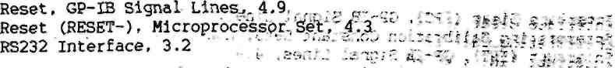
Safety, Setting Up ProcedurW^f^"^ '^i''J**$5* ЗШШШ Self Test, 8.13 , _{a} _,_...., £s* 1-W**P§ ^-1
Self Test Fail, 1.6 ^{ь}'° '$^{П1}*^{Г}- ЭР r.Wj№M.?S$g
Service Request (SRQ), GP-IB Signal Lines, 4.9 M >*^3> V'i
Siqnal Conditioning, Functional Description... 1.3 , . _{t} Split Pads, Presentation of..Information, l.f ?*^{M}-**W* *)#ft#iSS
Test Equipment, Setting Up Procedure,_ .9-1-_-,. *_{г} _{s} ,■
Test Points, Presentation of Irifonria^ie-n," 1\7»!* s9f$.*8№&* **i.»
Test Points, Printed Circuit Board 3. 3.13. .
Test Points, Printed Circuit Board 4, 4.10 j' ;*** fgftK^W&tR
Test Points, Printed Circuit Board 5, 5.8 *•«■ /*J#H*WS f#4$?
Test Points, Printed Circuit Board 6, 6.8 *•$ >*Ш&&$ -ОДДО$ ■
Top Ohms Constants, CALIBRATE ₄.DUMP_{V} .8.8. ;_, ,..
Transmit/Receive Control ^gtiais:0/^X%^/R2f,^^M^:^k$^^Si 4><
Vac Calibration Constants, CALIBRATEf DUHpY 8ДГ⁰⁸⁶* #£*j?£^"^{Vl}\3a#
Vdc Calibration Constants, CALIBRATE, DUMP, 8.8 ,
V-to-T Converter, 5.1 **^{c} * ?i^*P g^ft
Wakeup, Floating Link, 3.1, '"'L.L^l^'¹¹^ Г*³*?? **^' **?*S WR, GP-IB Signal Lines, 4.8 : rj.'j \^**'^{ш}1 "'• '•■": .».-*&'** '•*>
Zener Current Token Value; CAtrSRAfE, Ъинр,:8;8'.;:^| ?Щ\£?&*4
•i,r .K ь?$ое 7?>vr.3'**зт*£# .: •/j .ri?-^
J.-"i:;?7Sc? ,E?f?u/iO i£-:*r>10 2ns vjcc:;? : ?r-v. .'-?■
1 ..т./.'с[-;:.с-С ;6.-0гс-оя^ .\'.cor?-£*«>.■■;$
->'-'..; %£}:{$£$ »&C3W%^"'- -Ф *"t£ sWV
j .; :,^?.^^^ ;W-;? ^:^л

; Ь^£ ::^:л:с;: 2?-3.\rs4
0053g/1122g/PD
(SwSu^^{r}Wff(?

