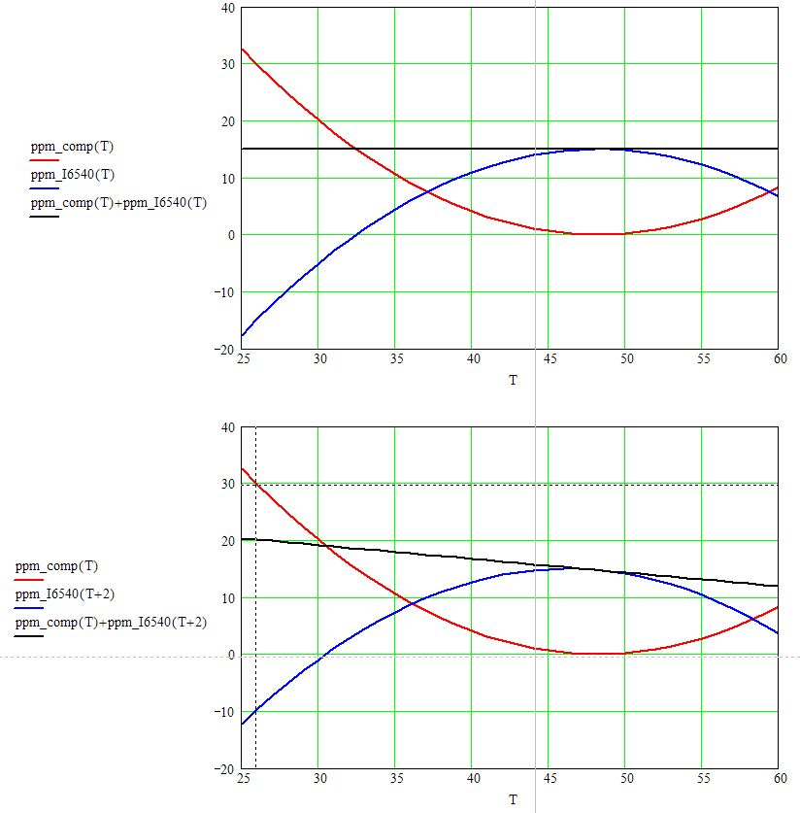
Reference
voltage error, ppm
Temperature
TC compensation
Zener itself
Zener current, uA
AD590 and Zener temperature difference, C. deg.

