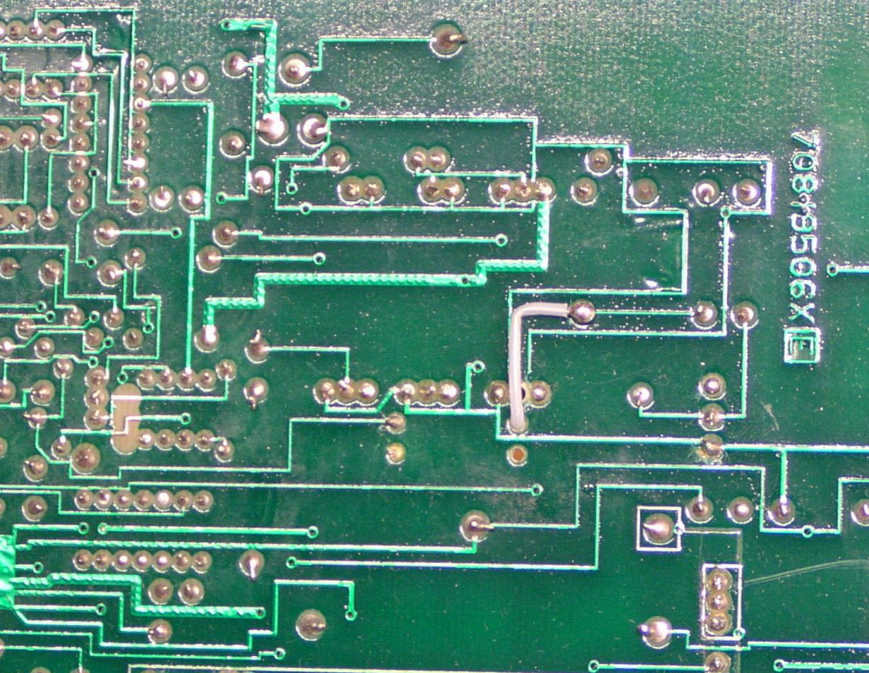
Signal ground
RL704
Guard
IC705 Input
0.1V, 1 V, input protection
D712, D713 …
Coil
(-10 V)
Coil (switch)
Leakage current path

