(11)Publication number | 07-066564
(43)Date of publication of application | 10.03.1995
(51)Int.Cl. | H05K 3/46  H05K 9/00
(21)Application number | 05-232444
(22)Date of filing | 25.08.1993
(71)Applicant | ADVANTEST CORP
(72)Inventor | YADA HIDEKAZU  KIMURA HIROKI

(54)GUARD ELECTRODE STRUCTURE IN MULTI-LAYER PRINTED WIRING BOARD

(57)Abstract
PURPOSE: To prevent an error generated by the inflow of a leakage current into a signal line by a method wherein a guard ring of a low impedance wiring pattern at the same electric potential as a high impedance signal line is formed and is used as a guard electrode of a beta pattern on an internal layer surface to connect with each other via a through hole.
CONSTITUTION: In the periphery of a high impedance signal line 2, a guard ring 3 of a low impedance wiring pattern at the same electric potential as the high impedance signal line 2 is formed. Next, a guard electrode 8 composed of a beta pattern is formed on the internal layer surface 6. A through hole 9 is provided at a narrow pitch as much as possible on a pattern of the guard ring 3 so that the guard electrode 8 can be connected to the guard ring 3. Also, the guard electrode 8 is made to have the same as or be larger than a circumferential radius of the guard ring 3, whereby a leakage current flows from a normal pattern 10 existing on another internal layer 6 or a lowermost layer surface 7 and the influence caused therefrom is completely removed.

CLAIMS
[Claim(s)]
[Claim 1]In structure of guard electrodes (8) of a wiring circuit in a multilayer printed circuit board (1), are in a wiring circuit and around a high impedance signal line (2) by the high impedance signal line (2) and same electric potential, And a guard ring (3) formed in a wiring circuit which is low impedance, Internal-layer surface (6) ** in which the guard ring (3) is not formed provides guard electrodes (8) which consists of a pattern to a bottom-of-the-heap surface (7), Structure of guard electrodes in a multilayer printed circuit board characterized by what a through hole (9) performs [ a thing ] an electrical link for the guard ring (3) and the guard electrodes (8).
[Claim 2]In structure of guard electrodes (8) in the multilayer printed circuit board (1) according to claim 1, An internal-layer surface (6) of a multilayer printed circuit board (1) is wired in a high impedance signal line (2), And structure of guard electrodes in a multilayer printed circuit board characterized by what a guard ring (3) is formed similarly and the guard electrodes (8) are formed in an upper layer surface and a lower layer surface of the internal-layer surface (6) for.

DETAILED DESCRIPTION
[Detailed Description of the Invention]
[0001]
[Industrial Application]In the multilayer printed circuit board used for mounting of the electronic measuring machine machine in an electronic measurement technical field, the present invention relates that a high impedance signal line is affected by the inflow of the weak leakage current from other wiring circuits to the structure of the guard electrodes prevented more reliably.
[0002]With reference to Fig.5 - Fig.7, it describes about a Prior art. As shown in the key map of the example shown in Fig.5, in the wiring circuit on the multilayer printed circuit board 1 (a layered substrate is called hereafter), Since [ which they is high sensitivity, such as summing of 4 circuits of operational amplifiers, ] there are many a certain things by the way, even if the usual high impedance signal line 2 has the inflow of the weak leakage current from other wiring circuits, it produces an error in response to the influence in many cases. As a measure for that, the guard ring 3 which is the signal line 2 and same electric potential, and is low impedance was provided around the high impedance signal line 2, and, usually the influence by the inflow of the weak leakage current from other surrounding wiring circuits is prevented.
[0003]Fig.6 shows the cross sectional view of the layered substrate 1 where it corresponds to the example shown in the key map of Fig.5. Fig.7 is an equivalent circuit where the weak leakage current 5 shows the example of a situation which flows into the high impedance signal line 2 which is 4 circuits of operational amplifiers via the insulation resistance (impedance) Z2 of a layered substrate.
[0004]
[Problem to be solved by the invention]Like other electronic devices, also in the electronic measuring machine machine in an electronic measurement technical field, a miniaturization and high integration are progressing as an indispensable thing so that it may be seen generally. One of the important mounting technology for realizing the miniaturization and high integration has technology of the circuit configuration method in a printed-circuit board. It is how in the limited space, the circuit constituted fulfills an electrical property and realizes high integration. Therefore, in order that the composition of a printed-circuit board may realize miniaturization and high integration, multilayering has been taken in inevitably. Wiring density became high for high integration, and like the example of the Prior art of the aforementioned present invention, the so-called guard ring was provided to the circumference of the wiring pattern (circuit) which is a signal line which is high impedance, and it has corresponded to it, for example so that an electrical property may not be impaired.
[0005]However, although [1] guard ring exerts an effect to the leakage current which it is transmitted about the surface of a printed-circuit board, When the high impedance signal line which should guard the bottom-of-the-heap side ** of a layered substrate from an internal-layer surface exists in an internal layer, moreover, error generating by the inflow of the leakage current from a lower layer is not avoided.
[2] Although a bottom-of-the-heap surface and an internal-layer surface do not provide a wiring circuit, but only the top layer in which a high impedance signal line exists can wire, a guard ring can be provided as the measure, for example and it can also correspond, Space of the stratification plane of many layered substrates which can be mounted will be made useless, and a packaging design in the limited layered substrate space will be difficult. There was a problem to say.
[0006]So, in the present invention, in the wiring circuit constituted in a layered substrate a high impedance signal line, they are high sensitivity, such as summing of an operational amplifier circuit, -- however -- usually -- coming out -- since it is large, even the inflow of the weak leakage current from other wiring circuits should tend to be affected, and since it had become a cause of error generating, eliminate the influence completely. The pan aimed at enabling more effectively practical use of the wiring pattern space which a layered substrate has.
[0007]
[Means for solving problem]In order to achieve the aforementioned object, in the structure of the guard electrodes of the present invention, the structure of the guard electrodes which make possible total exclusiveness of the influence by the leakage current to a high impedance signal line in the cut nothing profitable multilayer printed circuit board was taken only by the Prior art. Fig.1 is a case where the high impedance signal line 2 is wired in the top layer surface 11 of the layered substrate (this example cross sectional view in four layer boards) 1. At this time, the guard ring 3 which is the signal line 2 and same electric potential, and is a low impedance wiring pattern is first formed in the circumference of the high impedance signal line 2. So far, it is that the Prior art has also been performed. Next, it has composition connected with the guard ring 3 which formed the guard electrodes 8 in the internal-layer surface 6 by the solid pattern (** is a mesh pattern) by the present invention, and was formed in the above-mentioned top layer surface 11 in the through hole 9. By this, the influence by the leakage current from the usual pattern (pattern with the electric potential which gives an error) 10 of the guard electrodes 8 which is in an internal-layer surface (here the third layer) and the bottom-of-the-heap surface 7 further can be eliminated.
[0008]As for the node by the above-mentioned through hole 9, it is preferable to carry out by providing in the narrowest possible pitch. The guard electrodes 8 formed are ranges equivalent to the peripheral diameter of the guard ring 3, or possible, and are good to consider it as larger form than it.
[0009]
[Function]A working effect of the present invention is described by Fig.3 and Fig.4. It is for Fig.3 describing the functions and effects of the present invention in a layered substrate (this example cross sectional view in four layer boards), and Fig.4 shows the equivalent circuit to the electric circuit of Fig.3. In the figure, An error. The electric potential to give. The voltage of the usual pattern 10 which it has. For the insulation resistance (impedance) from Z1V1 to the guard electrodes 8, if impedance of Z3 high-impedance signal line 2 is set to Z4 for the insulation resistance (impedance) from the Z2 guard electrodes 8 to the high impedance signal line 2, the impedance of the V1 guard electrodes 8, Leakage current IR5 which flows into a high impedance signal line is IR=V1/Z0 and Z1/(Z1+Z3+Z4).
However, Z0=Z2+(Z1, Z3+Z1, andZ4)/(Z1+Z3+Z4)
Since it is Z1<<Z2, and Z3 and Z4, IR serves as a very small value in ** in which IR is substantially equal to V1/Z2 and Z1/(Z1+Z2+Z3). as compared with the case where there are no guard electrodes, it becomes abbreviation Z1-/(Z1+Z2+Z3) twice --)
[0010]
[Working example]Next, it describes about the composition of the structure of the guard electrodes in the multilayer printed circuit board (layered substrate) in the present invention.
[0011]It describes by the layered substrate (this figure four layer boards) shown in Fig.1. First, moreover, the guard ring 3 which is a wiring pattern of low impedance is formed in the circumference of the high impedance signal line 2 by the signal line 2 and same electric potential by a Prior art. Next, among those, the guard electrodes 8 which consists of a solid pattern (or mesh pattern) are formed in the stratification plane 6 (here the 2nd stratification plane). The through hole 9 in the narrowest possible pitch is provided for the guard electrodes 8 and above-mentioned guard ring 3 on the pattern of the guard ring 3, and the guard electrodes 8 are connected. The guard electrodes 8 are taken as what [ equivalent to the peripheral diameter of the guard ring 3 or ] is larger than it. By this, the influence by the leakage current and IR5 from the usual pattern (pattern with the electric potential which gives an error) 10 which exists in other internal-layer surfaces 6 and bottom-of-the-heap surfaces 7 has eliminated completely.
[0012]When the high impedance signal line 2 is arranged like the Example shown in Fig.2 in the internal-layer surface 6 (here the third stratification plane), the same guard ring 3 as the above is provided around it, and the guard electrodes 8 are provided to the upper layer surface (here secondary layer surface) and lower layer surface (here fourth stratification plane). And the guard ring 3 and guard electrodes 8 are connected by the through hole 9 in the same manner as the above. The influence from the usual pattern 10 with the electric potential which gives the error which exists in other layers by that has been eliminated completely.
[0013]This can be carried out, if how many layers the composition of the layered substrate 1 will be, and if a high impedance signal line will be in many places of the same stratification plane and I will be in each of the class surface of a layered substrate.
[0014]
[Effect of the Invention]Since the present invention is constituted as described above, it produces an effect as taken below.
[0015][1] The error occurrence prevention by the inflow of the leakage current to the cut high impedance signal line profitable nothing has prevented completely by taking the structure of the guard electrodes of the present invention only in the measure against processing in the guard ring by a Prior art.
[2] A wiring pattern can be designed very freely after the third stratification plane by considering it as the constituent of the present invention which arranges a high impedance signal line to a top layer surface (for example, first pass surface), and arranges guard electrodes in a secondary layer surface in it.
[3] Therefore, there is no futility as space of a wiring pattern, and it can utilize now very effectively the space of the whole stratification plane which a layered substrate has.

DESCRIPTION OF DRAWINGS
[Brief Description of the Drawings]
A [FIG. 1] It is a cross sectional view showing the structure of the guard electrodes in the Example in the multilayer printed circuit board by a constituent of the present invention.
A [FIG. 2] Although it is a cross sectional view showing the structure of the guard electrodes by a constituent of the present invention, it is an Example in case a high impedance signal line is arranged in an internal-layer surface.
A [FIG. 3] Although it is a cross sectional view showing the structure of the guard electrodes in the layered substrate by a constituent of the present invention, it is a key map for describing the functions and effects of the present invention.
A [FIG. 4] It is for describing the functions and effects of the present invention, and the equivalent circuit of the electric circuit in Fig.3 is shown.
A [FIG. 5] It is a key map showing the case where the guard ring currently performed by the technology from the former is arranged.
A [FIG. 6] It is for describing about the technology from the former, and the cross sectional view of Fig.5 is shown.
A [FIG. 7] It is for weak leakage current to describe the principle which flows into the high impedance signal line of an operational amplifier circuit via the insulation resistance of a layered substrate, and gives an error, and a representative circuit schematic is shown.
[Explanations of letters or numerals]
1 Multilayer printed circuit board (layered substrate)
2 High impedance signal line
3 Guard ring
4 Operational amplifier
5 Leakage current IR
6 Internal-layer surface
7 Bottom-of-the-heap surface
8 Guard electrodes
9 Through hole
10 The usual pattern
11 Top layer surface

DRAWINGS
A [FIG. 1]
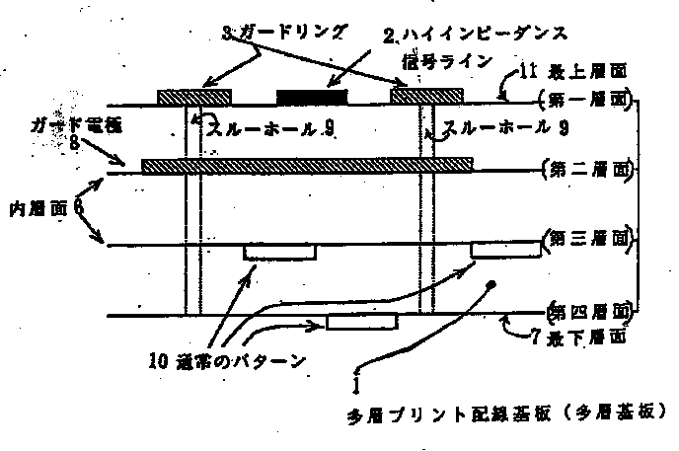
A [FIG. 2]
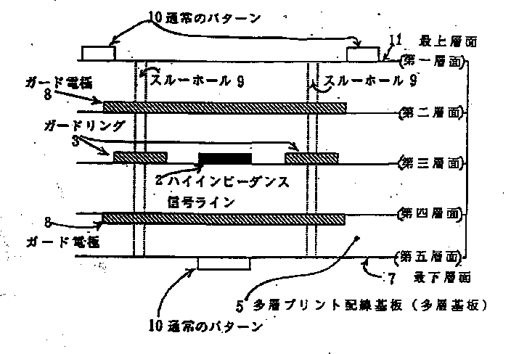
A [FIG. 4]
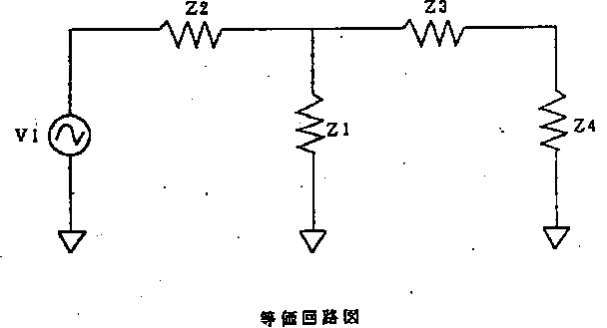
A [FIG. 6]
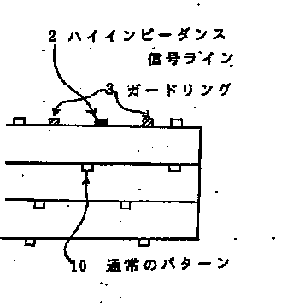
A [FIG. 7]
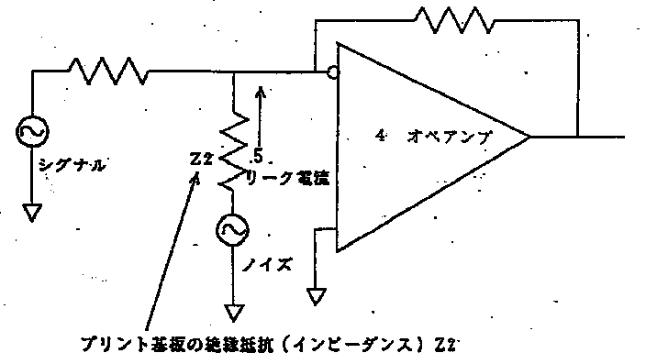
A [FIG. 3]
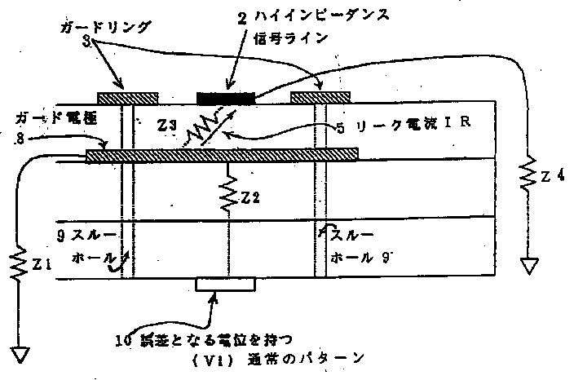
A [FIG. 5]
