(11)Publication number | 06-123751
(43)Date of publication of application | 06.05.1994
(51)Int.Cl. | G01R 27/02  G01R 31/02
(21)Application number | 04-271957
(22)Date of filing | 09.10.1992
(71)Applicant | ADVANTEST CORP
(72)Inventor | YADA HIDEKAZU  OCHIAI SHIGEYUKI

(54)CONNECTION TEST METHOD FOR FOUR-WIRE RESISTANCE MEASUREMENT AND FOUR-WIRE RESISTANCE MEASURING UNIT CAPABLE OF EMPLOYING THE METHOD

(57)Abstract
PURPOSE: To allow decision making on whether a cable is disconnected and which cable is disconnected, prior to calculation of resistance to be measured by measuring the voltage across the resistance to be measured and the voltage of one current cable.
CONSTITUTION: Current flows from a current supply 5 through two current cables L1, L4 into a resistance Rx to be measured. Two voltage cables L2, L3 are connected in order to measure the potential difference between the opposite ends of the resistance Rx. Three voltages V1, V2, V3 are then measured using switches S1, S2, S3 thus confirming connection of four cables L1-L4. In other words, the voltage V3 is measured, and when it represents overload, the cable L4 is disconnected whereas when the voltage V3 is close to 0, the cable L3 is disconnected. Subsequently, the voltage V1 is measured and if it represents overload, the cable L1 is disconnected. If the voltage V2 is not sufficiently close to the voltage V1, the cable L2 is disconnected. Dicision is made in this order.

CLAIMS
[Claim(s)]
[Claim 1]It is the method of checking disconnection of a cable or un-connecting, [ which is four path cords to resistance to be measured in 4-wire system measure resistance ] Equipment which measures voltage of another side to both ends of resistance to be measured on the basis of one side of a connecting terminal which connects two current cables connected, respectively, respectively, It provides besides equipment which measures each voltage of a connecting terminal which connects two voltage cables connected to both ends of the resistance to be measured, respectively, respectively, A connection testing method before execution of 4-wire system measure resistance which checks connection with resistance of the four above-mentioned cables to be measured by measuring these three voltage.
[Claim 2]It is based on one side of two connecting terminals which connect two current cables connected to resistance to be measured, Voltage of a connecting terminal of a voltage cable connected to resistance to be measured in the direction of a side to which current cables made into this standard are connected is measured, . [ whether the absolute value is greater than reference value with it near 0 next in whether it is an overload, and ] Voltage of a connecting terminal of a direction which was not made into the above-mentioned standard of current cables is measured, Voltage of a connecting terminal of a voltage cable of a side different from the above is measured [ whether it is an overload and ] next, The path cord test method according to claim 1 before execution of 4-wire system measure resistance which checks disconnection or whether four cables are connected in an order of judging whether it being close to voltage of a connecting terminal of a direction which it did not make a standard of previous current cables enough, or it has connected.
[Claim 3]Besides [ which is a 4-wire system measure resistance machine which performs 4-wire system measure resistance, and provides a switch which can intercept each of that cable run to two cable runs which connect two connecting terminals and internal circuits for measurement for connecting two voltage cables which measure voltage of both ends of resistance to be measured, respectively, respectively, respectively ], In order to measure voltage of a cable run of a direction which is not made into a standard of an amplitude measurement among two cable runs which connect two connecting terminals which connect to resistance to be measured two current cables which send current, respectively, and current sources, respectively, A 4-wire system measure resistance machine which enabled it to perform easily a connection confirm of a cable of 4-wire system measure resistance constituting the cable run and internal circuit for measurement of a direction to measure so that an electrical link can be performed via a switch.
[Claim 4]After performing connection work to resistance to be measured, a cable which are four path cords to resistance to be measured in 4-wire system measure resistance, About all the combination of six kinds of cables which combine two of these four, correspond to those six kinds, do an examination of whether between connecting terminals which connected those two cables conducts 6 times, and by 6 times of that test result, A connection testing method before execution of 4-wire system measure resistance which checks connection with resistance of said four cables to be measured.
[Claim 5]In six continuity tests to which it corresponds to the six kinds performed about all the six-kind combination that combines two cables among four cables, The connection testing method according to claim 4 characterized by giving a different evaluation value for every time of that, and enabling it to judge which cable is disconnected with a value which all the evaluation values totaled when a result of being non-conducting came out for every time of that.
[Claim 6]It is a 4-wire system measure resistance machine which performs 4-wire system measure resistance, When six kinds of connection test circuits which can do mechanically six kinds of energization examinations done combining two cables among four cables use a switch selectively. The 4-wire system measure resistance machine according to claim 3 characterized by incorporating a relay selection circuit which consists of combination of a relay contact which can be constituted between a cable connection terminal of the 4-wire system measure resistance machine, and an internal circuit for measurement, and enabling it to use the relay selectively.

DETAILED DESCRIPTION
[Detailed Description of the Invention]
[0001]
[Industrial Application]although the present invention has technology of the 4-wire system measure resistance for measuring resistance, especially low resistance value correctly, it relates to the cable connection check which checks whether four connecting cables (it is only called a cable) which make the cable run for connection of these four lines are reliably connected to resistance to be measured.
[0002]
[Description of the Prior Art]To the both ends of resistance to be measured, 4-wire system measure resistance connects the current cables for sending known current to the resistance, respectively, and sends known constant current through the resistance to be measured from the current source of a measuring instrument via these current cables. Thus, in order to know the potential difference between the both ends of the resistance when known current is flowing into resistance to be measured, connect two voltage cables linked to the both ends of the resistance to the connecting terminal of a measuring instrument, but. There is technology for measuring especially low resistance correctly of measuring and having the potential difference between these both ends, making the error by resistance of a voltage cable small as long as it is possible as current is not sent, as long as it is possible on this voltage cable, and measuring resistance.
[0003]The measuring circuit which actually carries out this measurement is shown in Fig.8. R_{x}of the figure shows resistance to be measured, L₁ and L₄ are current cables, respectively, and L₂ and L₃ are voltage cables. It is connected to the both ends of illustrated resistance R_{x} to be measured, respectively. The known current i is sent through resistance R_{x} to be measured from a current source, the switches S1 and S2 are closed in turn, and voltage V₂ and V₃ of both ends of resistance R_{x} to be measured are measured. Since input amplifier AMP is high impedance, the cable run which goes into input amplifier AMP which is one copy of the internal circuit for measurement through the switches S1 and S2 via the connecting terminal (1, 2, 3, 4) of the measuring instrument displayed by O seal from this voltage cable L₂ and L₃ further is. Current does not flow into L₂ and L₃ substantially, therefore the voltage drop by resistance of voltage cable L₂ and L₃ is set, and since there is nothing, it can measure potential difference V₃-V₂ between **** of R_{x} correctly. And since the constant current i is known, it can calculate resistance with a following formula.
[0004]R_{x}=(V₃-V₂)/i [omega]
(Only S1 is turned ON by Fig.8, V₂ is measured, and next, only S2 is turned ON and measures V₃.)
[0005]
[Problem to be solved by the invention]In current cables (L₁ and L₄), in this 4-wire system measure resistance, current does not flow into resistance to be measured at the time of disconnection or un-connecting (it shall also mean un-connecting with disconnection). At this time, the potential difference between resistance terminals to be measured may be set to 0V, and may be accidentally measured with R_{x}=0 [omega]. If the voltage cable (L₂ and L₃) is disconnected, the input to the internal circuit 6 for measurement of Fig.8 will become open, and measured value will become unstable, but there is no telling which cable is disconnected, from the direction of measured value.
[0006]The description in that case is added as a case where only one cable which may often among four cable L₁ shown by Fig.8, L₂, L₃, and L₄ happen has disconnected this.
(1) L₁ -- disconnection: -- since current does not flow into resistance R_{x} to be measured, in order to measure voltage with V₂ and V₃ with the same zero V, R_{x} carries out an erroneous decision to zero omega by a front type. In this case, since measured value is stably, it is not known that the trouble has occurred.
(2) L₂ -- disconnection: -- in the voltage which corresponds to V₂, the measured value of ******, therefore R_{x} serves as instability (it becomes an unexpected value and, moreover, does not become settled), and it turns out that the trouble has occurred.
(3) L₃ -- disconnection: -- the voltage which corresponds to V₃ becomes unstable [ the measured value of ******, therefore R_{x} ], and it turns out that the trouble has occurred.
(4) L₄ -- disconnection: -- it will be in the state where it was like resistance infinite as resistance to be measured having been connected, and since both V₂ and V₃ become an overload (it means measuring the big no-load voltage of a constant current source.), they turn out to be a trouble occurrence.
[0007]As mentioned above, since measured value serves as instability or an overload, it turns out that the trouble occurred, but when cable L₁ is disconnection, wrong measurement of the time of disconnection of only one of cable L₂, L₃, and L₄ will be carried out [ that a trouble is not known ]. That is, it is not known that the trouble has generated disconnection of L₁ from the measurement result.
[0008]Then, if it does not understand before disconnection of L₁ measuring, will be troubled, but. Since measured value is not obtained unless it understands before disconnection mist beam measurement of cables other than L₁, when it understands whether disconnection of a cable is before measurement by the ****** method, and which cable disconnected further, it is very convenient and convenient.
[0009]Since it was not restricted but two or more may have disconnected it, only one is much more convenient, when disconnection of a cable is understood that that was also taken into consideration and which and which have disconnected it.
[0010]The present invention sets it as the purpose to obtain the existence of disconnection of a cable, distinction of which cable is disconnected, and the means that can distinguish which cable and which cable are disconnected further in the stage before computing the value of resistance to be measured by solving these problems.
[0011]
[Means for Solving the Problem and its Function]The present invention starts 4-wire system measure resistance, and relates to a method using a measuring instrument which can perform the measurement, and its measuring instrument. There is a current source for sending existing known ****** current to resistance to be measured in the measuring instrument, and it makes it the current flow into resistance R_{x} to be measured via two current-cables L₁ and L₄which are connected to a connecting terminal of a measuring instrument. And two voltage cable L₂ for measuring potential difference for both ends of resistance R_{x} to be measured and L₃ are connected also to a connecting terminal of a measuring instrument, and a measurement setup is carried out.
[0012]It is related with checking whether connection of four cables which did in this way and carried out a measurement setup of the present invention is perfect, before measuring, and one electric potential of a connecting terminal which connected current cables is made into a standard (it usually grounds), Voltage of a connecting terminal of current cables of a direction which was not made into a connecting terminal of two voltage cables and a standard is measured. at this time, the switch S3 (refer to Fig.1) for measuring voltage of a connecting terminal of current cables of a direction which it not only measures voltage of a connecting terminal of two voltage cables, but was not made in particular into a standard using the switches S1 and S2 in a Prior art is provided. But this switch S3 is not provided in a 4-wire system, although it provides ordinarily by a measuring method which uses a cable of L₁ and L₃by 2-wire system measure resistance.
[0013]And this switch S3 is also used, three voltage is measured with the switches S1 and S2, and connection of four cables was checked with that voltage.
[0014]Since there are many a things even if it is common that there is no disconnection as for each cable and it disconnects, it may judge as follows with three upper voltage to find it out noting that there is any 1 disconnection first.
[0015]Namely, measure voltage of a connecting terminal of a voltage cable on the standard side, and cable L₄ will be disconnected if it is an overload, Cable L₃ is disconnected if a value with it near [ that is not right and ] 0 is not shown, Next, measure voltage of a connecting terminal of current cables which are not standard sides, and cable L₁ will be disconnected if it is an overload, Next, if a value with voltage of a connecting terminal of a voltage cable which is not a standard side near sufficiently for voltage of a connecting terminal of current cables which are not the standard sides is not shown, a way cable L₂ judges in an order of disconnection is good.
[0016]In addition, if a process in which a value of constant current which makes a range and exaggerated judgment that a measurement range is unsuitable, and it sends through resistance R_{x} to be measured is lowered is added when a connecting terminal of a voltage cable as for which a standard side does not come out at this time shows voltage near an overload, it will become much more convenient for measurement of actual R_{x}.
[0017]A case where a possibility that disconnection did not restrict with one but two or more have next occurred is also considered is described. If confirmation work also including this possibility is performed, earlier more certain work can be done.
[0018]Although the present invention uses a total of four cables of two current cables and two voltage cables in the target 4-wire system measure resistance, It should energize, if not every cable has disconnection and it is connected to R_{x}, and it investigates whether two of four connecting terminal throats to which these four cables are connected are chosen, and it energizes between these two terminals. If one of these four cables is disconnected, there must be combination of a connecting terminal which is not energized. An energization examination is done using this idea.
[0019]Although there are six kinds of combination which combines any two cables among four cables, an energization examination of whether energization to other connecting terminals [ connecting terminal / one ] is made about six kinds of the all is done. Four kinds in this six-kind energization examination investigate connection via resistance R_{x} to be measured, and two kinds of remaining things investigate connection of two cables through a connecting terminal, without passing R_{x}. And it can be judged that there is no cable which will have been disconnected if these six-kind energization examinations of all are energization. And if one cable has disconnection, three of six kinds of kinds will not energize, but if two cables have disconnection, only one only of six kinds of kinds will be energized. Although distinction with a case where a case where three cables have disconnected this way, and all the cables are disconnected is not attached, If distinction in case there is three or more disconnection not only sticks, but a result of six kinds of this energization examination is analyzed [ when normal, ] when there is one disconnection, and there is two disconnection, Resistance R_{x} to be measured can carry out a range which is too larger than a predetermined value, and a judgment of which cable or a cable of which and which unless it is exaggerated, is disconnected.
[0020]And by six kinds of this energization examination, since a range and judgment of being exaggerated can also be performed subordinately, it can judge which cable or cable of which and which in one or two disconnection, is disconnected. And in six continuity tests to which it corresponds to the six above-mentioned kinds for performing this easily, If a result of being non-conducting comes out for every time of that and an evaluation value which is different in ****** each other for every time of that will be given, convenience that it can judge which cable or a cable of which and which is disconnected with all the total values of the evaluation value can be obtained.
[0021]And a relay selection circuit which included a relay contact in the inside side of a connecting terminal of a measuring instrument as a device for making easy six kinds of this energization examination can be provided, and a circuit which can do six kinds of upper energization examinations can be constituted by using these relays and choosing ON/OFF of contact. That is, a relay selection circuit can be incorporated between four connecting terminals and an internal circuit for measurement of a measuring instrument of a measuring instrument, and a circuit which can do automatically six kinds of above-mentioned energization examinations can be constituted by using the relay selectively and in turn.
[0022]Provide a stage of examining automatically whether the present invention having disconnection of a cable before calculating resistance of R_{x} with a 4-wire system measure resistance machine, or there being nothing, and it is shown which cable when there is disconnection, is disconnected, Only when normal in any way, it is good to make it give a play so that resistance of R_{x} may be calculated. And as it includes in a process in which existence of the above-mentioned disconnection of a process in which judgment that it is better for resistance of R_{x} to change a range of measurement into a stage of investigating whether these cables being disconnected, largely from a schedule range can be performed is investigated, automation of operation can be attained.
[0023]
[Working example]An Example of the present invention is shown in Fig.1. As for resistance to be measured, L₁, and L₄, as for a voltage cable and O seal, current cables, L₂, and L₃ are [ R_{x} / a switch, AMP and A/DC of a connecting terminal of a measuring instrument, and S1, S2 and S3 ] the inner circuits 6 for measurement. The figure provides S3 other than S1 and S2 which are usually used by 4-wire system measure resistance, as shown in the figure, and it enables it to measure it in an internal circuit for measurement by closing electric potential of a point of V₁at contact of S3 besides V₂ and V₃. Since a switch which corresponds to these S3 in 2-wire system measure resistance which does not use voltage cable L₂ and L₃ usually exists, it does not need to provide S3 anew in a measure resistance meter which can do a 2-wire system and a 4-wire system. It becomes new composition to use these S3 for a 4-wire system then. When there is disconnection of two or more cables, the example of this figure needs to repeat a judgment process and is slightly unsuitable.
[0024]After connecting cable L₁, L₂, L₃, and L₄ to R_{x} and preparing measurement according to a flow chart as shown in Fig.2 using a circuit of Fig.1, If V₁, V₂, and V₃ are measured, and it judges and goes by this flow chart based on each judgment matter by predetermined turn, it can judge which cable is disconnected. And when every cable can be judged that there is no disconnection, a cable check is ended and resistance of R_{x} is computed by a conventional method.
[0025]If it judges by measuring V₁, V₂, and V₃ according to this flow chart, the judgment that the value of R_{x} is too large and it should change a measurement range can be performed in the process of the judgment which investigates disconnection of a cable.
[0026]A description is added to this flow chart. If L₄ has disconnected the overload in V₁, V₂, and V₃ of after-measurement judgment [I] of V₃, it means that the big load voltage of a current source appears in V₃. Since V₃ does not become a value near zero (ground potential), but it will become the value separated from 0 although it is unstable if L₃ is disconnected, the value near 0 as reference value may be beforehand determined as the |V₃|> reference value of the following judgment [II] suitably. It means that the following judgment [III] can make judgment that not existence but R_{x} of cable disconnection are that exceeding the schedule range (the constant current sent through R_{x} in practice is too large.), and it is appropriate to make a measurement range small. That is, I hear that the constant current sent through R_{x} is made small, and measurement of V₁, V₂, and V₃ is redone, saying "it is judged as an overload and proceeds to the next." It is certain if all are remeasured. (V₃ does not need to measure.) R_{x} is in addition good at this time to indicate by a purport too greatly. Since big load voltage appears in V₁ when L₁ is disconnection, the following judgment [IV] sees this voltage whether come out or not. If its V₂ must be substantially equal to V₁ if L₂ has not disconnected the following judgment [V], and L₂ is disconnected, since V₁ will show a different unstable value, V₂, It is going to judge the existence of disconnection of L₂ by whether V₂ is substantially equal to V₁.
[0027]The flow chart of Fig.2 can be changed. Although judgment [I] and judgment [IV] need to be in this order, others can change them. Judgment [III] has the good judgment [I] back. Furthermore, the measurement period of V₁, V₂, and V₃ may be measured [ by ], when making each judgment and the data is needed. Probably, the illustrated order of the order of judgment will be convenient, since judgment [IV] and judgment [V] may be performed after it is judgment [III], it can omit judgment [IV] and judgment [V] when R_{x} can be judged to be an overload and a measurement range is changed, and making it the following measurement range.
[0028]Next, although one disconnection of four cables is natural, it can do about the Example performed in consideration of the possibility of two or more disconnection.
[0029]The Example is shown in Fig.3. a relay selection circuit -- seven -- a switch -- S4 -- S -- five -- S -- six -- S -- seven -- S -- eight -- S9 -- this -- an Example -- a sake -- a measuring instrument -- a connecting terminal -- measurement -- ** -- an internal circuit -- between -- having described above -- six -- a kind -- energization -- an examination -- easy -- carrying out -- a sake -- incorporating -- having had -- a relay contact -- it is . Although it is a thing of a ****** sake about the work as a front Example with the same switches S1, S2, and S3 and is for measuring V₂, V₃, and V₁, respectively, Especially in the case of this Example, in that energization examination, if you use the switch S3 in order to judge whether two selected cables energize, it is useful. switch S4 and S5 are change-over switches -- respectively -- the (a and c) -- or (b and d) are simultaneously set to ON and it becomes off, and the relay is used so that either (a and c), or (b and d) may be chosen as ON.
[0030]The energization circuit of six patterns in which it corresponds to six energization examinations mentioned above using the circuit shown in this Fig.3 is made. And a relay is used and contact is chosen so that each of the energization circuit can do each contact.
[0031]Pattern 1: Send the connection check current of cable L₁ and L₄ in order of S9-S5 c-L₄-R_{x}-L₁-S4a-S6, measure the electric potential of V₁, and investigate whether it is an overload. When either L₁ or L₄ is disconnection, V₁ serves as an overload.
[0032]Pattern 2: Send the connection check current of cable L₁ and L₃ in order of S9-S5 b-L₃-R_{x}-L₁-S4a-S6, measure the electric potential of V₁, and investigate whether it is an overload. When either L₁ or L₃ is disconnection, V₁ serves as an overload.
[0033]Pattern 3: Send the connection check current of cable L₂ and L₃ in order of S9-S5 b-L₃-R_{x}-L₂-S4d-S6, measure the electric potential of V₁, and investigate whether it is an overload. When either L₂ or L₃ is disconnection, V₁ serves as an overload.
[0034]Pattern 4: Send the connection check current of cable L₂ and L₄ in order of S9-S5 c-L₄-R_{x}-L₂-S4d-S6, measure the electric potential of V₁, and investigate whether it is an overload. When either L₂ or L₄ is disconnection, V₁ serves as an overload.
[0035]Pattern 5: Send the connection check current of cable L₁ and L₂ in order of S8-S4c-L₂-L₁-S4a-S6, measure the electric potential of V₁, and investigate whether it is an overload. When either L₁ or L₂ is disconnection, V₁ serves as an overload.
[0036]Pattern 6: Send the connection check current of cable L₃ and L₄ in order of S9-S5 c-L₄-L₃-S5 a-S7, measure the electric potential of V₁, and investigate whether it is an overload. When either L₃ or L₄ is disconnection, V₁ serves as an overload.
[0037]It can judge which cable (also including plurality) the electric potential of V₁ was measured about the above six patterns, and is disconnected by the result. Although it is one useful means to investigate whether between the connecting terminals which connected two cables energizes, it is good by other means to measure the electric potential of V₁.
[0038]Although the current path could be acquired by using the switch of the relay selection circuit selectively in the circuit which showed the six above-mentioned patterns by Fig.3, the figure which displayed selection of ON/OFF of each switch about each of that pattern, i.e., setting out of a switch, was shown as Fig.4. X of the figure [0039]
[External character 1]
Yes, although it is ON whether it is a gap, in the pattern (the pattern 5 or the pattern 6), it expresses that whichever may be ON.
[0040]It expressed with the figure (the 1) which displayed the cable which confirms whether the electric potential of V₁ about the above six patterns is an overload, or there is nothing on the upper line, and displayed the referee conditions which are the decision tables of Fig.5 and Fig.6 about a decision table (the 2). The time of the time of the size of R_{x} being in the range of the range to measure having too larger than a schedule a size of R_{x} at Fig.5 is denoted by Fig.6. The numerical value given to the lowermost row of Fig.5 and Fig.6 is an evaluation value in each pattern of six judgments. For example, if it is disconnected (at the time of V₁ overload [HI of Fig.6 and Fig.7]) in the connection check of L₁ of the pattern 1, and L₄, the evaluation value will be set to 32. Normalcy is set to 0. What totaled the evaluation value about six patterns is expressed to the rightmost sequence of Fig.5 and Fig.6 in the evaluation value of each pattern. The disconnection or the normal state of the cable of L₁L₂L₃L₄ expressed to the direction on the left-hand side of these two figures by the numerical value of that evaluation is discriminable. But a range and when exaggerated, a limit has a time of three or more cables being disconnection, and R_{x} in identification.
[0041]It is good to lower the constant current which R_{x} operates a current source and sends through R_{x} when it is judged with it being exaggerated, a range and, that is, to change a range, and to redo an energization examination.
[0042]And the result that all are normal comes out. That is, when the sum total of an evaluation value is 0 in Fig.6, the resistance of the R_{x} will be calculated by a Prior art, but [ therefore ] the value of V₂ and V₃ will be measured.
[0043]although it is how to measure V₂ and V₃ when all connection of a cable becomes normal when the circuit of Fig.3 is used -- the constant current at that time -- the order of S9-S5 c-L₄-R_{x}-L₁-S4a-S6 -- flow -- the bottom uses as. Since S4c and S5a are set to ON at this time, S1 is turned ON first and V₂ is measured in the internal circuit for measurement. Next S1 is turned OFF, S2 is set to ON, and V₃ is measured similarly. In this way, since the constant current i at this time is known and understands V₂ and V₃ by measurement, the value of R_{x} is computed by an operation.
[0044]As mentioned above, although the circuit of Fig.3 is conveniently used to an energization examination and the measurement at the time of normal, it can consider the Example of the deformation which used the comparator instead except for S3 of the figure. It is shown in Fig.7. In the case of this figure, other portions, such as a relay selection circuit, are a case of the Example of Fig.3, and an identical configuration.
[0045]
[Effect of the Invention]Since it can check before measurement of resistance that the present invention has a defect of disconnection of the cable in 4-wire system measure resistance. High reliability can be given to calculation of resistance, and it becomes, without it seeming that wrong measurement is carried out like before, and the characteristics that this is easily automatable also have the method of this invention further. And the range and the exaggerated detection process of R_{x} are easily incorporable in the check process of the cable connection of the present invention.

DESCRIPTION OF DRAWINGS
[Brief Description of the Drawings]
A [FIG. 1] The circuit configuration figure showing the Example of the present invention
A [FIG. 2] The flow chart for a description of operation which uses the circuit of Fig.1
A [FIG. 3] The circuit configuration figure showing other Examples of the present invention
A [FIG. 4] The figure which displayed the switch established state of the example which uses the circuit of Fig.3
A [FIG. 5] The figure which displayed the referee conditions for judging the existence of disconnection using the circuit of Fig.3 (the 1)
A [FIG. 6] The figure which displayed the referee conditions for judging the existence of disconnection using the circuit of Fig.3 (the 2)
A [FIG. 7] The circuit configuration figure showing another Example replaced with the circuit of Fig.3
A [FIG. 8] The circuit configuration figure showing the example for performing the conventional 4-wire system measure resistance
[Explanations of letters or numerals]
1, 2, 3, and 4 Connecting terminal
5 Current source
6 The internal circuit for measurement
7 Relay selection circuit
S1, S2, S3, S4, S5, S6, S7 and S8, and S9 Switch
L₁, L₂, L₃, L₄ cable
R_{x} resistance under test
8 Comparator
9 Micro CPU I/O Port

DRAWINGS
A [FIG. 1]
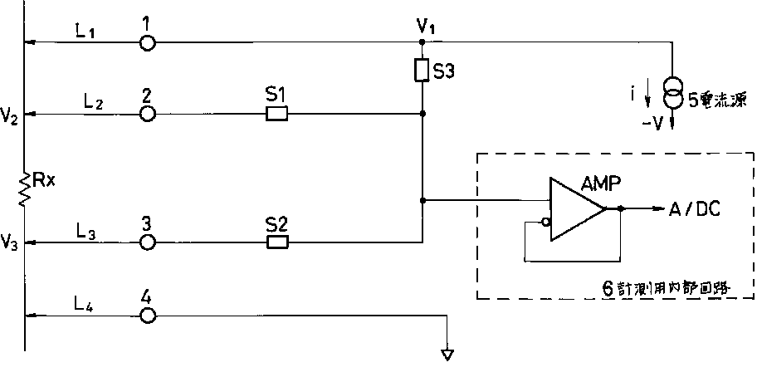
A [FIG. 3]
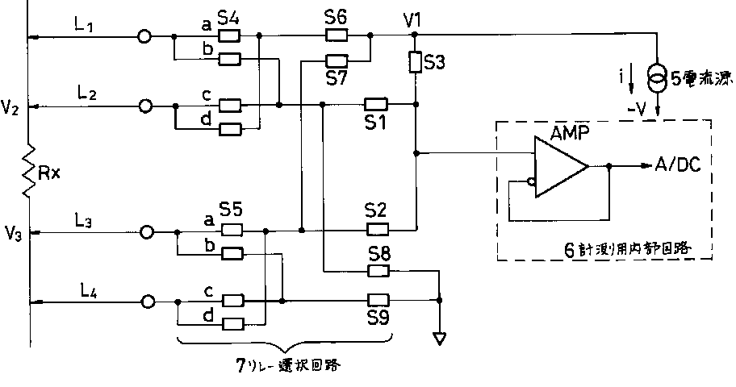
A [FIG. 4]
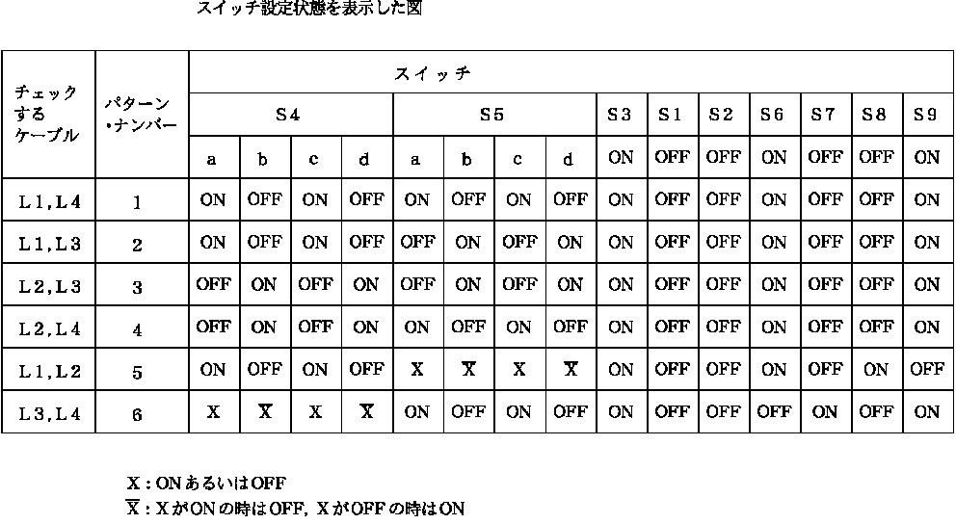
A [FIG. 2]
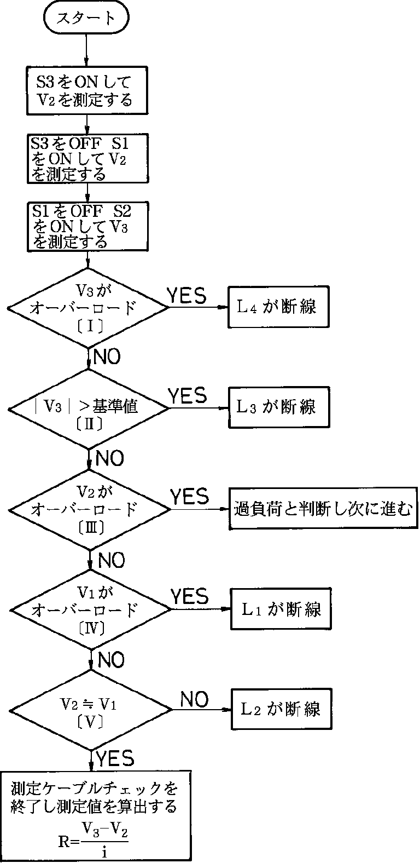
A [FIG. 5]
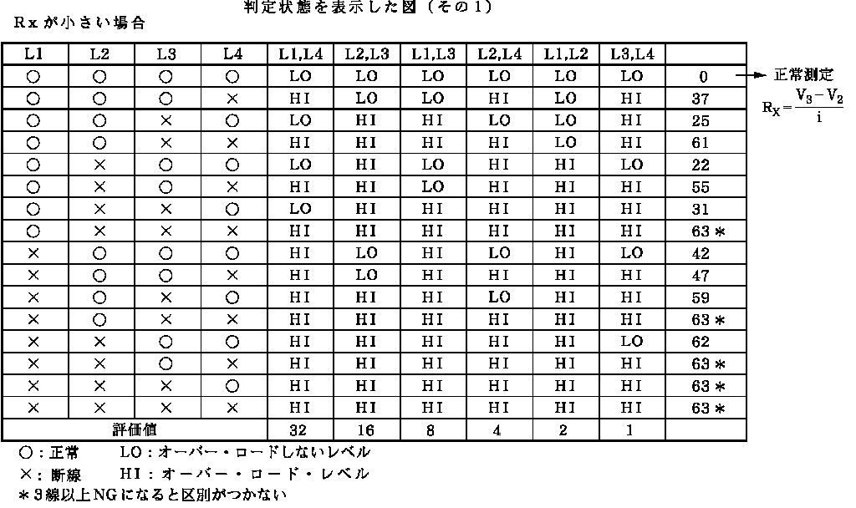
A [FIG. 6]
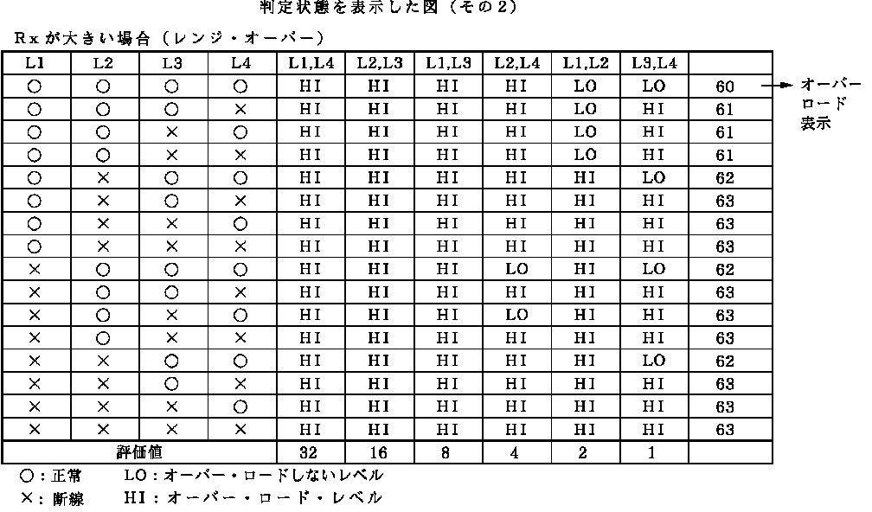
A [FIG. 7]
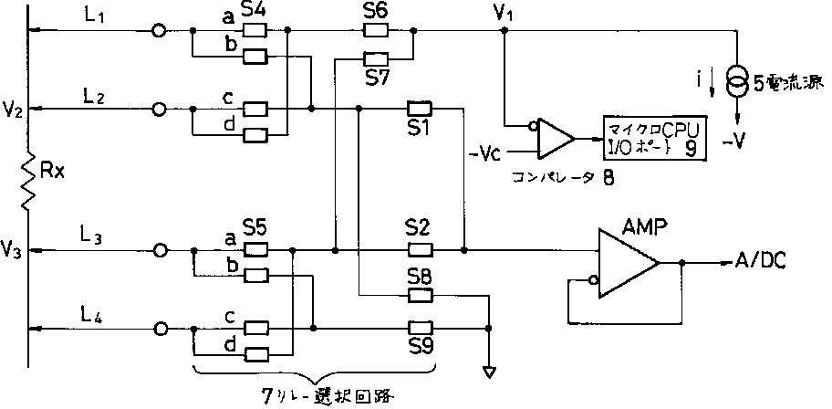
A [FIG. 8]
