(11)Publication number | 05-288778
(43)Date of publication of application | 02.11.1993
(51)Int.Cl. | G01R 15/08  G01R 27/02
(21)Application number | 04-092908
(22)Date of filing | 13.04.1992
(71)Applicant | ADVANTEST CORP
(72)Inventor | YADA HIDEKAZU

(54)IMPEDANCE MEASURING EQUIPMENT

(57)Abstract
PURPOSE: To perform measurement by reaching an optimum range in a short time.
CONSTITUTION: In the case of measurement of resistance, it is asked whether a lower range is specified or not, specification by a key 4 is received when the lower range is specified. Then, it is asked whether an upper range is specified or not, specification by the key 4 is received when the upper range is specified. The specified auto range is rewritten into a memory 5, range shift by the auto range within the rewritten range is performed, and then measurement operation is performed.

CLAIMS
[Claim(s)]
[Claim 1]In impedance measuring equipment which divides a time base range into a plurality of ranges, and has a control means for measuring an element to be measured by an auto range function to which a range to measure moves sequentially and reaches optimal range,
Impedance measuring equipment comprising:
A setting means which specifies at least 1 side of a range of a maximum beforehand used for measurement among each above-mentioned range, and a minimum.
An alteration means which changes the aforementioned control means so that an auto range function may be used only in the range limited at the specified maximum or minimum.

DETAILED DESCRIPTION
[Detailed Description of the Invention]
[0001]
[Industrial Application]The present invention relates to the impedance measuring equipment which can be measured by an auto range function.
[0002]
[Description of the Prior Art]Conventionally, what divided the time base range into a plurality of ranges in impedance measuring equipment is common. And when determining the range used among a plurality of ranges, there is much what has a fixing range and a selectable auto range. If an input cable is connected to an element to be measured when an auto range is chosen, the range to measure will move sequentially and will reach the optimal range. Desired impedance is measured in this optimal range.
[0003]
[Problem to be solved by the invention]In the conventional impedance measuring equipment mentioned above, since an input cable is connected to an element to be measured from an open condition, when it is used in an auto range, it will move to the optimal range from impedance infinity, and there is a problem that range movement takes useless time. This problem is remarkable when measuring a thing especially with small impedance.
[0004]There is the object of this invention in providing the impedance measuring equipment which can shorten the time which range movement of an auto range takes, and can measure by reaching the optimal range for a short time.
[0005]
[Means for solving problem]The present invention is characterized by that impedance measuring equipment which has a control means for a range which impedance measuring equipment of the present invention divides a time base range into a plurality of ranges, and it measures to measure an element to be measured by an auto range function which moves sequentially and reaches optimal range comprises:
A setting means which specifies at least 1 side of a range of a maximum beforehand used for measurement among each above-mentioned range, and a minimum.
An alteration means which changes the aforementioned control means so that an auto range function may be used only in the range limited at the specified maximum or minimum.
[0006]
[Function]When the approximate value of the impedance of an element to be measured is known, according to the approximate value, specification (it is described as the range specification of an auto range below) of a maximum range (it is described as an upper level range below) or the range (it is described as a lower level range below) of a minimum is attained. Since it will move to the optimal range from the specified range when an input cable is connected to an element to be measured from an open condition for impedance measurement if the range which carries out range movement in an auto range is limited by the range specification of this auto range, range transit time is shortened.
[0007]
[Working example]Next, with reference to Drawings, it describes about the Example of the present invention.
[0008]Fig.1 is a block diagram showing one Example of the present invention.
[0009]This example is provided with the measuring part 1 which can also measure a pressure value, an electric current value, frequency, etc. besides the resistance which constitutes impedance, an inductance, and a capacitance. The control part 3 (it is described as CPU3 below) controls the writing to the region which can write in the memory 5, the display to the display part 2, the range specification of an auto range, and the measuring operation of the measuring part 1 according to the instruction input from the program and the key 4 in the memory 5. In the region which can write in the above-mentioned memory 5, the region where the range of an auto range is written in is included.
[0010]In this example, only in the case of measure resistance, range specification of an auto range shall be performed, and, in other measurement, range specification shall not be performed. Let the range of measure resistance be nine steps of each range, 10ohm, 100ohm, 1komega, 10komega, 100komega, 1 M omega, 10 M omega, 100 M omega, and 1000 M omega. In the range specification described below, it is known that the value of resistance to be measured is below 10komega, and suppose that it is an upper level range a 10-ohm range about 10komega and a lower level range.
[0011]Fig.2 is a flow chart which shows control of the range specification of the Example shown in Fig.1.
[0012]CPU3 gives first an indication which asks whether to be measure resistance to the display part 2, and it waits for specification by the key 4 (Step 11). When it is not measure resistance, the appointed measuring operation is performed immediately (Step 23).
[0013]It asks whether ask whether specify the range of a lower level range, when it is measure resistance (Step 12), receive specification by the key 4, when specifying (Step 13), subsequently specify the range of an upper level range (Step 14), and when specifying, specification by the key 4 is received (Step 15). When not specifying the range of a lower level range at Step 12, it asks whether specify the range of an upper level range (Step 16), and when not specifying, measuring operation of resistance in all the ranges is performed immediately (Step 23). It asks whether receive specification by the key 4, when specifying the range of an upper level range at Step 16 (Step 17), subsequently specify the range of a lower level range (Step 18), and when specifying, specification by the key 4 is received (Step 19).
[0014]When not specifying the range of an upper level range or a lower level range at Steps 14 and 18, and when specification is received at Steps 15 and 19, the size of an upper level range and a lower level range is compared (Step 20). However, when it should be specified as a 1000-M omega range when the upper level range is not specified, and the lower level range was not specified, it should be specified as a 10-ohm range. When an upper level range is larger than a lower level range, range movement in the auto range in the range which rewrote the range of the specified auto range in the memory 5 (Step 21), and was rewritten after that is carried out, and measuring operation is performed (Step 23). When there is no upper level range largely from a lower level range, an error display is carried out (Step 22) and measuring operation of all the ranges is performed immediately (Step 23).
[0015]
[Effect of the Invention]When the present invention specifies the range of an auto range that it described above and the approximate value of the impedance of an element to be measured is known, it can measure by reaching the optimal range for a short time, and there is an effect which can improve the efficiency of measurement.

DESCRIPTION OF DRAWINGS
[Brief Description of the Drawings]
A [FIG. 1] It is a block diagram showing one Example of the present invention.
A [FIG. 2] It is a flow chart which shows control of the range specification of the Example shown in Fig.1.
[Explanations of letters or numerals]
1 Measuring instrument
2 Display part
3 CPU
4 Key
5 Memory

DRAWINGS
A [FIG. 1]
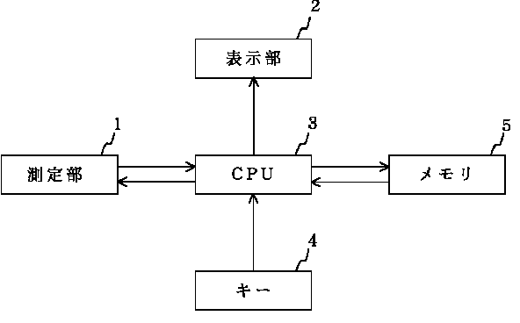
A [FIG. 2]
