(11)Publication number | 05-053663
(43)Date of publication of application | 05.03.1993
(51)Int.Cl. | G05F 1/56  G01R 27/02
(21)Application number | 03-209495
(22)Date of filing | 21.08.1991
(71)Applicant | ADVANTEST CORP
(72)Inventor | YADA HIDEKAZU

(54)CONSTANT CURRENT CIRCUIT FOR MEASUREMENT OF RESISTANCE

(57)Abstract
PURPOSE: To provide a constant current circuit for measurement of resistance which can obtain the resistance value of a measured object after applying a fixed current to the measured object and measuring the voltage generated et the measured object, can reduce the level of release voltage generated at a measurement terminal, and can test such an element as a semiconductor integrated circuit, etc., with no breakage.
CONSTITUTION: A constant current circuit for measurement of resistance consists of a constant voltage generating circuit 10 and a voltage/current converter circuit which converts the constant voltage outputted from the circuit 10 and applies a fixed current to a measured object 30. Then a voltage switch means 14 is added to a feedback circuit of the circuit 10, and the reference voltage applied to the voltage/current converter circuit is changed. Then the level of release voltage can be reduced.

CLAIMS
[Claim(s)]
[Claim 1]A. Fixed voltage is given to a non-inversed input terminal, and an inversed input terminal is grounded with an input-resistance machine, and. A constant voltage circuit which a feedback resister machine was connected between an output terminal and this inversed input terminal, and was constituted, B. Output voltage of this constant voltage circuit is given to an inversed input terminal of an operational amplifier through a current sensing resistor machine, Reference voltage is given to a non-inversed input terminal of this operational amplifier, and output voltage of the above-mentioned operational amplifier is given to a control electrode of an active device, A voltage-current conversion circuit which current which flows through an active device is given to the above-mentioned current sensing resistor machine, and voltage which occurs in a current sensing resistor machine is given to the above-mentioned operational amplifier as feedback voltage, and is constituted, C. A current regulator circuit for measure resistance constituted as resemble a switching means which changes a pressure value which is provided by the above-mentioned constant voltage circuit and given to the above-mentioned voltage-current conversion circuit.

DETAILED DESCRIPTION
[Detailed Description of the Invention]
[0001]
[Industrial Application]This invention relates to the current regulator circuit for measure resistance used when measuring direct current resistance, such as a semiconductor integrated circuit or a diode, a light emitting diode, and a resistor, for example.
[0002]
[Description of the Prior Art]The conventional current regulator circuit for measure resistance is shown in Fig.2. Ten in the figure shows a constant voltage circuit, and 20 shows a voltage-current conversion circuit. The voltage source 11 to which the constant voltage circuit 10 gives fixed voltage-V_{r} to the non-inversed input terminal of operational amplifier U₁ and this operational amplifier U₁, It is constituted by the input-resistance machine 12 connected to during the inversed input terminal of operational amplifier U₁, and the common potential point ARS, and the feedback resister machine 13 connected to between this inversed input terminal and output terminal, and fixed voltage V₁ is output to the output terminal 15.
[0003]The voltage-current conversion circuit 20 is constituted by operational amplifier U₂, and the active device Q and the current sensing resistor machine 21 connected to an output side of this operational amplifier U₂. Connect the non-inversed input terminal of operational amplifier U₂ to the voltage source 11 which outputs reference voltage-V_{r}, and fixed voltage-V_{r} is given, and the current sensing resistor machine 21 connects one end to the output terminal 15 of the constant voltage circuit 10, and it connects the other end to the sense terminal A through the active device Q. It connects at the common potential point ARS, and the sense terminal B connects the body 30 to be measured among the sense terminals A and B. The inversed input terminal of operational amplifier U₂ is connected at the node K of the active device Q and the current sensing resistor machine 21, and operational amplifier U₂ and the active device Q operate so that the current which flows into the current sensing resistor machine 21 may always maintain constant value.
[0004]That is, the voltage between the node K and the common potential point ARS serves as the same voltage-V_{r} as a non-inversed input terminal. If the gain of operational amplifier U₂considers it as sufficient large thing, however resistance R_{X} of the body 30 to be measured may change, the voltage of the node K will be maintained by -V_{r}. The current which flows through the current sensing resistor machine 21 is substantially equal to current I_{S1} which flows through the body 30 to be measured, when the body 30 to be measured is connected among the sense terminals A and B. Voltage V₂₁ which occurs in the current sensing resistor machine 21 becomes V₂₁=V₁- (-V_{r}). Therefore, voltage V₂₁ which occurs in the current sensing resistor machine 21 maintains constant value regardless of resistance R_{X} of the body 30 to be measured, and current I_{S1} which flows through the body 30 to be measured also always serves as constant value regardless of resistance R_{X}.
[0005]This is described with expression. When the resistance of R₂ and the current sensing resistor machine 21 is made [ the resistance of the input-resistance machine 12 ] into R₃ for the resistance of R₁ and the feedback resister machine 13, output voltage V₁ of the constant voltage circuit 10 is V₁=-V_{r}. - (1+R₂/R₁) --- (1)
I_{S1}={V₁-(-V_{r})} 1/R₃ ... (2)
(2) Formula I_{S1}=-V_{r} and R₂/R₁ and R₃ (3)
Electric current value I_{S1} which flows through a next door and the body 30 to be measured maintains constant value regardless of resistance R_{X} of the body 30 to be measured.
[0006]Therefore, by measuring voltage E_{X} which occurs among the sense terminals A and B, resistance R_{X} of the body 30 to be measured is calculated by R_{X}=E_{X}/I_{S1}. Thus, since current I_{S1}was decided preliminarily, calculation of resistance R_{X} of the body 30 to be measured can be performed, without measuring electric current value I_{S1}.
[0007]
[Problem to be solved by the invention]In the conventional current regulator circuit for measure resistance, the voltage of the sense terminal A reaches near the output voltage V₁ of the constant voltage circuit 10 at the maximum in the state where the body 30 to be measured is not connected among the sense terminals A and B. That is, it is V_{open}=V₁ when voltage of the sense terminal A in the state where the body 30 to be measured is not connected is made into V_{open}. -(R₃ and I_{G}+V_{DS})... (4)
the current and V_{DS} through which I_{G} flows into the control electrode of the active device Q -- the drain of the active device Q, and the voltage; between sources -- current I_{G} which flows into the control electrode of a field effect transistor generally is very small. Therefore, (R₃ and I_{G}+V_{DS}) serve as sufficient small value, and serves as V_{open}nearly equal toV₁. Output voltage V₁ of the current regulator circuit 10 at the time of opening serves as about [ 10-20V ] voltage. In the state where the voltage of 20V has occurred among the sense terminals A and B as a result, when withstand voltage connects a semiconductor integrated circuit or a diode not more than 20V, etc. among the sense terminals A and B, there is a possibility that voltage destruction of the semiconductor integrated circuit may be carried out.
[0008]The object of this invention tends to provide the constant current source circuit for measure resistance which can change the voltage at the time of opening to a low state, without changing the electric current value which flows through the body 30 to be measured.
[0009]
[Means for solving problem]In this invention, the means which changes the reference voltage given to the voltage-current conversion circuit 20 from the constant voltage circuit 10 is provided. It can be set up to make low voltage which occurs by the change of this reference voltage at the node K of an active device and a current sensing resistor machine, and voltage which occurs at the time of opening of a sense terminal can be made low by making low voltage which occurs at the node K.
[0010]Therefore, if it makes low reference voltage given to a voltage-current conversion circuit in measuring the resistance of a semiconductor device with low withstand voltage, the voltage which occurs in a sense terminal can be stopped low. As a result, the body to be measured is connectable in the state where the sense terminal is opened wide.
[0011]
[Working example]One Example of this invention is shown in Fig.1. A community code is attached and shown in Fig.3 and identical parts among the figure. In this invention, the switching means 14 which changes reference voltage V_{R} given to the voltage-current conversion circuit 20 from the constant voltage circuit 10 is provided. This switching means 14 can constitute a feedback resister machine with the switch 14A of 13A, 13B, and the feedback resister machines 13A and 13B of one of these which were divided into two which short-circuits 13B on the other hand, Reference voltage V_{R} is taken out from the node of the feedback resister machines 13A and 13B, and this reference voltage V_{R} is supplied to the voltage-current conversion circuit 20.
[0012]When output voltage of the constant voltage circuit 10 at the time of changing the switching means 14 is made into V_{2OFF} and V_{2ON}, it is V_{2OFF}=-V_{r} {1+(R₄+R₂')/R₁}... (5)
V_{2ON}=-V_{r}(1+R₂'/R₁) ... (6)
It becomes. However, it is considered as R₂nearly equal toR₂'+R₄ to resistance R₂ of the feedback resister machine 13 with which R₂' showed the resistance of the feedback resister machine 13A to Fig.2, and R₄ showed the resistance of the feedback resister machine 13B, and the resistance of R₂' and R₄ to it.
[0013]Reference voltage V_{R} output from the switching means 14 on the other hand, is V_{ROFF}=-V_{r} (1+R₄/R₁)... (7)
V_{RON}=-V_{r}--- (8)
It becomes. current I_{S2OFF} into which the switch 14A flows through the body 30 to be measured at the time of OFF -- I_{S2OFF}=(V_{2OFF}-V_{ROFF})/R₃ ... (9)
= [-V_{r}{1+(R₄+R₂')/R₁}-{-V_{r} (1+(R₄/R₁)}]/R₃=-V_{r} and R₂'/R₁ and R₃---) (10) The switch 14A the body 30 of ON state to be measured. Flowing current I_{S2ON} is . I_{S2ON}=(V_{2ON}-V_{RON})/R₃=[-V_{r}(1+R₂'/R₁)-(-V_{r})]/R₃=-V_{r} and R₂'/R₁ and R₃ ... (11) (10) , Current I_{S2OFF} and I_{S2ON} into which the switch 14A flows through the body 30 to be measured also in the state of OFF also in the state of ON turn into I_{S2OFF}=I_{S2ON} so that clearly from (11) types.
[0014]Release voltage V_{OPEN1} which the switch 14A generates in the sense terminal A in the state of OFF is V_{OPEN1}=V_{2OFF}. - (R₃ and I_{G}+V_{DS})
Release voltage V_{OPEN2} which the switch 14A generates in the sense terminal A in the state of ON is V_{OPEN2}=V_{2ON}. - (R₃ and I_{G}+V_{DS})
V_{2OFF} and V_{2ON} are V_{2OFF}>V_{2ON} so that clearly from (5) and (6) types.
[0015]Therefore, release voltage which occurs in the sense terminal A can be made small by changing the switch 14A to the state of ON. the case where the ratio of V_{2OFF} and V_{2ON} is made into R₄=R₂' -- about -- it is set to one half.
[0016]
[Effect of the Invention]As described above, in the present invention, the switch 14A is changed to a state of ON.
Therefore, release voltage which occurs in the sense terminal A can be made low, without giving change to current I_{S2OFF} and I_{S2ON} which flow through the body to be measured.
Therefore, a semiconductor integrated circuit can be promptly connected from a release position, and experimental efficiency can be improved. The advantage which can examine efficiently therefore the semiconductor device of a semiconductor integrated circuit or others in a short time is acquired.

DESCRIPTION OF DRAWINGS
[Brief Description of the Drawings]
A [FIG. 1] The connection diagram showing one Example of this invention.
A [FIG. 2] The connection diagram for describing a Prior art.
[Explanations of letters or numerals]
10 Constant voltage circuit
14 Switching means
14A Switch
20 Voltage-current conversion circuit
30 The body to be measured
A and B Sense terminal

DRAWINGS
A [FIG. 1]
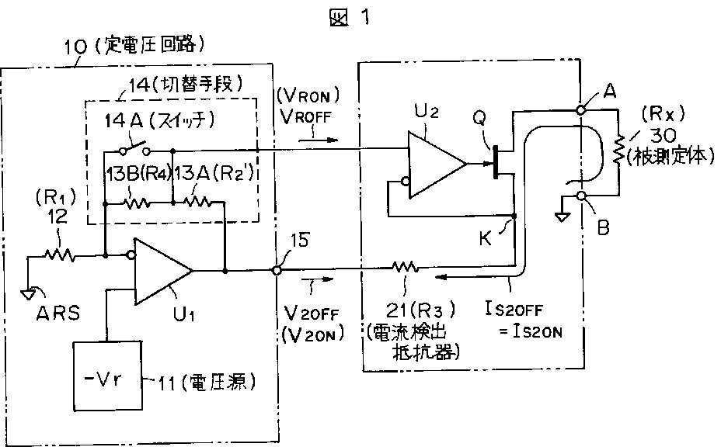
A [FIG. 2]
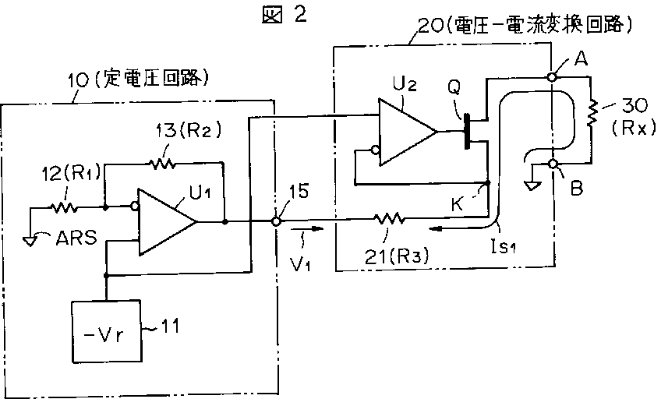

CORRECTION OR AMENDMENT
[Kind of official gazette]Printing of correction by regulation of Patent Law Article 17bis
[Section Type] The 3rd Type of the part VI gate
[Publication date]Heisei 9(1997) (1997) February 14
[Publication No.]JP,5-53663,A
[Date of Publication]Heisei 5(1993) (1993) March 5
[Annual volume number] Published unexamined patent application 5-537
[Application number]Japanese Patent Application No. 3-209495
[International Patent Classification (6th Edition)]
G05F 1/56 310
G01R 27/02
[FI]
G05F 1/56 310 T 4237-5H
G01R 27/02 R 9213-2G
[Written Amendment]
[Filing date]Heisei 8(1996) March 26
[Amendment 1]
[Document to be Amended]Description
[Item(s) to be Amended]0011
[Method of Amendment]Change
[Proposed Amendment]
[0011]
[Working example]One Example of this invention is shown in Fig.1. A community code is attached and shown in Fig.2 and identical parts among the figure. In this invention, the switching means 14 which changes reference voltage V_{R} given to the voltage-current conversion circuit 20 from the constant voltage circuit 10 is provided. This switching means 14 can constitute a feedback resister machine with the switch 14A of 13A, 13B, and the feedback resister machines 13A and 13B of one of these which were divided into two which short-circuits 13B on the other hand, Reference voltage V_{R} is taken out from the node of the feedback resister machines 13A and 13B, and this reference voltage V_{R} is supplied to the voltage-current conversion circuit 20.

CORRECTION OR AMENDMENT
[Kind of official gazette]Printing of correction by regulation of Patent Law Article 17bis
[Section Type] The 3rd Type of the part VI gate
[Publication date]Heisei 10(1998) (1998) November 13
[Publication No.]JP,5-53663,A
[Date of Publication]Heisei 5(1993) (1993) March 5
[Annual volume number] Published unexamined patent application 5-537
[Application number]Japanese Patent Application No. 3-209495
[International Patent Classification (6th Edition)]
G05F 1/56 310
G01R 27/02
[FI]
G05F 1/56 310 T
G01R 27/02 R
[Written Amendment]
[Filing date]Heisei 8(1996) March 26
[Amendment 1]
[Document to be Amended]Description
[Item(s) to be Amended]0011
[Method of Amendment]Change
[Proposed Amendment]
[0011]
[Working example]One Example of this invention is shown in Fig.1. A community code is attached and shown in Fig.2 and identical parts among the figure. In this invention, the switching means 14 which changes reference voltage V_{R} given to the voltage-current conversion circuit 20 from the constant voltage circuit 10 is provided. This switching means 14 can constitute a feedback resister machine with the switch 14A of 13A, 13B, and the feedback resister machines 13A and 13B of one of these which were divided into two which short-circuits 13B on the other hand, Reference voltage V_{R} is taken out from the node of the feedback resister machines 13A and 13B, and this reference voltage V_{R} is supplied to the voltage-current conversion circuit 20.

